# Crystal structures of reaction products of 2-cyanothiazole with gold(III) compounds

## M. Ejnik, A. Ciborska, Ł. Ponikiewski, A. Dołęga

### Department of Inorganic Chemistry, Faculty of Chemistry, Gdansk University of Technology, Narutowicza 11/12, 80-233 Gdańsk,

### e-mail: s185339@student.pg.edu.pl

Due to increasing bacterial drug resistance, research on new antimicrobial agents is of great importance. Studies of Au(III) chlorocomplexes show their increased biological activity [1,2]. We recently showed, that gold(III) chlorocomplex with the chelating amide shows better biological activity compared to similar complexes with non-chelating ligands [1].

Regarding our previous research on metal-facilitated hydrolysis of nitrile bond in gold(III) complexes of 2-cyanopyridine and   
2,4-dicyanopyridine, we continued our studies using previously established methods [1]. We focused on characterizing the yet unknown crystal structures of gold(III) chlorocomplexes with 2-cyanothiazole and products of its alcoholysis. Our main goal was to fully characterize each product spectroscopically and structurally and to determine their antimicrobial activity.

As a result of the syntheses we isolated three different gold(III) compounds (Fig. 1).

**Figure 1**. Synthetic routes for compounds 1, 2 and 3

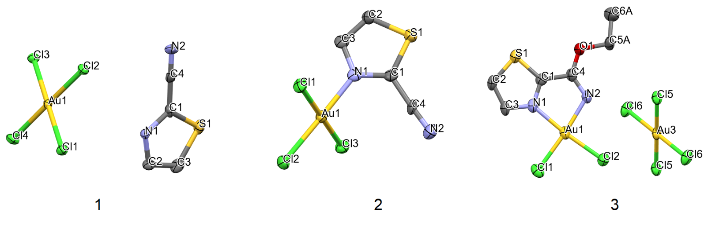Each of the above mentioned compounds was obtained in the monocrystalline form and further characterized by X-ray diffraction   
(Fig 2.)

###### **Figure 2**. X-ray molecular structures of compounds 1, 2 and 3. Ellipsoids at 50% probability, hydrogens omitted for clarity

#### [1] M. Ejnik, P. Bruździak, K. Gutmańska, A. Ciborska, M. Malik, A. Brillowska-Dąbrowska, D. Gudat, A. Dołęga (2025) *Spectrochim. Acta A*

#### **325**, 125055.

#### [2] B. Đ. Glišić,, M. I. Djuran, (2014) *Dalton Trans*. **43**, 5950.

Research was financed by the "Excellence Initiative - Research University" program of the Gdańsk University of Technology: RADIUM LEARNING THROUGH RESEARCH PROGRAM 1/2/2024/IDUB/III.1a/Ra