## The impact of reaction conditions in the co-crystallization of modified isoniazid compounds Mark G. Smith1, Andreas Lemmerer2

### 1Department of Chemistry, University of South Africa, Florida, Johannesburg, South Africa; 2Molecular Sciences Institute, School of Chemistry, University of the Witwatersrand, South Africa

### smithm2@unisa.ac.za

The formation of co-crystals involving covalently modified isoniazid and hydroxybenzoic acid co-formers has been found to depend on reaction conditions, rather than crystallization conditions. In particular, benzophenone-substituted isoniazid compounds displayed variable supramolecular outcomes based on subtle experimental changes. The incorporation of one or two methyl groups on the benzophenone moiety led to the formation of isostructural co-crystals, showing that small molecular modifications do not necessarily change the supramolecular structure

Adjusting the reflux duration during crystallization altered the stoichiometry of the products, while adding excess quantities of a starting material produced distinct polymorphic outcomes. When an acid catalyst was included in a one-pot synthesis, solvate formation was successfully suppressed. Further, a comparison between mechanochemical and reflux-based methods revealed that the choice of synthetic route could influence polymorph expression. Unexpectedly, sunlight exposure initiated free radical polymerization.

This presentation will showcase several case studies where minor changes to reaction parameters led to significant differences in supramolecular structure, emphasizing the delicate balance governing supramolecular synthesis.

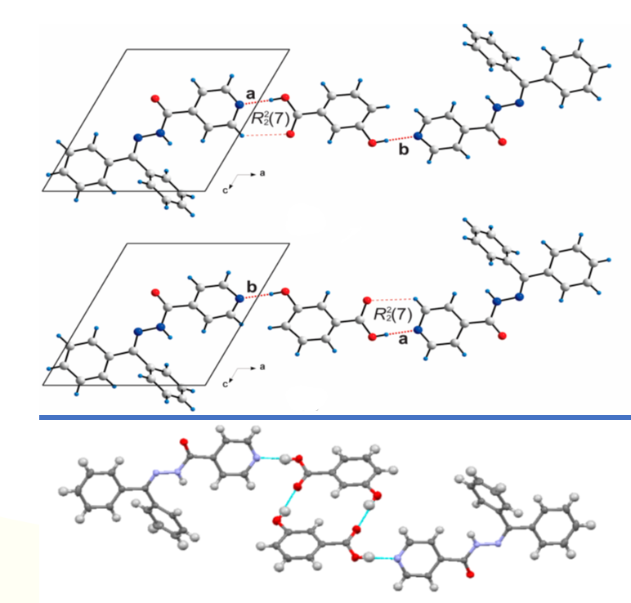

###### **Figure 1**. Change in reaction conditions resulted in structural and stoichiometric variations [1].

#### [1] Smith, MG.; Lemmerer, A.; *Cryst. Growth Des.* (2018), **18**, 4777-4789

[2] Smith, MG.; Lemmerer, A; *J.Mol. Struct*. (2019), **1179**, 132-144