Design and Synthesis of Bifunctional Cobalt-based Single-Molecular Magnets
Juliane Kamlah, Paula Stark, Nico Graw, Regine Herbst-Irmer, Anna Krawczuk, Dietmar Stalke
Institute of Inorganic Chemistry, Georg-August Universität Göttingen, Tammannstr. 4, 37077 Göttingen

juliane.kamlah@uni-goettingen.de
Multifunctional molecular materials with tuneable physical properties, like magnetism, are gaining increasing importance due to their potential applications across various technological fields. As part of this research, bifunctional molecular systems are being explored by incorporating luminescence into a single molecular system, further broadening their range of applications, including data storage and bioimaging.^{[1]} To achieve this, the sulfur diimide ligand system, previously developed in our group for single-molecule magnets, has been modified by adding an anthracene residue and subsequently complexated with Co(II).^{[2]} Here, I present the first Co(II)-based single-molecule magnet featuring an anthracene-containing ligand system, showing promising magnetic and luminescent properties.^{[3]}


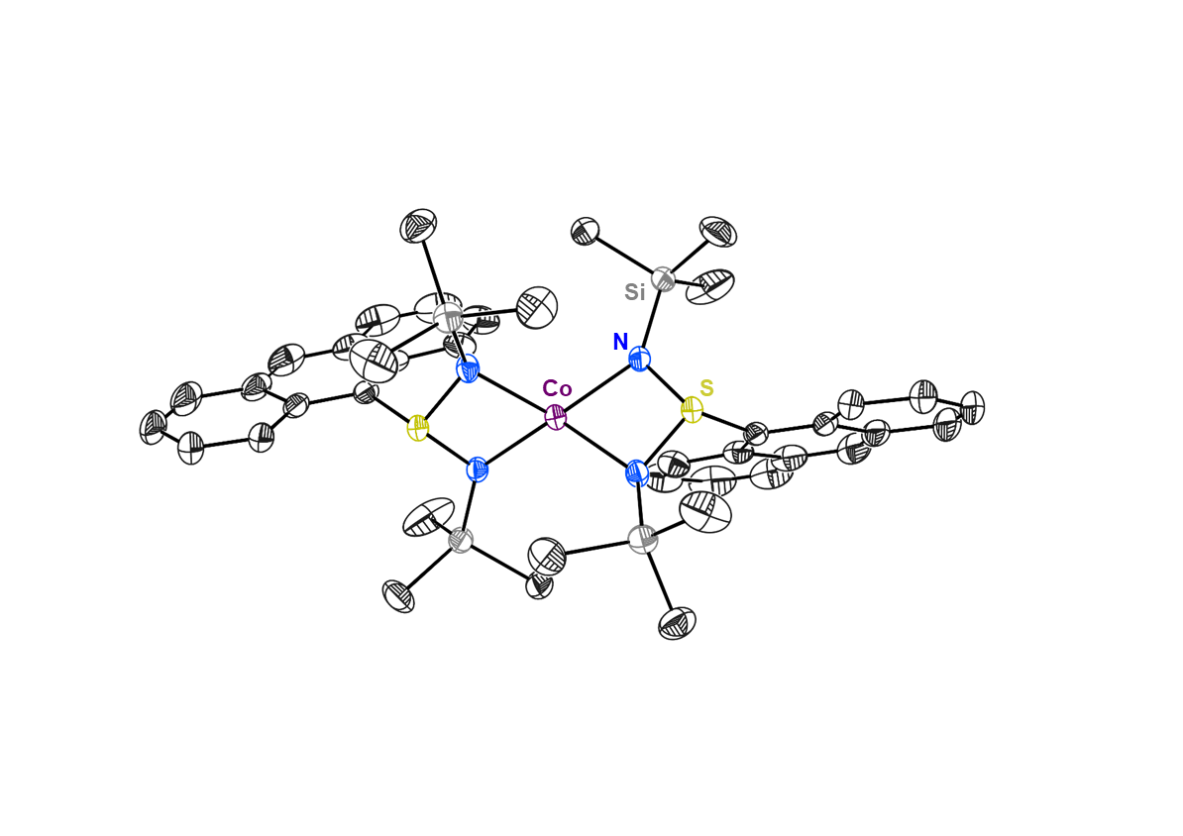
Figure 1: Crystal structure of Co(II)-based single molecule magnet with the sulfur-diimide ligand containing an anthracene residue Co{AnS(NTMS)₂}₂.^{[3]}
The focus is primarily on the variation of the N-Co-N bite angle and the π-stacking interactions between anthracene scaffolds. The former affects the magnetic anisotropy and could potentially maximize it, while the latter plays a role in determining the material’s luminescent response. Crystallography allows for the investigation of the structure-property correlation of the newly synthesized compounds, providing deeper insights into how structural modifications impact their magnetic and luminescent properties. The experimental data can further confirm these correlations and contribute to a more comprehensive understanding of the material's performance.^{[2]}
References:
[1] a) J. Long, Y. Guari, R. A. S. Ferreira, L. D. Carlos, J. Larionova, Coord. Chem. Rev. 2018, 363, 57-70. b) R. Marin, G. Brunet, M. Murugesu, Angew. Chem. 2021, 133, 1752-1772.
[2] a) C. M. Legendre, E. Damgaard-Møller, J. Overgaard, D. Stalke, Eur. J. Inorg. Chem. 2021, 30, 3108-3114. b) T. Schulz, D. Stalke, Z. Naturforsch. 2010, 65b, 701-710.
[3] J. Kamlah, P. Stark, A. Krawczuk, D. Stalke, in preparation.

