# The origin of biological homochirality: asymmetry between RNA enantiomers in a crystal lattice

## A. Kiliszek and W. Rypniewski

### 1Institute of Bioorganic Chemistry Polish Academy of Sciences, Noskowskiego 12/14, 61-704 Poznan, Poland

### kiliszek@ibch.poznan.pl

Elucidating the origin of the homochirality of biological molecules necessitates a mechanism that disrupts the natural equilibrium between enantiomers and amplifies the initial imbalance to significant levels. Authors of existing models have sought explanations in the parity-breaking weak nuclear force, in selectively acting external factors, or in random fluctuations that subsequently became amplified by an autocatalytic process [1, 2]. We have obtained crystals in which L- and D-enantiomers of short RNA duplexes assemble asymmetrically (Fig. 1) [3]. These enantiomers form different lattice contacts and exhibit varying exposures to water and metal ions present in the crystal. It appears that asymmetry between enantiomers can arise from their mutual interactions and subsequently propagate through crystallization. Asymmetric racemic compounds merit consideration as potential factors in symmetry breaking and enantioenrichment that occurred in the early biosphere.

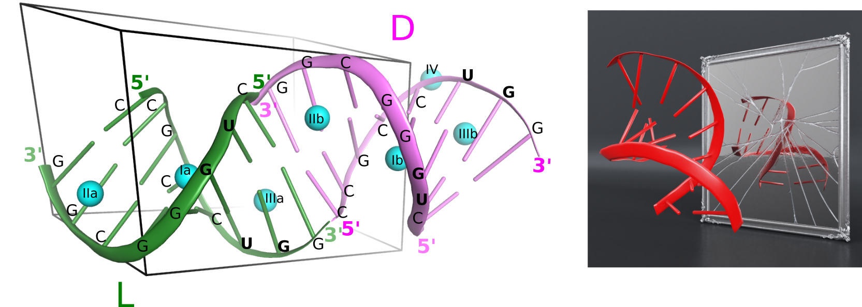

###### **Figure 1**. The crystal packing of L- and D-RNA duplexes (green and pink, respectively), with the bound Zn2+ ions (blue spheres) (left). The artistic representation of broken symmetry between L and D enantiomers of RNA molecules (right).

[1] Blackmond, D.G. (2019). *Cold Spring Harb Perspect Biol*, **11**.

#### [2] Kiliszek, A. & Rypniewski, W. (2023). *Acta biochimica Polonica*, **70(3)**, 481–485.

#### [3] Kiliszek, A. Błaszczyk, L. Bejger, M. & Rypniewski, W. (2021). *Nucleic acids research*, ***49*(21)**, 12535–12539.