# The structural features of 4-(1h-benzimidazol-2-yl)-1-phenyl-1h-1,2,3-triazol-5-amine halogen derivatives

## V. Dyakonenko1, A. Shaposhnyk1, S. Shishkina1

### 1 SSI ‘‘Institute for Single Crystals’’, National Academy of Sciences of Ukraine, 60 Nauki Ave., 61001 Kharkiv, Ukraine

### Email of communicating dyakvik@gmail.com

Hybrid compounds based on benzimidazole and triazole with halogen phenyl substituents (e.g., Cl, Br, I) are significant for the development of new pharmaceuticals and functional materials. These compounds attract attention due to synergistic effects arising from the combination of biologically active structural units. They are studied as anticancer agents, antimicrobial and antiviral drugs, as well as for creating materials with nonlinear optical properties. Investigating the molecular and crystalline structure allows optimizing their properties, predicting polymorphism, and developing more effective drugs, considering the influence of halogen phenyl groups on activity. This paper presents a study of the molecular and crystal structure of 4-(1H-benzimidazol-2-yl)-1-phenyl-1H-1,2,3-triazol-5-amine with different halogens (X=Cl, Br, I).

 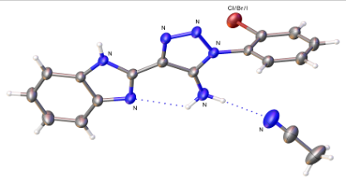

**Figure1**. Scheme (left) and molecular structure (right) of **I-III**

X-ray structural analysis showed that structures **I-III** are solvates with acetonitrile (Fig. 1) and have similar molecular and crystal structures. Compounds I (**Cl**) and II (**Br**) are isostructural (Table 1). The main difference in the molecular structure of compounds **I-III** is the varying angle of rotation of the X-substituent relative to the plane of the triazole ring. In structures I (Cl)-II(Br) this angle is approximately -92º , while in structure **III (I)** it is 100 º. Using quantum chemical calculations, the influence of intermolecular interactions on the formation of the crystal structure was analyzed.

**Table 1**. The unit cell parameters of **I-III**.

|  |  |  |  |
| --- | --- | --- | --- |
|  | **X** | **Space group.** | **Unit cell parameters, Å ,°** |
| **I** | **Cl** | **P-1** | *a*=7.19  *b=*10.07 *c*=12.98 α=100.12 β=104.29 γ=104.98 |
| **II** | **Br** | **P-1** | *a*=7.29  *b=*10.09  *c*=13.00 α=100.87 β=104.58 γ=103.86 |
| **III** | **I** | **P-1** | *a*=8.16  *b=* 9.36  *c*=12.88 α= 96.87 β= 96.58 γ=104.80 |

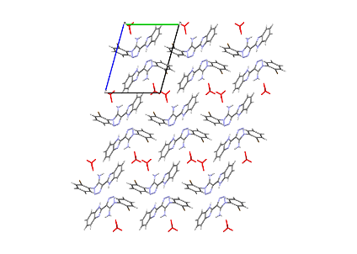 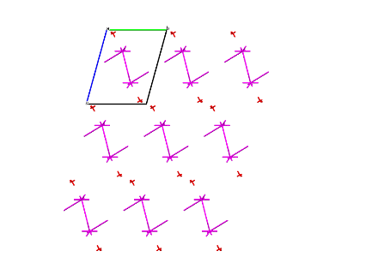 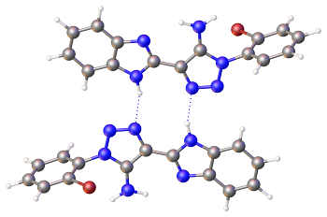

a b c

**Figure 2**. Crystal packing (a) and EVD (b), the structure forming dimer (c) in the structures **I-III**. Projection along *a* crystallographic plane. The molecules of acetonitrile are highlighted by red color

The structural motif in crystals **I-III** consists of layers of dimers parallel to the crystallographic planes *ab*. The solvent molecules located in the cavities between layers (Fig. 2a). The dimers (Fig. 2 c) are formed through relatively strong N-H…N hydrogen bonds (interaction energy -17 kcal/mol). The stacking interactions (approximately -12 kcal/mol) are observed between these dimers within the layer. Interactions involving halogens were found to be energetically much weaker (approximately -7 to -9 kcal/mol) and do not participate in the formation of the layer. Therefore, the nature of the halogen in compounds **I-III** does not influence the formation of the crystal structure. Structure **III (I)** is not formally isostructural with respect to structures **I (Cl)** and **II (Br)**, but the structural motif and the interactions forming it are completely identical to structures **I (Cl)** and **II (Br)**.