# Regulation of Retinal membrane Guanylate Cyclase 1 (RetGC 1) by guanylate cyclase activating protein 1 (GCAP1)

## Nelam kumar1,2, Humberto Fernandes1,2

### 1International Centre for Translational Eye Research, Institute of Physical Chemistry, Polish Academy of Sciences, Skierniewicka 10A, 01-230 Warsaw, Poland, 2Institute of Physical Chemistry, Polish Academy of Sciences, Kasprzaka 44/52, 01-224 Warsaw, Poland

### [knelam@ichf.edu.pl](mailto:knelam@ichf.edu.pl)

Human retinal guanylyl cyclase 1 (RetGC1) is a 120 kDa dimeric membrane guanylyl cyclase protein, expressed in the photoreceptor cells. This is one of the crucial proteins in the phototransduction process and is responsible for re-establishing the cGMP pool [1]. The catalytic activity of RetGC1 is regulated by its binding to regulatory proteins, guanylate cyclase activating proteins (GCAP1 and GCAP2) and the retinal degeneration protein 3 (RD3). Human GCAP1 is a 23 kDa neuronal Ca2+ sensor (NCS) protein having four EF hands. RetGC1 is activated and synthesizes a secondary messenger, called cyclic GMP, when binding to Ca2+-free/Mg2+-bound GCAP1 at low cytosolic Ca2+ levels in light-activated photoreceptors. By contrast, RetGC1 is inactivated by binding to Ca2+-bound GCAP1 at elevated Ca2+ levels in dark-adapted photoreceptors. At a genetic level, RetGC1 is a known hotspot for mutation that results in several human vision disorders like cone-rod dystrophy (CORD), leber congenital amaurosis (LCA) and night blindness, with some generating a constantly active RetGC1 [2]. The RetGC1 is already a target for genetic engineering approaches, trying to address some of those illnesses. Of note, there is currently no RetGC1 structure to aid in drug design or to explain the molecular details of its regulation, in part likely due to being a membrane protein, the difficulty of getting the protein recombinantly, and its low levels in the retina (hindering native isolations). There are, however, some high-resolution 3D structures of GCAP1 available from different species [3]. The aim of this project is to get the soluble protein of RetGC1 (full-length or shorter constructs that preserve catalytic activity), and its complex with GCAP1, to gain molecular insight via crystallization. The stoichiometry and binding mode of this complex are key to deciphering the RetGC1 protein’s activity.

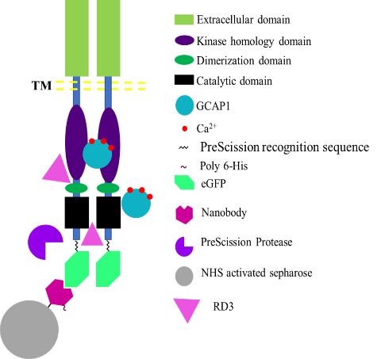

###### **Figure 1**. Domain organization and working hypothesis of RetGC1

#### [1] Vadim Y. Arshavsky, Trevor D. Lamb, and Edward N. Pugh Jr., "G proteins and phototransduction." Annual review of physiology 64, 153-187: (2002).

#### [2] Ames B. James, "Structural basis of retinal membrane guanylate cyclase regulation by GCAP1 and RD3." Frontiers in Molecular Neuroscience, 479: (2022).

#### [3] Dizhoor M. Alexander, and Peshenko V. Igor, "Regulation of retinal membrane guanylyl cyclase (RetGC) by negative calcium feedback and RD3 protein." Pflügers Archiv-European Journal of Physiology. 1-18: (2021).

The International Centre for Translational Eye Research (FENG.02.01-IP.05-T005/23) project is carried out within the International Research Agendas programme of the Foundation for Polish Sciences co-financed by the European Union under the European Funds for Smart Economy 2021-2027 (FENG).