# Two polymorphs of MgClO4 • 6Urea

## G. Velyanova and K. Kossev

### Institute of Mineralogy and Crystallography, Bulgarian Academy of Sciences, Acad. G. Bonchev Str. 1113 Sofia, Bulgaria

### gergana315@gmail.com

The coordination chemistry of magnesium is well known as it is one of the most abundant elements in both inanimate and animate nature. It is one of the most important biogenic elements and a component of many rock-forming minerals. Magnesium favours octahedral coordination both in solutions and crystalline compounds. With the discovery of perchlorates ClO4– on Mars by NASA Phoenix Lander the interest in studying the physicochemical characteristics of MgClO4 • nH2O increased. Hydrates containing 6, 4, and 2 water molecules are currently known, with the latter two formed by dehydrating MgClO4 • 6H2O at 384 and 423 K, respectively [1,2]. Our previous research has shown that urea displaces water from the coordination sphere of magnesium in various magnesium salts. Depending on the physicochemical conditions, compounds with varying amounts of water and urea in the crystal structure are obtained [3,4]. In this research, we present results of the investigation of phases in the MgClO4 – Urea – H2O system for the first time. At room temperature, MgClO4 • 6Urea is obtained, exhibiting a monoclinic crystal structure in which the magnesium atom is octahedrally coordinated by six urea molecules, forming the complex [Mg • 6Urea]2+ cation, which is connected to the ClO41- anion through hydrogen bonds. After twelve months, the monoclinic structure undergoes a phase transformation, resulting in the formation of three symmetry-independent magnesium octahedra, whose arrangement leads to the development of a crystal structure with orthorhombic symmetry. The symmetry-non-equivalent structural units that make up the two polymorph modifications are shown in Figure 1. The density of the new (orthorhombic) structure is lower than that of the monoclinic one – 1.704 and 1.715 g/cm³, respectively – indicating a gradual and very slow decomposition of the structure. Interestingly, tribochemical activation of both systems, MgClO4 • 6H2O:6Urea and MgClO4:6Urea, crystallizes the monoclinic polymorphic modification of MgClO4 • 6Urea.

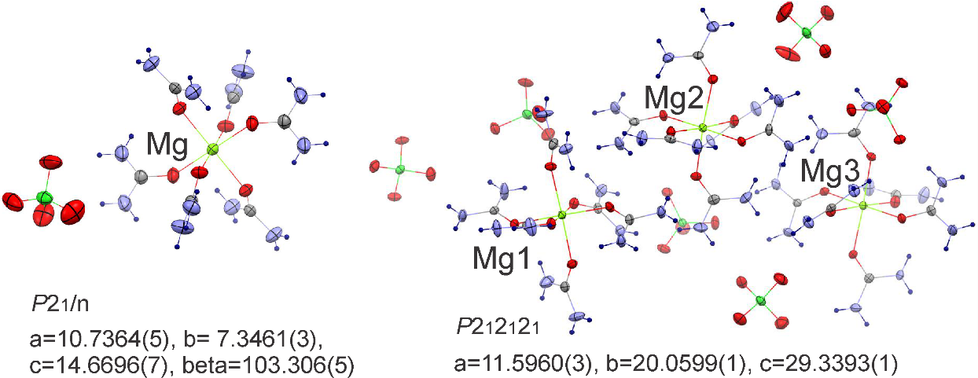

###### **Figure 1**. Symmetry non-equivalent structural units for MgClO4 • 6Urea polymorphs.

References:

#### [1] West, C. D. (1935). *Zeitschrift für Kristallographie-Crystalline Materials*, **91**, 480-493.

#### [2] Robertson, K., Bish, D. (2010). *Structural Science***, 66**, 579-584.

#### [3] Georgieva, I., Kossev, K., Titorenkova, R., Petrova, N., Zahariev, T., & Nikolova, R. (2022). *Journal of Solid State Chemistry*, **312**, 123263.

[4] Nikolova, R., Kostov-Kytin, V., Petrova, N., Kossev, K., Titorenkova, R., & Velyanova, G. (2024). *Crystals*, **14**, 227.

#### Bunge, H. J. (1982).

The authors thanks to the Bulgarian National Science Fund (grant agreement КП-06-Н64/4, 15.12.2022) for the financial support.