# The formation of organic structures through the analysis of concomitant polymorphs using quantum-chemical methods

## S. Shishkina1,2

### 1 Institute of Functional Materials Chemistry, State Scientific Institution “Institute for Single Crystals” of National Academy of Sciences of Ukraine, Nauky ave. 60, Kharkiv, Ukraine, 2Institute of Organic Chemistry of National Academy of Sciences of Ukraine, Academician Kukhar Str. 5, Kyiv, Ukraine

### [sveta12.20@gmail.com](mailto:sveta12.20@gmail.com)

Formation of concomitant polymorphs that crystallize from the same solution is the most unpleasant and undesirable in the pharmaceutical industry. Professor Bernstein very accurately formulated the whole gamut of feelings that the phenomenon of concomitant polymorphism evokes: "Is the phenomenon of concomitant polymorphs a curse or a blessing? It can be both." For the pharmaceutical industry, the formation of concomitant polymorphs is rather a curse, as it affects the properties of the product. For scientific studies of crystallization processes and patterns of formation of intermolecular interactions, concomitant polymorphs are invaluable objects. In general, the formation of two or three crystalline forms from the same solution is usually explained by kinetic and thermodynamic factors influencing the crystallization process. Some analogy between the creation of a new molecule due to the formation of chemical bonds during the synthesis process and the creation of a crystal due to the formation of intermolecular interactions during the crystallization process seems quite appropriate and allows us to consider crystallization as a supramolecular synthesis that obeys all known physicochemical laws. As a result of changes in factors affecting the crystallization process (concentration, temperature, cooling rate, etc.), crystalline structures formed from the same solution may contain molecules in different conformations, differ in systems of intermolecular interactions, and even be different enantiomers.

It should be noted that in most cases, especially in the development of drug production technology, the study of polymorphic modifications is limited to experimental methods. However, theoretical approaches to the study of crystal structures and their properties are no less, and often more effective. The use of modern methods of quantum chemistry allows a much more complete and reliable study of the conformational behaviour of molecules, the formation of intermolecular interactions, the main structural motifs in the crystal, the crystal lattice energies, as well as to predict properties of the crystal structure.

The use of quantum chemistry methods to study the concomitant polymorphs [1-3] allowed us to look into the fascinating world of crystallization and reveal patterns of crystal structure formation (Fig. 1).

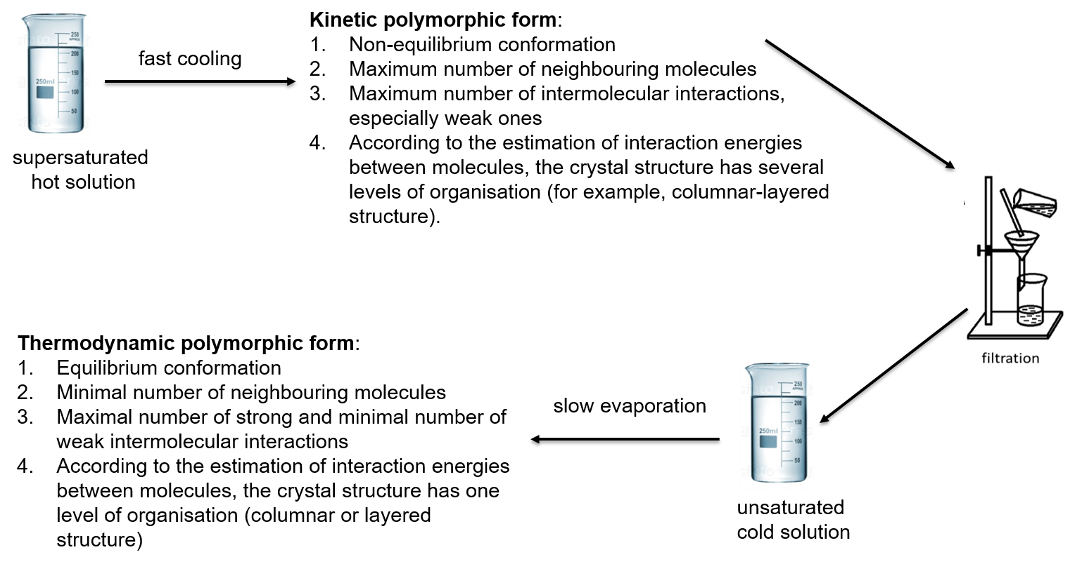

**Figure 1**. Regularities of crystal structures formation from the same solution.

#### [1] Shishkina S. V., Baumer V. N., Kovalenko S. M., Trostianko P. V., Bunatyan N. D. (2021) *ACS Omega* **6**, 3120.

#### [2] Shishkina S. V., Shaposhnyk A. M., Dyakonenko V. V., Shyshkina M. O., Kovalenko S. M. (2024) *CrystEngComm*, **26**, 1481.

#### [3] Shishkina S. V., Shaposhnyk A. M., Konovalova I. S., Dyakonenko V. V., Vaksler Ye. O. (2024), *Acta Crystallogr., Section B* **B80,** 27.