# Structural insights into the active site of *Escherichia coli* type III L-asparaginase: a site-directed mutagenesis approach

## M. Kilichowska1,2, A. Zieleziński3, M. Jaskólski4,5, J. Loch2

### 1Doctoral School of Exact and Natural Sciences, Jagiellonian University, Łojasiewicza 11, 30-348 Kraków, Poland, 2Faculty of Chemistry, Jagiellonian University, Gronostajowa 2, 30-387 Kraków, Poland, 3Faculty of Biology, Adam Mickiewicz University, Uniwersytetu Poznańskiego 6, 61-614 Poznań, Poland, 4Faculty of Chemistry, Adam Mickiewicz University, Uniwersytetu Poznańskiego 8, 61-614 Poznań, Poland, 5Institute of Bioorganic Chemistry, Polish Academy of Sciences, Noskowskiego 12/14, 61‑704 Poznań, Poland

### marta.kilichowska@doctoral.uj.edu.pl

L-asparaginases are widely recognized as very efficient anticancer agents in the treatment of acute lymphoblastic leukemia and several other malignancies. However, due to their bacterial origin, currently used enzymes induce immune response, often leading to allergic reactions [1]. Here, we present our investigation on type III L-asparaginases, which are smaller than the currently used therapeutics and therefore less likely to cause adverse effects [2].

Type III L-asparaginases typically possess three catalytic threonine residues (T-T-T). Type III enzymes are synthesized as homodimeric precursors (Fig. 1a), which undergo autoproteolysis, liberating the α-amino group of the N-terminal threonine and thus activating the enzyme (Fig. 1b) [3]. It remains unclear why other nucleophilic residues (e.g. serine or cysteine), present in catalytic positions in other enzymes from the same superfamily of Ntn-hydrolases, are almost absent in type III L-asparaginases.

In our work, we introduced serine and cysteine substitutions in the catalytic positions in type III L-asparaginase from *Escherichia coli* (EcAIII). Types of mutations were selected based on a bioinformatic analysis. We designed and produced six new variants of EcAIII and determined crystal structures of wild-type and modified enzymes in resolution range 1.6 - 2.0 Å. Our structural data revealed that (nucleophilic) threonine residue in the first catalytic position is essential for efficient autoproteolysis of the precursor. In the variants that remained almost completely uncleaved, we managed to obtain electron density for the region directly preceding the scissile bond, which plays an important role in the autoproteolysis, and which adapted a conformation different than in previously published structures. Apart from the catalytic residues, we observed all four possible states of a so-called “molecular switch”, comprising two residues responsible for substrate anchoring in the active site. Our research was supported by kinetic studies and determination of thermal stability of the constructed variants, which support the structural data and shed light on the structure-function relationship.

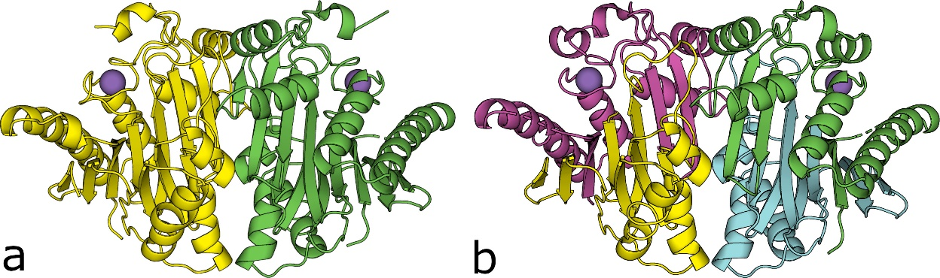

###### **Figure 1**. Crystallographic structures of T179S (uncleaved, a) and wild-type (cleaved, b) variants of type III L-asparaginase from *Escherichia coli* obtained in our laboratory.

#### [1] Darvishi, F., Jahanafrooz, Z. & Mokhtarzadeh, A. (2022). *Appl. Microbiol. Biotechnol.* **106**, 5335-5347.

#### [2] Nomme, J., Su, Y., Konrad, M., & Lavie, A. (2001). *Biochemistry*, **51**, 6816-6826.

#### [3] Michalska, K. & Jaskolski, M. (2006). *Acta Biochim. Pol.*, **53**, 627-640.

Work supported by National Science Centre (NCN, Poland) grant 2020/38/E/NZ1/00035. Work supported by the Doctoral School of Exact and Natural Sciences under the programme “Excellence Initiative – Research University” at Jagiellonian University.