# New Binders of the Cancer-Linked Enzyme PYCR1 Identified via XFS

## D. Czerwonka1, W. Ragin-Oh1, Linh H.Tran1, M. Ruszkowski1

### 1 Department of Structural Biology of Eukaryotes, Institute of Bioorganic Chemistry, Polish Academy of Sciences, Noskowskiego 12/14, 61-704 Poznan, Poland

### dczerwonka@ibch.poznan.pl

In human cells, PYCR1 (δ¹-pyrroline-5-carboxylate reductase 1) catalyzes the final step of proline biosynthesis by reducing P5C using NAD(P)H as a cofactor [1]. Beyond its metabolic role, PYCR1 has gained recognition as a pro-tumorigenic factor, with elevated expression observed in multiple malignancies including hepatocellular, breast, and prostate cancers. Its overexpression correlates with poor clinical outcomes and contributes to metabolic reprogramming, redox homeostasis, and extracellular matrix remodeling—features critical to cancer progression and metastasis [2]. Despite growing therapeutic interest, the chemical space of PYCR1 inhibitors remains underexplored, with most efforts focused on proline mimetics or analogues targeting the substrate-binding pocket. Such narrow strategies have yielded only modest inhibitors, none of which have structurally defined binding modes sufficient for rational drug development.

Here, we report the first crystallographic fragment screening (XFS) study targeting human PYCR1, employing the F2X-Entry Screen—comprising 96 chemically diverse fragments—to probe both substrate and cofactor binding regions. PYCR1 forms a homodecameric assembly of five obligate dimers, with each catalytic site residing at the dimer interface. The active site is structurally complex: the N-terminal domain adopts a Rossmann fold for NAD(P)H binding, while the substrate P5C occupies a pocket formed by loops in the C-terminal domain [3]. This arrangement generates a chemically diverse groove with addressable subsites for pyrrolidine, carboxylate, nicotinamide, two riboses, pyrophosphate, and adenine (**Fig. 1**).

Several fragment hits were identified within the P5C and/or NAD(P)H pockets. Notably, certain fragments induced conformational rearrangements within the active site, revealing its unexpected plasticity. These findings broaden the structural framework for ligand design and provide a valuable starting point for the development of novel PYCR1 inhibitors aimed at disrupting proline metabolism in cancer.

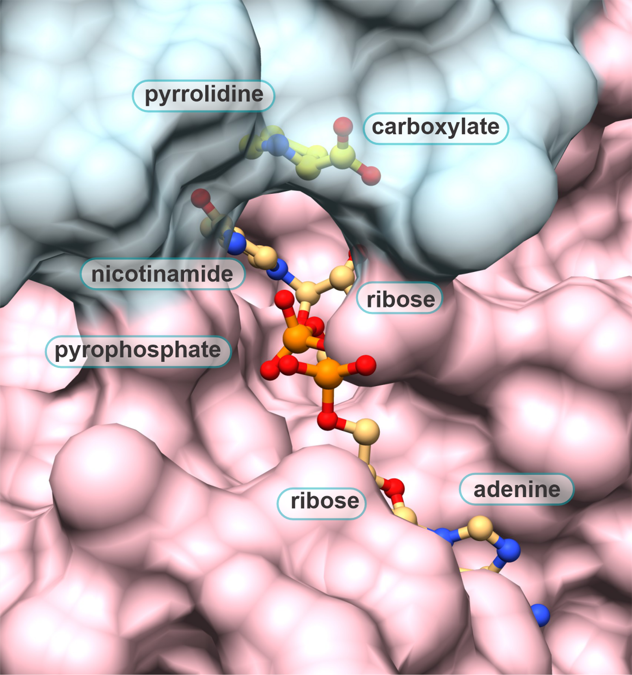

###### **Figure 1**. The PYCR1 active site.

#### [1] D'Aniello, C., Patriarca, E.J., Phang, J.M., Minchiotti, G. (2020). *Front Oncol*, **10**, 776.

[2] Ding, Z., Ericksen, R.E., Escande-Beillard, N., Lee, Q.Y., Loh, A., Denil, S., Steckel, M., Haegebarth, A., Wai Ho, T.S., Chow, P., Toh, H.C., Reversade, B., Gruenewald, S., Han, W. (2020). *J Hepatol*, **72**, 725.

[3] Christensen, E.M., Patel, S.M., Korasick, D.A., Campbell, A.C., Krause, K.L., Becker, D.F., Tanner, J.J. (2017). *J. Biol. Chem*., **292**, 7233.

The project is supported by the National Science Centre (Poland) grant number 2021/43/B/NZ7/01611.