# A one-dimensional coordination polymer with a pseudo face-centred monoclinic lattice: Structural and intermolecular insights

## H. Kherfi1,2, M. Hamadène1

### 1Laboratoire de Cristallographie-Thermodynamique, Faculté de Chimie, USTHB, BP 32 El-Alia, Bab-Ezzouar, Algiers, Algeria, 2Ecole Nationale Supérieure des Technologies Avancées, Algiers, Algeria

### hamza.kherfi@ensta.edu.dz

The present work reports the crystal structure study of a 1D coordination polymer, LiCr(C2O4)2(H2O)4 (**I**), determined by single crystal X-ray diffraction [1], along with an investigation of its intermolecular interactions via Hirshfeld surface analysis. The compound was prepared using reflex method in deionized water. It belongs to the monoclinic system, space group *C*2*/m*, with unit cell parameters, *a* = 10.097 (8) Å, *b* = 7.787 (8) Å, *c* = 6.737 (6) Å and β = 104.3 (1)°. The asymmetric unit contains both Li and Cr atoms on 2/*m* site symmetry leading to a pseudo face-centred monoclinic lattice, a half oxalate ligand and two independent water molecules lying on the mirror plane. The crystal structure is built up from octahedral *trans*-Cr(CO)4(H2O)2 and *trans*-Li(CO)4(H2O)2 units, bridged by the oxalate ligands, forming one-dimensional linear chains parallel to the [101] direction. Strong hydrogen-bonds are observed, involving tetrameric synthons (12), linked together to form H-bonded files that play a key role in the extension of the 2D supramolecular architecture. These noncovalent interactions were further highlighted through Hirshfeld surface analysis [2] and the corresponding 2D fingerprint plots [3]. The results confirmed their critical contribution to the crystal packing stabilization, with O⋅⋅⋅O contacts being the most dominant, accounting for 59.9% of the total interatomic interactions.

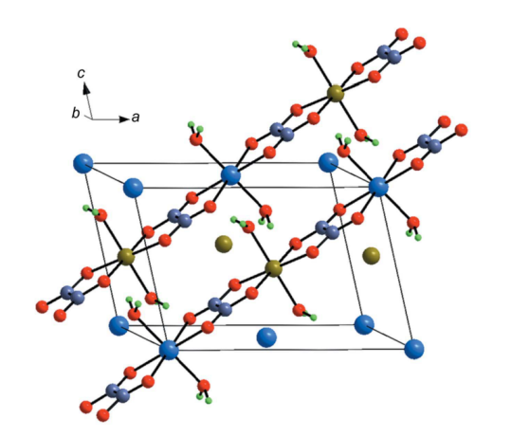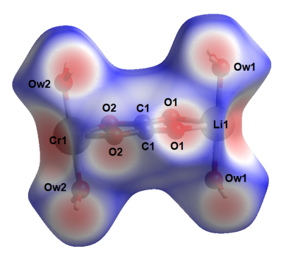

###### **Figure 1**. The face-centred monoclinic lattice in LiCr(C2O4)2(H2O)4 (Li blue and Cr olive-green), and its Hirshfeld surface plotted over dnorm.

#### [1] Kherfi, H., Benhacine, M. A. A., Hamadène, M., Balegroune, F. (2019). *Acta Cryst.*, **C75**, 1524.

#### [2] Spackman, M. A., Jayatilaka, D. (2009). *CrystEngComm*, **11**, 19.

#### [3] Spackman, M. A., McKinnon, J. J. (2002). *CrystEngComm*, **4**, 378.