## Structural study of the chromatin remodelling complex RSC in *Candida albicans*.

## R. Dupeyron1,2, L. Belot1, C. Sayou2, F. Weis1, E. Zarkadas1, S. Kieffer-Jaquinod3, J. Novion Ducassou3, A. Adrait3, Y. Couté3, J. Govin2, C. Petosa1

### 1Université Grenoble Alpes, CNRS, CEA, Institut de Biologie Structurale (IBS), 38000 Grenoble, France, 2Université Grenoble Alpes, CNRS UMR 5309, INSERM U1209, Institute for Advanced Biosciences (IAB), Site Sante´ – Allée des Alpes, 38700 La Tronche, France, 3Université Grenoble Alpes CEA, INSERM, UA13 BGE, CNRS, CEA, Grenoble, France.

### raphael.dupeyron@univ-grenoble-alpes.fr

Candidiasis is a fungal infection caused by fungi of the genus *Candida*, of which *C. albicans* is the main culprit. Invasive fungal infections are responsible of approximately *3.8 million deaths per year* [1]. The *RSC complex* (Remodeller of the Structure of the Chromatin) is well studied in *S. cerevisiae*. This remodeller, from SWI/SNF family, moves nucleosomes to -1 or +1 of the transcription start site (TSS) [2]. It is essential for eukaryotes and promotes gene expression in nucleosome-depleted regions. The resolved structures of *S. cerevisiae* 16-subunits complex (ScRSC) have made it possible to highlight the architecture of this remodelling complex in fungi [3]. However, mass spectrometry analyses indicate a 14-subunits composition of *C. albicans* complex (CaRSC). Three subunits from *S. cerevisiae* (Rsc3, Rsc30, Ldb7) do not have homologs in *C. albicans*. Moreover, two novel subunits (*Nri1* and *Nri2*) had been found but their function remained unknown [4]. Here we have used *cryoEM* to solve the structure of the *C. albicans* 11-proteins-core-endogenous-RSC-complex at a *3Å resolution*. We also validated its *14-subunits composition* and its activity. We revealed most of Nri2 structure within the RSC complex. This mysterious subunit seems to be structurally homologous to human SMARCE1 and *S. cerevisiae* Htl1. This protein is not oriented towards the nucleosome and has no remarkable domain of activity. Repressive conditional mutants of the *NRI2* gene (TetOFF) validate its role in yeast growth at high temperatures. Nri2, Htl1 and SMARCE1 belong to a class of *stabilizing proteins* whose role is to maintain the structure of polybromodomain complexes of the SWI/SNF family. Using our low-resolution density map and AlphaFold 3 presets, we predict the interaction of Nri1 with the tail of the complex at Rsc9. We develop pull-down assay on recombinants Rsc9 and Nri1 but Nri1 role remains unknown.

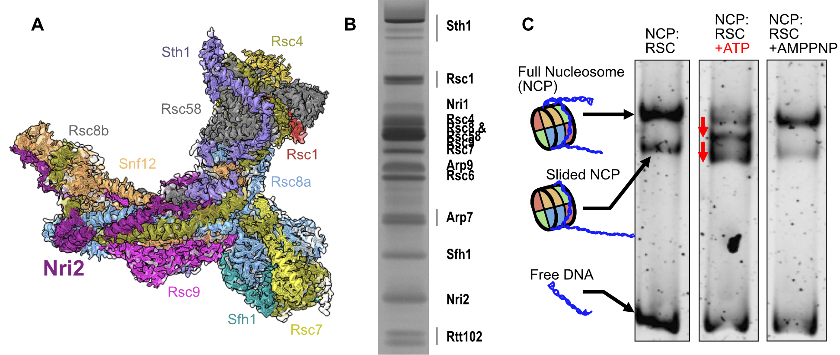

###### **Figure 1**. Structure Composition and activity of the RSC complex in candida albicans.

A/ CryoEM-resolved structure of the core complex at 3Å resolution. Subunits are shown in different colors. B/ SDS PAGE illustrating the subunits of the purified complex. C/ EMSA showing the activity of the complex on nucleosomes. In the presence of its substrate (ATP), there is a shift in nucleosome migration.

[1] Denning, David W. (2024). *The Lancet Infectious Diseases 24 (7)* [2] Lorch, Yahli, et Roger D. Kornberg. (2017). Quarterly Reviews of Biophysics 50:e5. [3] Ye, Youpi, Hao Wu, Kangjing Chen, Cedric R. Clapier, Naveen Verma, Wenhao Zhang, Haiteng Deng, Bradley R. Cairns, Ning Gao, et Zhucheng Chen. (2019). Science (New York, N.Y.) 366 (6467): 838‑43. [4] Balachandra, Vinutha K., Jiyoti Verma, Madhu Shankar, Timothy M. Tucey, Ana Traven, Ralf B. Schittenhelm, et Santanu K. Ghosh. (2020). PLOS Genetics 16 (11): e1009071.