## Synthesis, structural and chemical physical characterizations of new hybrid superconductors

### **Hadhemi Ben Attia 1,2, Mohammed S.M. Abdelbaky 2,3, Santiago García-Granda 2, Mohamed Dammak 1**

### 1 Laboratory of Inorganic Chemistry, LR 17ES07, University of Sfax, Tunisia

### 2 Department of Physical and Analytical Chemistry, Oviedo University-CINN, 33006, Oviedo, Spain.

### 3 Department of Physical Chemistry, Faculty of Chemical Science, University of Salamanca, E-37008, Salamanca, Spain.

### Email of communicating author: [mohammed@usal.es](mailto:mohammed@usal.es)

This work presents the synthesis and comprehensive characterization of a series of organic-inorganic hybrid materials (OIHs) derived from both Class I and Class II hybridization strategies. The initial phase of this research focused on the preparation and structural elucidation of a Class I hybrid compound, (C₇H₁₁N₂)₂CoCl₄ (**HM1**) [1]. Optical studies revealed that **HM1** exhibits notable blue light emission, indicating its potential applicability in electroluminescent devices and photovoltaic technologies. Subsequent investigations expanded to the synthesis and structural characterization of several Class II iron halide-based hybrids employing diverse azo organic ligands [2- 3], including (H₂Piper)₄[(FeF₆)₂FeF₅(H₂O)(H₂O)₄] [2], (8HQN)₆[Fe₄F₁₈] [2], and FeF₃(2,2'-bpy)₆ [3]. Motivated by these findings, a novel Class II hybrid material, [Fe(HPDC)(H₂O)Cl₂] (**HM2**), was synthesized by incorporating a bidentate ligand featuring carboxylate and azo functionalities. **HM2** displayed advantageous electrical and dielectric properties, such as high permittivity and low dielectric loss, underscoring its suitability for electrical and battery applications. These results suggest that such materials hold significant promise as eco-friendly alternatives for optical and electrical capacitor devices, contributing to the advancement of sustainable technologies. To investigate the influence of metal substitution on the physicochemical properties of these materials, the organic ligand 2,6-pyridinedicarboxylic acid (H₂PDC) was retained while the central metal ion was varied. This approach yielded the complexes [Cu(H₂PDC)Cl₂(H₂O)]·4H₂O (**HM3**) and [Zn(Hpydc)Cl₂]₂[Zn₂(Hpydc)(pydc)Cl₂]·2H₂O (**HM4**). The optical, dielectric, and electrical characteristics of these materials were systematically analyzed to elucidate the effects of metal substitution. Further, the complex [Zn(Hpydc)Cl₂]₂[Zn₂(Hpydc)(pydc)Cl₂]·2H₂O (**HM4**) was modified by introducing 1,10-phenanthroline, a ligand known for its strong chelating ability [4], resulting in the formation of [Zn₂(pydc)₂(Phen)₂]₂ (**HM5**). **HM5** exhibited enhanced visible light absorption and is identified as a promising candidate for innovative optoelectronic applications. Both **HM4** and **HM5** demonstrated intense blue-light emission with high color rendering index (CRI > 90), likely due to radiative recombination of strongly bound excitons, making them suitable for next-generation photoelectric devices. Biological evaluation revealed that the addition of Phen in **HM5** significantly improved its anticancer efficacy, highlighting its potential as a chemotherapeutic agent. As a final step, ligand engineering was extended to imidazole and 4-cyanopyridine derivatives while retaining zinc as the central metal. This strategy yielded a novel three-dimensional (3D) hybrid coordination framework (**HM6**), further expanding the structural diversity of the synthesized materials. The 3D architecture highlights the potential for tailoring dimensionality and functionality in OIH design. Collectively, these findings demonstrate that strategic manipulation of metal centers and organic ligands in OIHs can yield multifunctional materials with applications in optoelectronics, energy storage, and biomedicine.

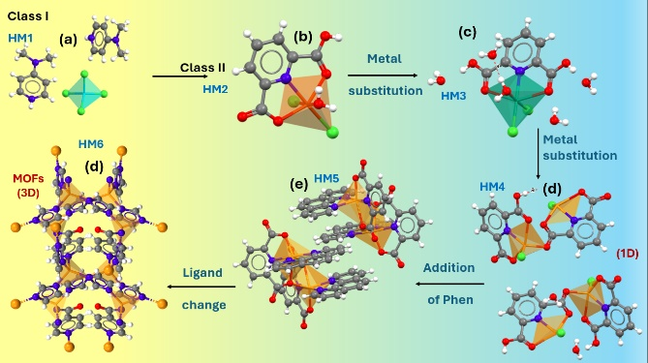

###### **Figure 1**. Overview of Synthesized Hybrid Materials: Class I: (**HM1**) and Class II: **HM2** (b), **HM3** (c), **HM4** (d), **HM5** (e), and **HM6** (f).

###### **The references**

[1] Ben Attia, H., Bentahar, F., Abdelbaky, M. S. M., Elferjani, A., García-Granda, S. & Dammak, M. (2023). J Alloys Compd 969, 172317.

#### [2] Moulahi, A., Guesmi, O., Abdelbaky, M. S. M., García-Granda, S. & Dammak, M. (2022). J Alloys Compd 898, 162956.

#### [3] Bouketaya, S., Elferjani, A., Abdelbaky, M. S. M., Dammak, M. & Garcia-Granda, S. (2019). J Solid State Chem 277, 395–405.

#### [4] Jara, Y., Araujo, M. L., Madden, W., Lubes, V. & Hernández, L. (2022). Phys Chem Liquids 60, 233–243.

**Acknowledgements:** The Minister of Superior Education and Research of Tunisia and Spanish Ministerio de Ciencia e Innovación (PID2020-113558RB-C41), University of Salamanca (K257 - 463AC01), Gobierno del Principado de Asturias (IDE/2024/000742) anare acknowledged. The authors extend their appreciation to the Scientific and Technical Services (STSs) staff at the University of Oviedo for their support in elaborating this work.