# Hydrogen bonds and F∙∙∙F contacts in pentafluorobenzene at high pressure

## M. Rusek and A. Katrusiak

### Faculty of Chemistry, Adam Mickiewicz University, Uniwersytetu Poznańskiego 8, 61-614 Poznań, Poland

### michalina.rusek@amu.edu.pl

Intermolecular interactions of fluorinated moieties are intensely studied due to the common applications of fluorinated compounds in pharmacy, polymers, surfactants, solvents and other materials. Hence the precise description of intermolecular forces involving fluorine atoms is essential for designing new compounds, modelling their structures and predicting their properties.

High-pressure experiments, the isothermal and isochoric crystallizations and X-ray diffraction measurements, were carried out with a Merrill-Bassett diamond-anvil cell (DAC). [1] In the first attempt the DAC chamber was filled with pure C6H1F5 and a single crystal was grown *in situ* at isochoric conditions, which resulted in obtaining the low-temperature phase I. [2] This monoclinic phase (space group *P*21/*c*, Z’=2) can be compressed to at least 3.60 GPa. The isothermal crystallization of neat compound resulted in the formation of a new phase II at 0.23 GPa, which can be compressed up to 0.58 GPa. All attempts to compress polymorph II above 0.60 GPa resulted in its transformation to polymorph I without crystallization. The symmetry of phase II is also monoclinic with different space group *P*21/*n* and reduction of Z’ from 2 to 1. In yet another experiment, the DAC chamber was filled with the mixture of C6H1F5:methanol:ethanol:water in a ratio 20:16:3:1. The polycrystalline C6H1F5 precipitated at 0.50 GPa and a single crystal of phase III was is grown. The symmetry of phase III is monoclinic, space group *C*2/*c* with Z’ equal 0.5, which implies that C6H1F5 molecules in phase III are disordered.

In phase I, the bifurcated H···F bonds are the shortest intermolecular distances. The molecules are also involved in two F···F and two C···F contacts shorter than the van der Waals radii. One of the F···F contact corresponds to type I of halogen bond and the other corresponds to type II of halogen bond and there are no F3 (Figure 1) motifs in phase I. In phase II the F3 motif is formed, but only two F∙∙∙F distances are shorter than the van der Waals radii. [3] Polymorph II can be compressed only to 0.58 GPa, and at higher pressure it transforms to phase I. Despite strong structural rearrangements, the transformation yields a single crystal of phase I. In polymorph III each molecule is involved in six F3 motifs, where all F···F contacts are shorter than 2RvdW(F). We can also observe a systematic change in the types of interactions between phases I, II and III. For example, contacts F···F in phase I are 2-centered, either of type I or II. In phase II, apart from contacts F···F type I and II, also the F3 patterns, which dominate the contacts in the sheets of phase III. Hydrogen bonds CH···F are both two- and three-centered in phase I, bifurcated and tandemic in phase II and these are weak disordered CH···F contacts in phase III.

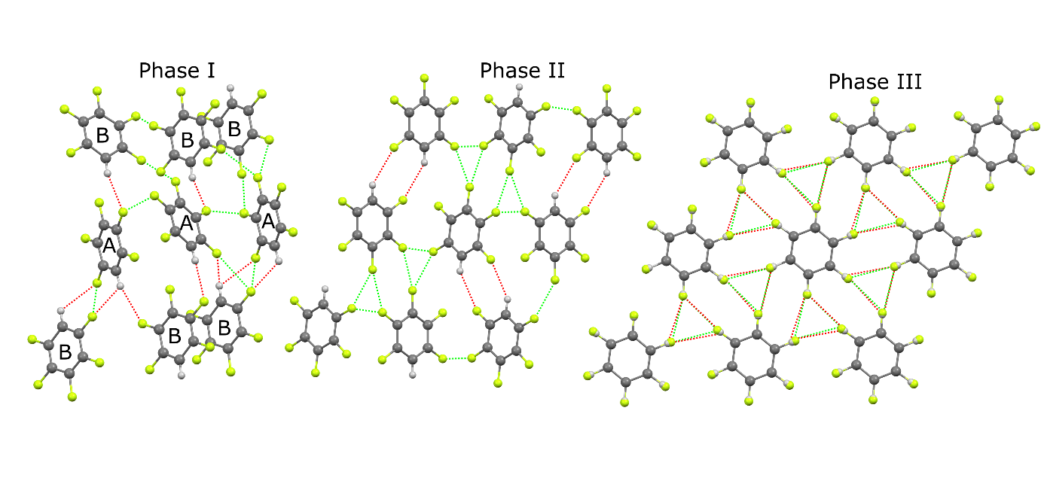

**Figure 1**. The shortest contacts in C6H1F5 phases I, II and III: contacts F···F (red) and H···F (green). The orientations of the aggregates was chosen for best view of the molecules and contacts.

#### [1] Merrill, L. & Bassett, W. A. (1974). *Rev. Sci. Instrum.* **45**, 290-294.

#### [2] Thalladi, V. R., Weiss, H. C., Bläser, D., Boese, R. Nangia, A. & Desiraju, G. R. (1998). *J. Am. Chem. Soc.* **120**, 8702-8710.

[3] Bondi, A. (1964). *J. Phys. Chem.* **68**, 441-451.