# Nornicotine enantiomers and their salts – crystallographic cases on the way to the synthesis and enantioseparation of pure (S)-nicotine

## B. Miroslaw1*, N. Trotsko2, R. Jasiński3, M. Długosz4, M. Sadczuk5 and O. M. Demchuk6

### 1Department of General and Coordination Chemistry and Crystallography, Institute of Chemical Sciences, Faculty of Chemistry, Maria Curie-Sklodowska University in Lublin, Poland; 2Department of Organic Chemistry, Medical University of Lublin, Poland; 3Department of Organic Chemistry and Technology, University of Technology in Cracow, Poland; 4A-Sense sp. z o.o, Poland; 5 Chair and Department of Synthesis and Chemical Technology of Pharmaceutical Substances, Medical University of Lublin, Poland; 6Faculty of Medicine, The John Paul II Catholic University of Lublin, Poland

### Email of communicating barbara.miroslaw@mail.umcs.pl

Nicotine related industry is still under development and methods for efficient synthesis of (*S*)-nicotine enantiomer are still wanted [1]. To fulfil this need a crystallization process as an intermediate step was proposed [2]. The studies on the crystal forms obtained during these experiments only mentioned previously are discussed here in details. The nornicotine was crystallized with N-lauroyl-(*S*)-alanine to yield a few crystallographic forms. The results of crystallization experiments are shown in Fig. 1. The number of hydrogen bonds and their architecture decided on the success of efficient enantioseparation process in certain conditions. This approach proved to be more economical and efficient than previously used multistep synthesis methods of (*S*)-nicotine. Additional advantage of this method is the lack of contamination with nitrosamines. Detailed crystallographic analysis of crystal structures of these salts is presented along with Hirshfeld surface and energy framework analysis.

a)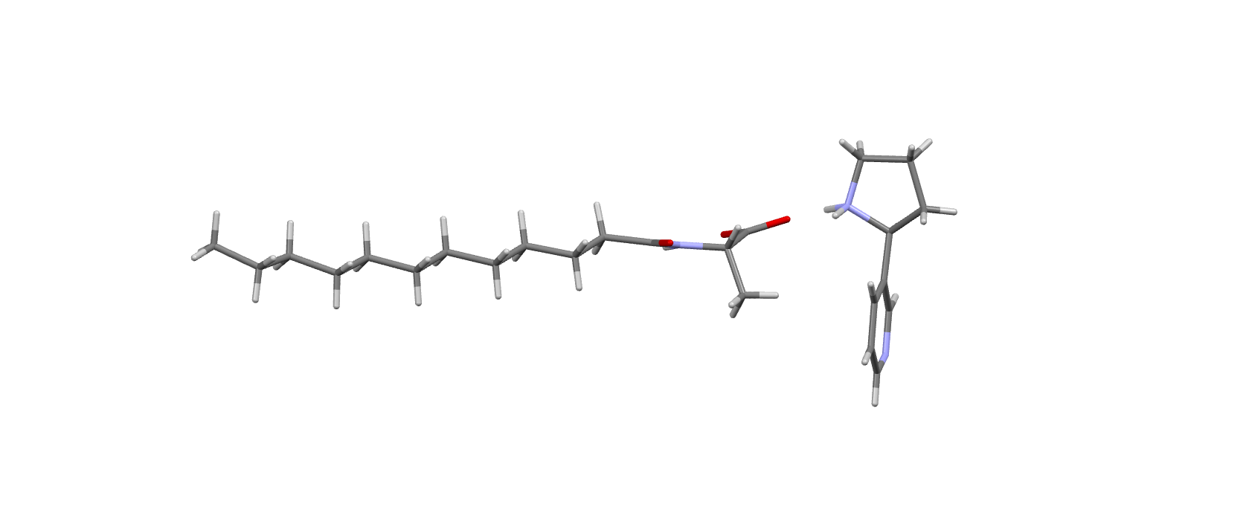 b)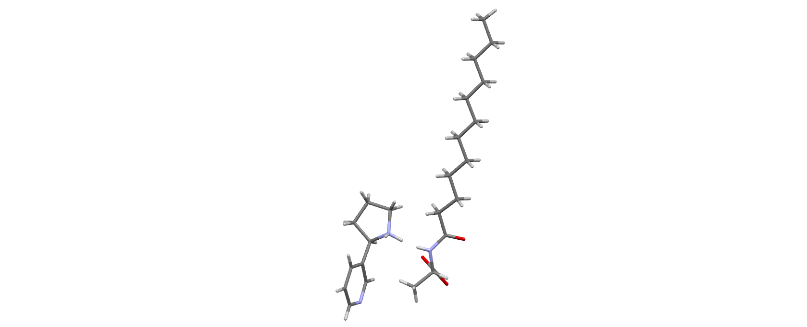 c)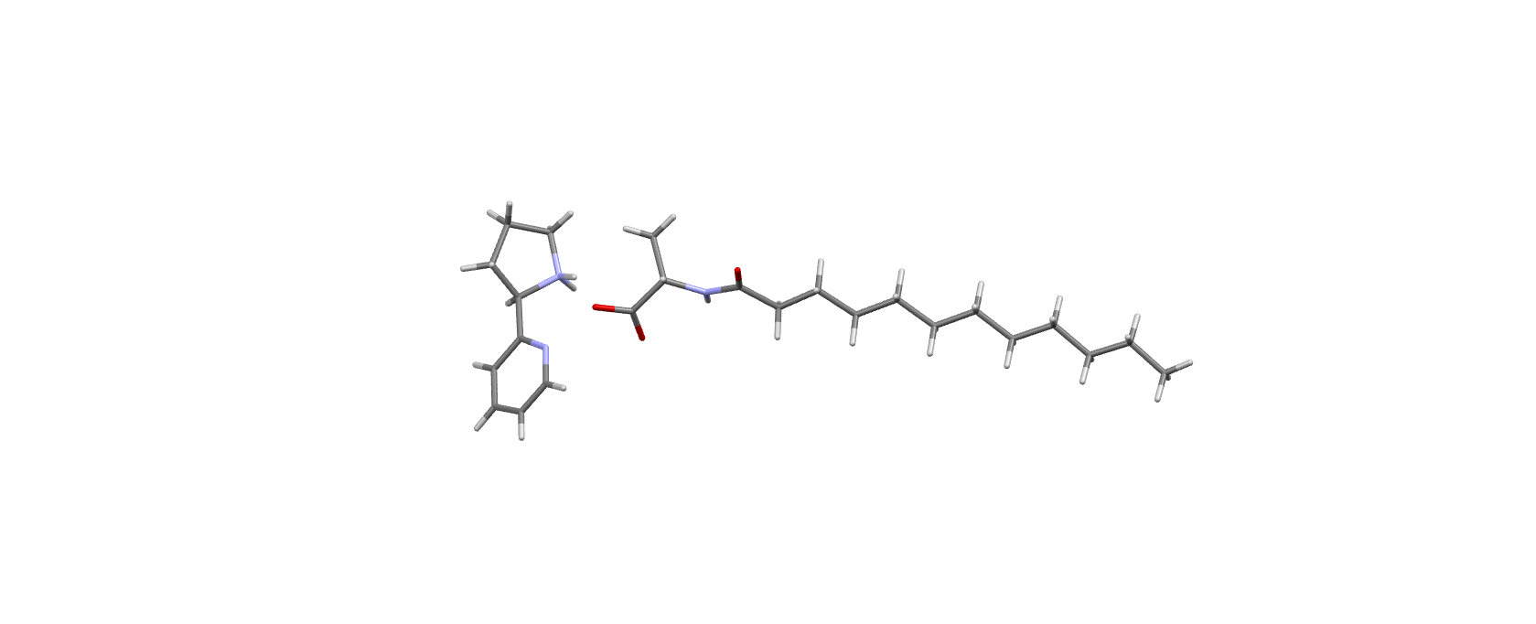

d)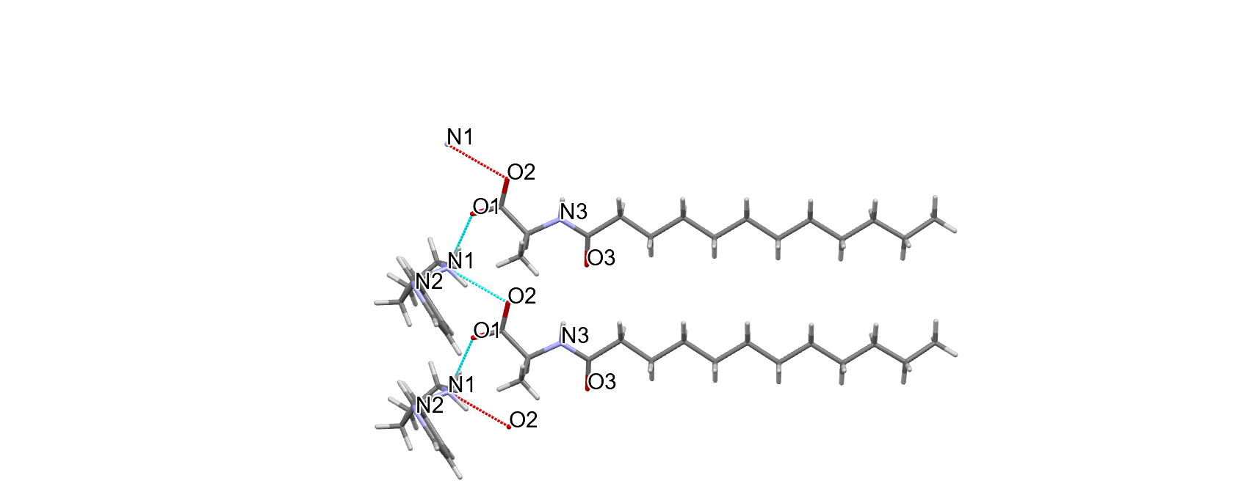 e)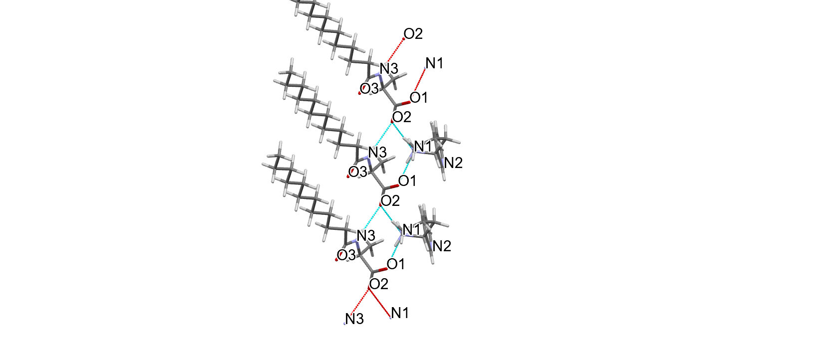 f)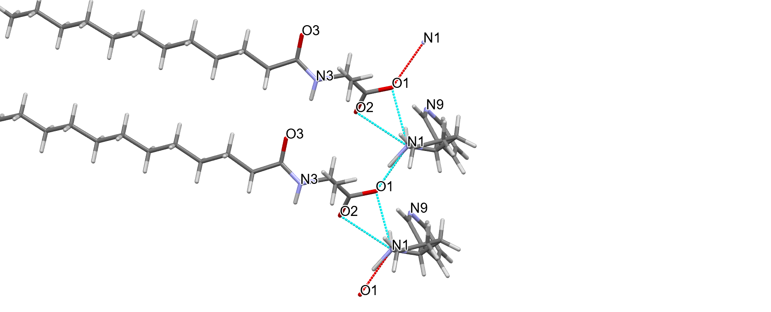

###### **Figure 1**. Crystal structures of obtained salts of nornicotine enantiomer *S* (a, d), *D* (b, e) and racemate (c, f) with N-lauroyl-(S)-alanine.

#### [1] Agarthimoole, R.K.; Gagan, S.; Parida, S.; Dimesh, T.K.; Karatholuvhu, M.S.; Palani, N.; Mukherjee, S. (2022) A novel approach for the synthesis of (*R*) and (*S*)-nicotine. Int. J. Org. Chem. ***12***, 189–199.

#### [2] Trotsko, N., Miroslaw, B., Jasiński, R., Długosz, M., Sadczuk, M., & Demchuk, O. M. (2024). Efficient Method of (*S*)-Nicotine Synthesis. *Molecules*, ***29***(23), 5731.

The A-Sense Sp. z o.o.is realizing the project FENG.01.01-IP.02-002/23 of Polish Agency for Enterprise Development et. “Launch of Nicxperience - synthetic nicotine for pharmaceutical applications”.