## Unveiling the invisible: energetic insights into supramolecular architectures of amino-substituted aromatics

I. S. Konovalova1

### 1 SSI “Institute for Single Crystals”, National Academy of Science of Ukraine, 60 Nauky ave., Kharkiv, 61001, Ukraine

### Email of communicating ikonovalova0210@gmail.com

The amino-substituted aromatics are key structural blocks of bioactive products, medically important compounds and organic functional materials (Fig.1). Therefore, the study of molecular and crystal structure of such a type of compounds has an immense importance.

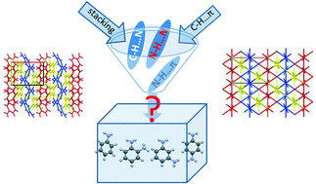

###### **Figure 1**. Crystal packing (on the left) and the energetic vector diagram (on the right) of 1,4-diaminobenzene

All modern approaches to molecular crystal structure analysis are primarily based on the comparison of geometric characteristics of intermolecular interactions. However, these methods often prove insufficient, particularly in cases where weak interactions dominate or where specific directional interactions are absent.

In amino-substituted aromatic compounds, the crystal structures are typically stabilized by weak interactions such as N–H···π, C–H···π, N–H···N hydrogen bonds, stacking interactions, and other non-specific intermolecular forces. This prevalence of weak interactions makes it difficult to accurately describe the crystal packing and to identify the primary structural motif solely through geometric analysis. In such cases, it remains unclear which interactions are energetically dominant in the stabilization of the crystal structure.

To overcome these limitations, an analysis of interaction energies between molecules provides valuable insights into the principles and regularities governing crystal structure formation. This energetic approach allows for the classification of supramolecular architectures in the investigated compounds as columnar, layered, or columnar-layered. Furthermore, it reveals structural trends that correlate with the positions of substituents in the molecular framework.