# Unusual planar anisotropy of the induced magnetism in KTb3F10

## O. Demortiera, S. Petita, B. Fauquéb, E. Ressouchec, I. Kibalind, J. Roberte, R. Sibillef, B. Roesslif, C. Coline, A. Ivanovd, O. Fabelod,T. Fennellf, D. Hrabovskyg, B. Leridonh, F. Le Berrei, J. Lhostei, and F. Damaya

### aUniversité Paris-Saclay, Laboratoire Léon Brillouin, CEA-CNRS UMR12, F-91191 Gif-sur-Yvette Cedex, France,bJEIP (USR 3573 CNRS), Collège de France, 75005 Paris, France, cIRIG, CEA and Université Grenoble Alpes, CEA Grenoble, F-38054 Grenoble, France, dInstitut Laue-Langevin, 71 avenue des Martyrs, F-38042 Grenoble Cedex 9, France, eInstitut Néel, CNRS, Université Grenoble-Alpes, CNRS, F-38042 Grenoble, France, fLaboratory for Neutron Scattering and Imaging, Paul Scherrer Institut, CH-5232, Villigen, Switzerland, gPhysics Department, Sorbonne Université, 4, place Jussieu, 75005 Paris, France, hLaboratoire de Physique et d’Etude de Matériaux (CNRS), ESPCI Paris, Université PSL, 75005 Paris, France, iInstitut des Molécules et Matériaux du Mans (IMMM), UMR CNRS 6283, Le Mans Université, Avenue Olivier Messiaen, F-72085 Le Mans Cedex 9, France.

### francoise.damay@cea.fr

KTb3F10 is a magneto-optical component [1] used as a high power Faraday rotator in optical insulators, to prevent light feedback in laser cavities. To understand better the origin of its magneto-optical properties, the magnetic ground state of KTb3F10 was investigated using a combination of magnetization measurements and neutron scattering experiments, carried out on a polycrystal and a single crystal sample, in zero and applied magnetic fields. In the *Fm*-3*m* cubic crystal structure of KTb3F10, each Tb3+ is surrounded by a distorted fluorine cage, made of two twisted but parallel square faces (Figure 1). There are three distinct orientations of this fluorine cage in the structure, which correspond to the 4-fold axis of the *Fm*-3*m* space group being parallel to either the **a**, **b**, or **c** axis of the cubic cell [2]. Results show that Tb3+ actually remains in a crystal electric field singlet state down to 30 mK. Applying a magnetic field, however, induces magnetism on the Tb sites. Using a local susceptibility tensor approach, we show that the Tb3+ moment is highly anisotropic and remains confined within a local anisotropy plane, parallel to the square face of the fluorine cage, a rather rare occurrence in Tb compounds. The magnetic space groups of the magnetic orderings observed in a large magnetic field applied along the three main symmetry directions of the cubic structure were determined and are in excellent agreement with the combined planar nature of the moment anisotropy and the existence of three orientations for the Tb cage (Figure 1). These results are a first step towards a microscopic understanding of the Faraday rotator property in this compound [3].

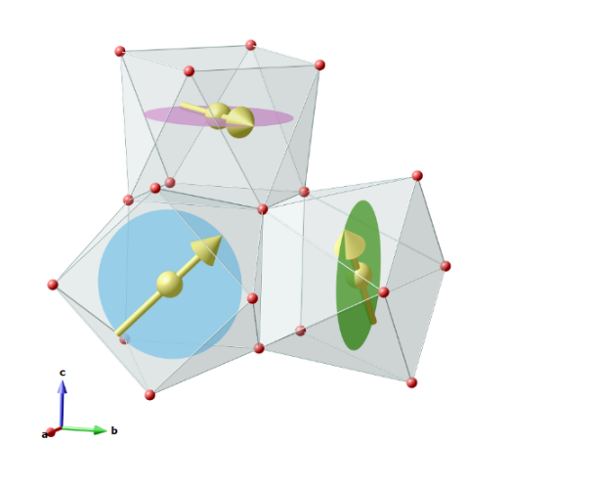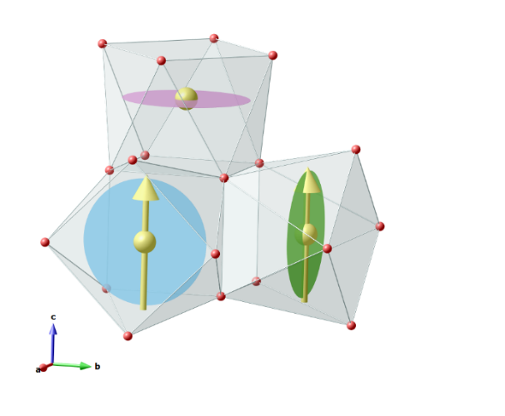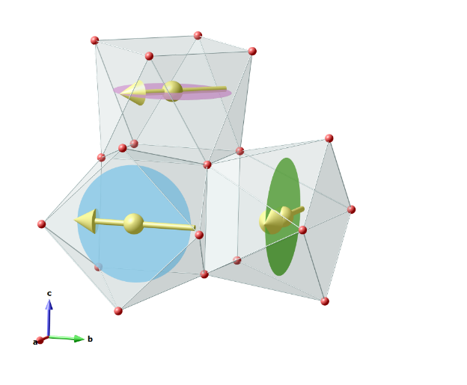

###### **Figure1.** Induced magnetic orders in KTb3F10, for a magnetic field applied along [111] (left), [001] (middle) and [1-10] (right panel). Illustrations are limited to only half of a Tb6F32 cluster for clarity reasons. Tb atoms are shown in yellow, F atoms in red. Anisotropy planes are shown as blue, green or pink ellipses, to distinguish planes perpendicular to the **a**, **b** or **c** axis of the cubic cell, respectively.

[1] Pues, P., et al. (2020). *J. Lumin.* **227,** 117523.

[2] Podberezskaya, N., et al. (1976). *J. Struct. Chem.* **17**, 815.

[3] Demortier, O., et al. (2025). Submitted to *Phys. Rev. Mater*.