# Non-nucleic acid four-stranded helix formed by the antiviral vidarabine 5′-monophosphate

## O. Kaszubowski1, K. Ślepokura1

### 1University of Wrocław, Faculty of Chemistry, 14. F. Joliot-Curie, 50-383 Wrocław, Poland

### oskar.kaszubowski@uwr.edu.pl

Vidarabine 5'-monophosphate is an antiviral analogue of adenosine 5'-monophosphate created by replacing ribose with arabinose. It is mainly used in therapies against *Herpes* viruses, and its crystal structure remains unknown. The supramolecular tendencies of nucleotides, nucleosides and their analogues in the solid state are concentrated around chains or layers. Indeed, there are only few cases where DNA-like double-stranded helical forms characteristic of nucleic acids have been observed in their crystals [1,2].

Here we present four-stranded right-handed helices observed in crystals of hydrated vidarabine 5′-monophosphate sodium salts. This unique supramolecular motif bears a strong resemblance to the *i*-motif commonly observed in cytosine-rich nucleic acid sequences [3] and is stabilised here by hydrogen-bonded and intercalated adenine base pairs (A:A; *trans*-Hoogsteen/Hoogsteen geometry). It is important to note that the four-stranded *i*-motif is practically never found in adenine-rich regions of nucleic acids (where parallel duplexes are much more common), making this case very exceptional, not only in the field of small organic molecules, but also in the context of macromolecules.

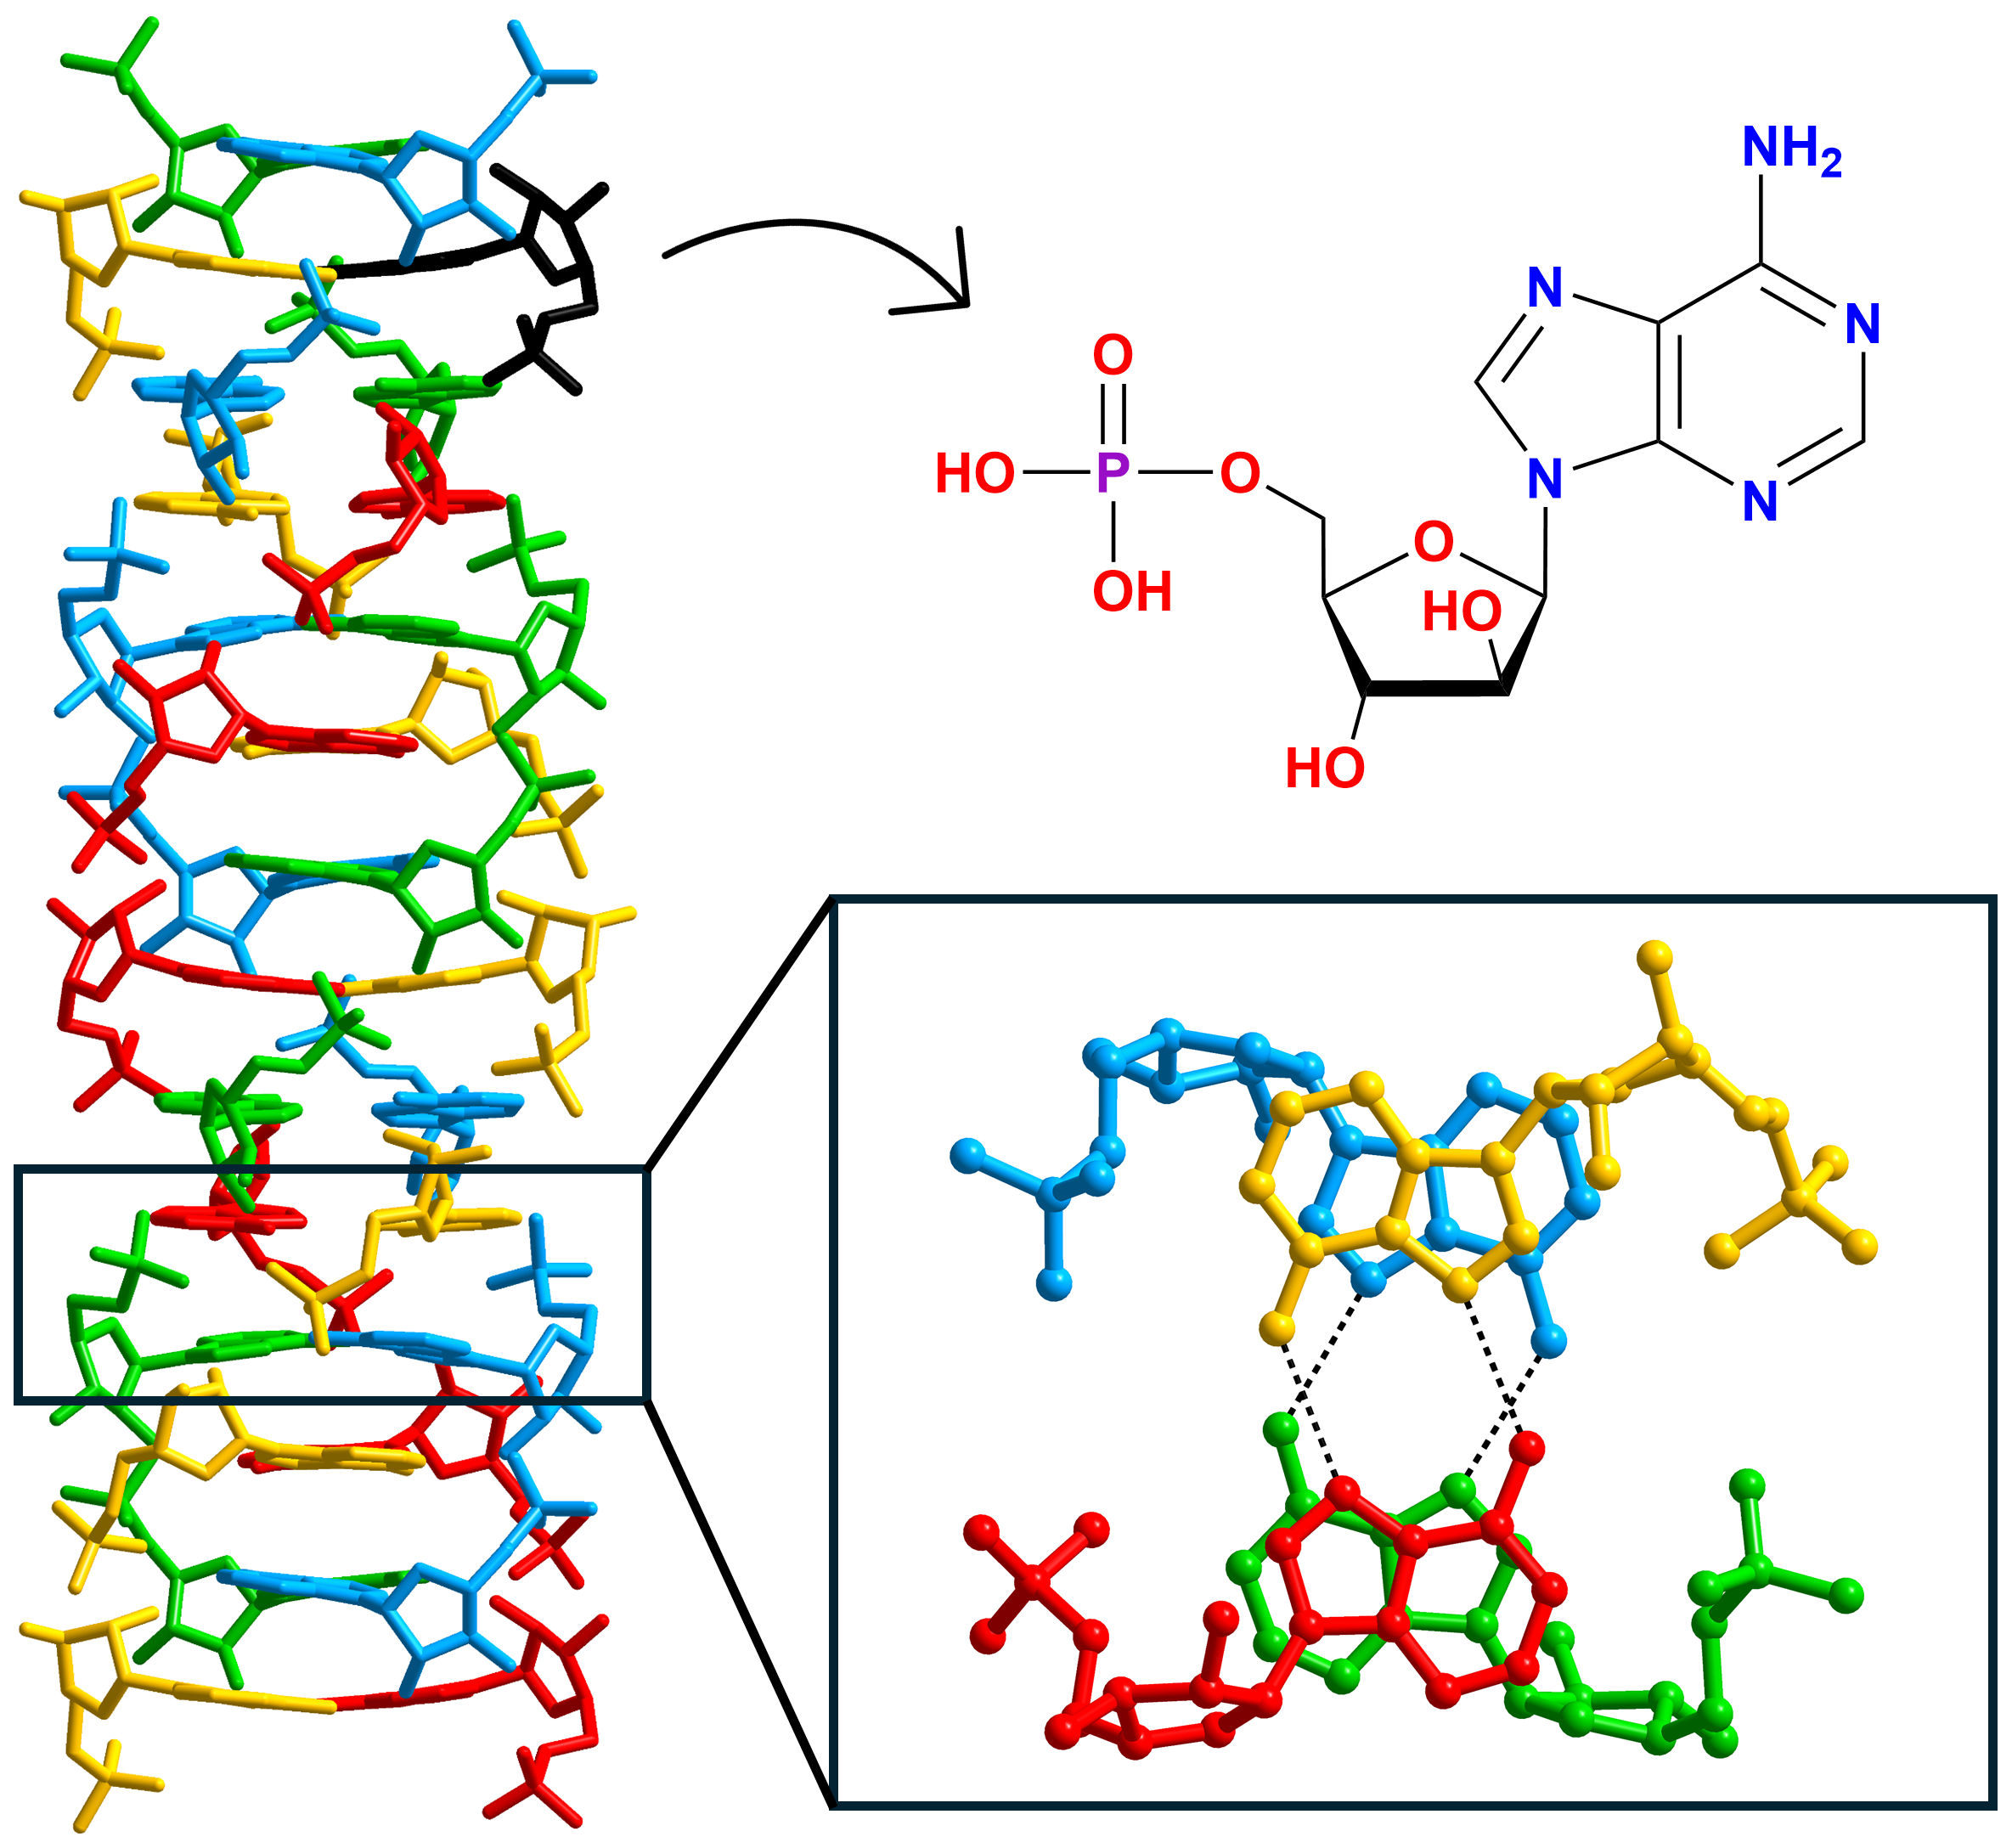

###### **Figure 1**. Helix (left) formed by four “strands” of vidarabine 5'-monophosphate (right). Hydrogen bonds formed between Hoogsteen edges of adenine are marked with black dashed lines.

[1] Vasconcelos, A. T., da Silva, C. C., Queiroz Júnior, L. H. K., Santana, M. J., Ferreira, V. S., Martins, F. T. (2014). *Cryst. Growth Des*. **14**, 4691−4702.

[2] Kulikov, V., Johnson, N. A. B., Surman, A. J., Hutin, M., Kelly, S. M., Hezwani, M., Long, D.-L., Meyer, G., Cronin, L. (2017). *Angew. Chem., Int. Ed.* **56**, 1141−1145.

[3] Abou Assi, H., Garavís, M., González, C., Damha, M. J. (2018). *Nucleic Acids Res*. **46**, 8038−8056.