# Quantitative and Qualitative Analyses of Symmetry Independent C−F⋅⋅⋅F−C Interaction and C−H⋯F–C Hydrogen Bonds in a Biologically Potent Isoquinoline Derivative: Insights from Charge Density Analysis

## Sakshi,a Yogita Gupta,b Angshuman Roy Choudhury,a,* and Parthapratim Munshi,b,*

### aDepartment of Chemical Sciences, Indian Institute of Science Education and Research Mohali, 140306, India. bChemical and Biological Crystallographic Laboratory, Department of Chemistry, School of Natural Sciences, Shiv Nadar University, Dadri, Uttar Pradesh-201314, India.

### Email: ph21091@iisermohali.ac.in

Intermolecular interactions offered by halogens are versatile, unpredictable, and mostly stabilizing. Among the halogens, the interactions offered by fluorine deserve special attention due to its high electronegativity, low polarizability, and frequent occurrence in drugs and pharmaceuticals. The importance of C‒H···F‒C hydrogen bonds and C‒F···F‒C interactions in various organic molecules was demonstrated through structural and computational analysis [1,2]. The best understanding of such weak interactions can be achieved using experimental and theoretical charge density analysis based on the high-resolution X-ray diffraction data [3,4]. Herein, a symmetry-independent type I C−F⋅⋅⋅F−C interaction and C−H⋯F–C hydrogen bonds in the presence of symmetry-related C−H⋯F–C hydrogen bonds in an isoquinoline derivative have been quantified based on high-resolution X-ray diffraction data, which are devoid of any other stronger interactions like N−H⋅⋅⋅O, O−H⋅⋅⋅O, N−H⋅⋅⋅N, and O−H⋅⋅⋅O hydrogen bonds. Additionally, the potency of this molecule as an anti-implantation agent has been evaluated against the cyclooxygenase-2 (COX-2) enzyme through molecular docking studies. The stabilizing nature of the interactions involving organic fluorine in this biologically potent molecule has been confirmed using interaction energy calculations, qualitative analysis of electrostatic potential plots (Fig. 1), and topological analyses of electron density obtained from both experimental and theoretical charge density analyses. Interesting aspects of these studies will be presented.

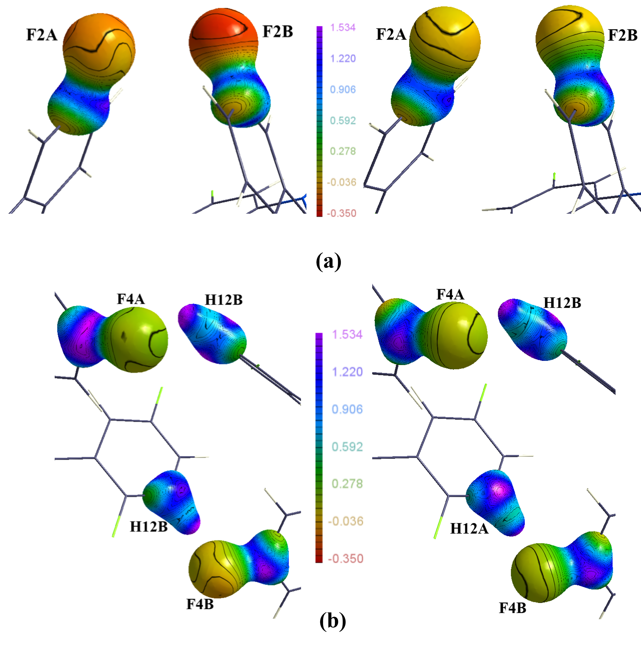

###### **Figure 1**. 3D Electrostatic potential plots highlighting the C−F···F−C interactions (left experimental, right theoretical).

#### [1] Kaur, G. & Choudhury, A. R. (2014). Cryst. Growth Des.,14, 1600−1616.

#### [2] Singla, L., Yadav, H. R. & Choudhury, A. R. (2022). Cryst. Growth Des., 22 (3), 1604−1622.

#### [3] Singla, L., Kumar, A., Robertson, C. M., Munshi, P. & Choudhury, A. R. (2023). Cryst. Growth Des., 23, 853–861.

#### [4] Sakshi, Gupta, Y., Robertson, C. M., Munshi, P. & Choudhury, A. R. (2025). CrystEngComm, 27, 478–487.

#### [5] Dunitz, J. D., Taylor, R. (1997). Chem. Eur. J., 3, 89-98.

S. and Y.G. thank IISER Mohali and SNIoE, respectively, for the research fellowship. PM and ARC thank SNIoE and IISER Mohali, respectively, for the financial support and the research facilities.