# Analysis of COF-300 synthesis: probing degradation processes and 3D electron diffraction structure

## L. Bourda1,2, S. Bhandary1, S. Ito3, S. Bhandary1, C.R. Göb4, P. Van Der Voort1, K. Van Hecke1

### 1Ghent University, Department of Chemistry, Gent, Belgium; 2KU Leuven, Department of Chemistry, Leuven, Belgium; 3Rigaku Corporation, Haijima, Tokyo, Japan, 4Rigaku Europe SE, Neu-Isenburg, Germany.

### Laurens.bourda@kuleuven.be

Although COF-300 is often used as a benchmark for the study of covalent organic frameworks (COFs), knowledge of the underlying synthetic processes is still fragmented. Here, an optimized synthetic procedure based on a combination of linker protection and modulation was applied. This way, the influence of time and temperature on the synthesis of COF-300 was studied. Synthesis times that were too short produced materials with limited crystallinity and porosity, lacking the typical pore flexibility associated with COF-300. On the other hand, synthesis times that were too long could be characterized by loss of crystallinity and pore order by degradation of the tetrakis(4-aminophenyl)methane (TAM) linker used. The presence of the degradation product was confirmed by visual inspection, Raman spectroscopy and X-ray photoelectron spectroscopy (XPS). This degradation process might be one of the reasons why the development of 3D COFs is still lagging compared with 2D COFs. However, COF crystals obtained via an optimized procedure could be structurally probed using 3D electron diffraction (3DED). The 3DED analysis resulted in a full structure determination of COF-300 at atomic resolution with satisfying data parameters. Comparison of our 3DED-derived structural model with previously reported single-crystal X-ray diffraction data for this material, as well as parameters derived from the Cambridge Structural Database, demonstrates the high accuracy of the 3DED method for structure determination. This validation might accelerate the exploitation of 3DED as a structure determination technique for COFs and other porous materials.

These results are published in Bourda et al., IUCrJ (2024), 11, 510-518. https://doi.org/10.1107/S2052252524003713

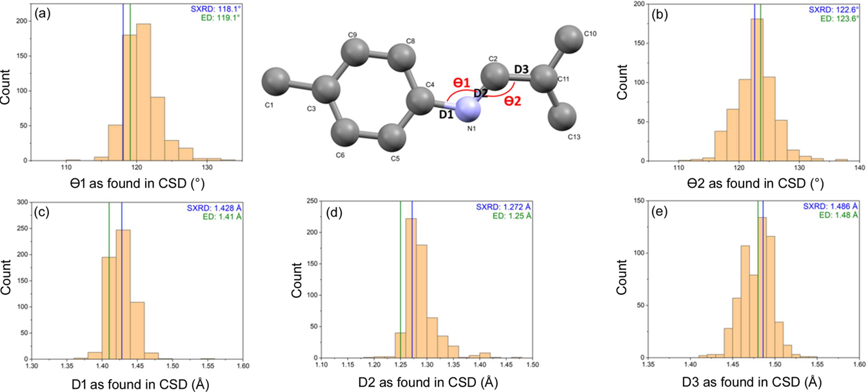

###### **Figure 1**. Structural details of the imine connection as encountered in COF-300 in this study and a previous X-ray based study [1] compared to values reported in the CSD [2].

[1] Ma, T., Kapustin, E.A., Yin, S.X., Liang, L., Zhou, Z., Niu, J., Li, L.-H., Wang, Y., Su, J., Li, J., Wang, X., Wang, W.D., Wang, W., Sun, J., Yaghi, O.M. (2018). *Science* **361**, 48.

[2] Groom, C. R., Bruno, I. J., Lightfoot, M. P. & Ward, S. C. (2016).. *Acta Cryst. B* **72**, 171.