# Conformational transformations in ruthenocene and osmocene coupled to the CH‧‧‧Ru and CH‧‧‧Os bonds

## I. Moszczyńska1, M. Szafrański2, A. Katrusiak1

### 1Department of Materials Chemistry, Faculty of Chemistry, Adam Mickiewicz University, Uniwersytetu Poznańskiego 8, 61-614 Poznań, Poland, 2 Faculty of Physics, Adam Mickiewicz University, Uniwersytetu Poznańskiego 2, 61-614 Poznań, Poland

### ida.moszczynska@amu.edu.pl

So far, ferrocene (FeCp2) was the only known metallocene crystal, undergoing transformations coupled with a change of molecular conformation. [1] Other metallocenes are either disordered in the staggered conformation or ordered in the eclipsed conformation. The 18-electron metallocene complexes, chemically stable, ferrocene, ruthenocene (RuCp2) and osmocene (OsCp2) occur in orthorhombic crystalline space group *Pnma* (RuCp2 and OsCp2 at ambient condition, while FeCp2in its low-temperature phase III). [1] Till recently, ruthenocene and osmocene were studied at ambient and low temperature and they have been known in the isostructural phases α only.

Under high-pressure conditions, we obtained the β phases of RuCp2 [2] and OsCp2 [3]. In these new phases, the CH‧‧‧*M* bonds (*M*=Ru, Os) become significant. The calculation of the electrostatic potential on the FeCp2, RuCp2 and OsCp2 molecules’ surface revealed that OsCp2 has the highest affinity to form CH‧‧‧*M* bonds, while that of FeCp2 is the lowest. Structural analysis confirmed these theoretical results: for each OsCp2 molecule in phase β, there are 4 independent CH‧‧‧*M* contacts, while for each RuCp2 molecule in β phase, there is only 1 independent CH‧‧‧*M* contact.

Our latest high-temperature diffraction experiments on single crystals revealed isostructural γ phases of RuCp2 (Tc= 394 K) and OsCp2 (Tc= 422 K). Each carbon atom in the Cp ring in those γ phases is disordered in four sites, two due to the seesaw movement of molecules about the [*y*] axis and another two due to the Cp rings rotation about the pseudo-*C*5 molecular axis (Figure 1). The mechanism of the phase transition is connected with the breaking of CH‧‧‧*M* contacts, which are present in the α and β phases of RuCp2 and OsCp2.

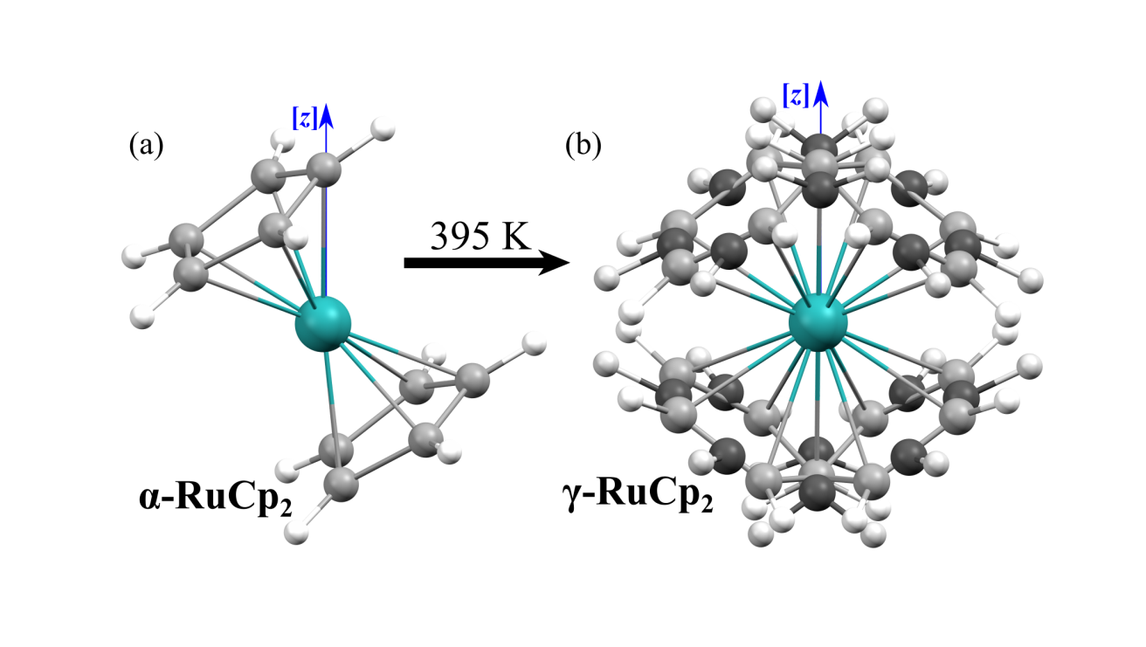

###### **Figure 1**. Ruthenocene molecule in (a) ordered phase α at 296(2) K and (b) disordered phase γ at 395(2) K.

#### [1] Seiler, P., Dunitz, J. D. (1982). *Acta Crystallogr. Sect. B.* **38**, 1741-1745.

#### [2] Moszczyńska, I., Katrusiak, A. (2022). *J. Phys. Chem. C* **126**, 5028-5035.

#### [3] Moszczyńska, I., Gulaczyk, I., Katrusiak, A. (2023). *J. Phys. Chem. C* **127**, 19250-19257.