## Unusual donor properties of nitrile groups in cyanothiazoles: Insights from X-ray crystallography and DFT of organic molecules and their Ag(I) complexes

## K. Gutmańska1, K. Szaciłowski2, A. Dołęga1

### 1 Department of Inorganic Chemistry, Gdańsk University of Technology, Narutowicza 11/12, 80-233 Gdańsk, Poland 2 Academic Centre for Materials and Nanotechnology of the AGH University of Science and Technology, al. Mickiewicza 30, 30-059 Kraków, Poland

### anna.dolega@pg.edu.pl

The primary motivation behind examining the structure and properties of novel cyanothiazole-based complexes lies in the pursuit of innovative materials with exceptional electrical and optical characteristics, holding promise for applications in optoelectronics and neuromorphic computing. The optical characteristics of these small molecules can be modulated by coordinating with transition metals.[1] Interestingly, the cyanothiazole isomers have both HOMO and LUMO frontier orbitals fully delocalized over whole molecules. This affects how the molecule interacts with metal centres in coordination complexes, making the nitrogen atom of the nitrile group just as likely to act as a donor as the nitrogen atom of the azole ring.[1] We used X-ray diffraction of monocrystals to study how cyanothiazoles coordinate with silver(I) ions and we identified several new silver complexes. One notable example is an uncommon compound in which 2-cyanothiazole and toluene act as coligands, as shown in Fig. 1. The dimeric cation features bridging mode of 2-cyanothiazole, which is typical for this small molecule. Comparable to related Cu(I) complexes the Ag(I)−Nazole bond is longer than Ag(I) −Nnitrile though the difference is very small – 0.08 Å [1] The toluene is η2-coordinated to silver, however we did not observe regular changes in the bond lengths within the toluene rings (there are two toluene molecules in the independent part – not shown in Figure 1).

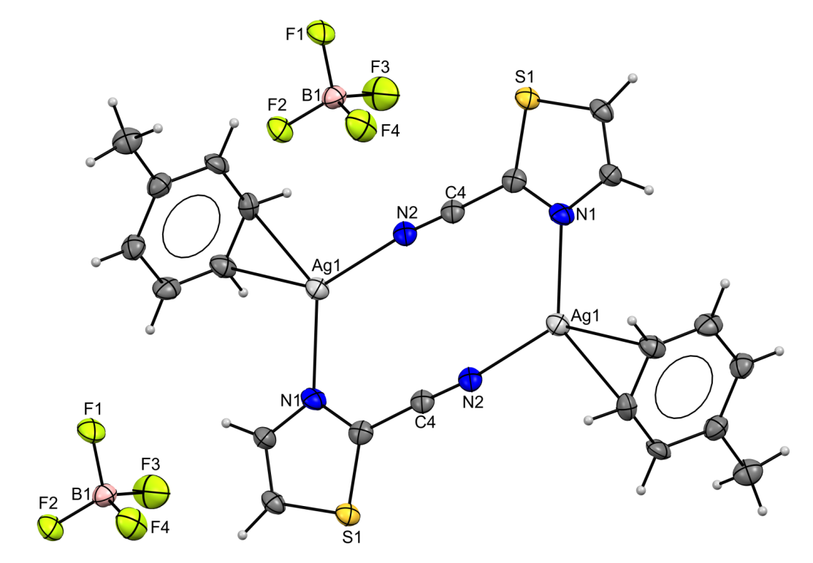

###### **Figure 1**. Fragment of the crystal structure of the AgBF₄ complex with 2-cyanothiazole and toluene.

#### [1] Gutmańska, K., Podborska, A., Mazur, T., Sławek, A., Sivasamy, R., Maximenko, A., Orzeł, Ł., Oszajca, J., Stochel, G., Dev, A.V., Vijayakumar, C., Szaciłowski, K., Dołęga, A. (2025). *Chem-Eur. J.***,** 10.1002/chem.202500215.

The authors express their gratitude for the financial support from the Polish National Science Centre under the OPUS programme, grant agreement no. 2022/47/B/ST4/00728.