# Mapping of the thermal mechanical properties of dicyanometallates

## A. J. Corkett1, A. Grzechnik,1 K. Friese1,2

### 1Jülich Centre for Neutron Science-2 (JCNS-2) Forschungzentrum Jülich GmbH, 52425 Jülich, Germany

### 2Institute of Crystallography, RWTH Aachen University, 52066 Aachen, Germany

### a.corkett@fz-juelich.de

Cyanide-based molecular framework materials, featuring corner linked metal centred-polyhedra, frequently display negative thermal expansion (NTE) due to the transverse vibrational motion of the cyanide bridge, as seen in Cd(CN)2 (α = −33.5 MK−1) and Prussian blues (CdPt(CN)6, α = −10.02(11) MK−1).[1] Moreover, it has been shown that by replacing diatomic cyanide bridges (M−CN−M) with dicyanometallate linkers (M−CN−A−NC−M, where A = Cu, Ag, Au) one can generate highly flexible interpenetrated networks of corner linked tetrahedra (MII(A(CN)2)2) and octahedra (A3(M(CN)6). Since both of these families adopt hexagonal structures, the thermal expansion in these systems is anisotropic. Ag3(Co(CN)6) exhibits positive thermal expansion along *a* (αa = +144 MK−1) and negative thermal expansion along *c* (αc = −126 MK−1) that is an order of magnitude greater than in other crystalline materials.[2] The origin of this ‘colossal’ response (α ≥ 100 MK−1) arises directly from the network topology which behaves like a 3D ‘garden fence’, that can expand in one direction whilst contracting in another with virtually no energy cost.

Here we examine the LnA3(CN)6.3H2O family, which share the same linear dicyanometallate structural motif, and crystallize in hexagonal structures (*P*63/*mcm*) featuring H2O face-capped LnN6 trigonal prisms that form three identical interpenetrating networks (Figure 1(a)). We have recently shown that it is possible to remove the coordinating water molecules from LaAu3(CN)6.3H2O (*a* = 6.6782(5) Å, *c* = 18.582(1) Å), by thermal treatment under a dynamic vacuum, yielding LaAu3(CN)6 (*a* = 6.546(1) Å, *c* = 17.430(3) Å) (Figure 1(b)).[3] This desolvation (Figure 1(d)) has a dramatic effect on the thermal expansion coefficients of these phases which go from αa = +105 MK−1 and αc = −37 MK−1 in LaAu3(CN)6.3H2O to αa = +120 MK−1 and αc = −91 MK−1 in LaAu3(CN)6. We then go on to investigate the effect of metallophilicity on this family via Au/Ag substitution on the Kagome lattice (Figure 3(c)) and also explore the compressibility of these phases.

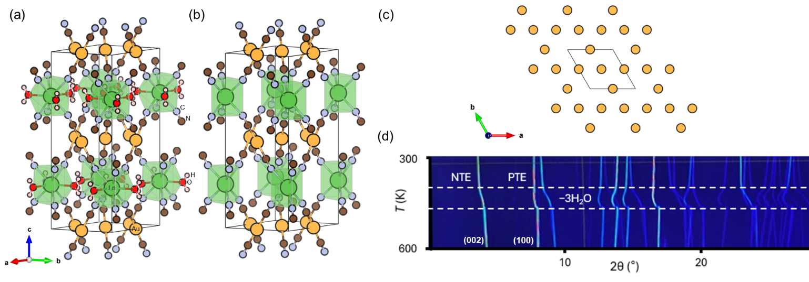

###### **Figure 1**. Crystal structure of LaAu3(CN)6.3H2O (a) and LaAu3(CN)6 (b). Au/Ag Kagome lattice (c). VT PXRD data collected on LaAu3(CN)6.3H2O on the BM01 beamline at the ESRF (λ = 0.6883 Å) (d).

#### [1] Fairbank, V. E., Thompson, A. L., Cooper, R. I., [Goodwin](https://scholar.google.com/citations?user=PtOBKdsAAAAJ&hl=de&oi=sra), A. L. (2012). *Phys. Rev. B* **86**, 104113

#### [2] Goodwin, A., [Calleja](https://www.science.org/doi/10.1126/science.1151442#con2), M., [Conterio](https://www.science.org/doi/10.1126/science.1151442#con3) M. J., Dove , M. T., [Evans](https://www.science.org/doi/10.1126/science.1151442#con5), J. S. O., [Keen](https://www.science.org/doi/10.1126/science.1151442#con6), D. A., [Peters](https://www.science.org/doi/10.1126/science.1151442#con7), L., & [Tucker](https://www.science.org/doi/10.1126/science.1151442#con8), M. G. (2008). *Science* **319**, 794.

#### [3] Colis, J. C. F., Larochelle, C., Staples, R., Herst-Irmer, R., Patterson, H., (2005). *Dalton Trans*. 675-679