# Cross-linked Lipase Crystals for the microfluidic detection of orlistat at nM concentration

## Pablo Moya-Garrido1, Isaac Rodríguez-Ruiz2, Sergio Martínez-Rodríguez3, José A. Gavira1, *

### 1Laboratory of Crystallographic Studies, IACT-CSIC, 18100, Granada, Spain, 2Laboratoire de Génie Chimique, CNRS, INP, UPS, Toulouse, France, 3Departamento de Bioquímica y Biología Molecular III e Inmunología, UGR, 18100, Granada, Spain

### [j.gavira@csic.es](mailto:j.gavira@csic.es)

Enzyme immobilization is a widely used strategy to extend catalytic lifetime under extreme conditions, and to enhance efficiency and reusability. Among the different immobilization methods, such as enzyme aggregates on different supports, Cross-Linked Enzyme Crystals (CLECs) have emerged as a superior approach, offering enhanced catalyst stability and recoverability, compared to Cross-Linked Enzyme Aggregates (CLEAs) [1]. CLECs facilitate easy recovery from the reaction medium for reuse, while also displaying enhanced enzyme stability under harsh conditions such as high temperatures, extreme pH levels, and the presence of organic solvents. They also provide protection against proteolytic degradation [2]. Reinforced Cross-Linked Lipase Crystals (R-CLLCs) have been successfully produced at semi-preparative scale for use in packed-bed reactors operating under continuous flow conditions [3]. Moreover, CLEC-based microreactors have been proposed for biotechnological and sensing applications, demonstrating unprecedented shelf-life and operational stability compared to traditional biosensors [4].

In addition to their physiological roles, lipases are of significant biotechnological interest due to their catalytic versatility, and are widely employed in biodiesel production, detergents, and food processing [5]. In this study, we used biolipase L, derived from *Thermomyces lanuginosus*, to demonstrate the potential of CLLCs embedded in microfluidic chips as robust, stable sensors capable of detecting nanomolar concentrations of the anti-obesity drug orlistat, which is commonly found in waste and surface waters [6]. Sensor performance was evaluated by measuring enzymatic activity with *p*-nitrophenyl butyrate under varying pH, temperature, and solvent polarity conditions.

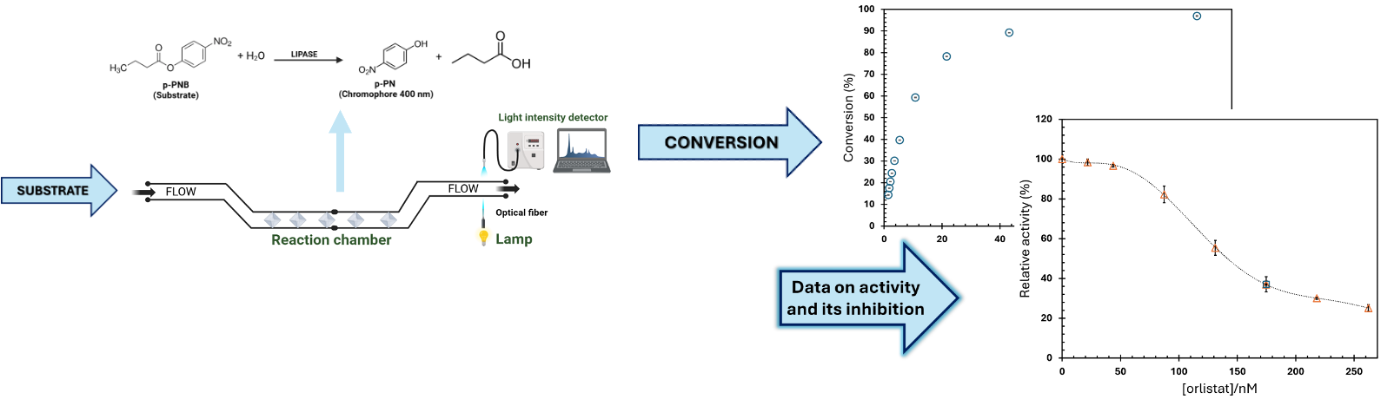

###### **Figure 1**. Schematic representation of the workflow.

The results revealed high initial activity, excellent reusability over multiple cycles, and partial irreversible inhibition by orlistat, hihglighting the sensor’s potential for contaminant detection. Additional characterization confirmed both amidase and esterification activities in non-aqueous media, further broadening the device’s applicability.

In conclusion, this study supports the development of compact, stable, and versatile enzymatic devices for environmental monitoring based on activity-based detection. Beyond the intrinsic benefits of CLECs, integration into a microfluidic system enables continuous-flow operation, achieving a sevenfold increase in enzymatic activity compared to batch mode, while preserving the ability to reuse each device multiple times.

#### [1] Brady, D. et al., (2009). *J. Biotech. Letters.* **31**, 1639.

#### [2] Margolin & Navia, (2001). *Angew. Chem. Int. Ed Engl*., **40**, 2204.

#### [3] Fernandez-Penas et al., (2021). *Cryst. Growth Des.*, **21**, 1698.

#### [4] Conejero-Muriel et al., (2016). *Anal. Chem.*, **88**, 11919.

#### [5] Chandra, P., et al., (2020). *Microb. Cell Fact.*, **19,** 1.

[6] Garcia-Ac, A., et al., (2009). *J. Environ. Monit.,* **11**, 830.

Supported by the Spanish Ministry for Science and Innovation/Agencia Estatal de Investigación 10.13039/501100011033, grant PID2020-116261GB-I, and by the Institut National Politechnique de Toulouse ETI 2025 program (project InCySe)