Holistic approach for estimating lattice thermal conductivity in diamond-like materials

Taras Parashchuk^{1*}

¹AGH University of Krakow, Faculty of Materials Science and Ceramics, Department of Inorganic Chemistry,
Thermoelectric Research Laboratory, Mickiewicza Ave. 30, 30-059 Krakow, Poland

parashchuk@agh.edu.pl
The lattice thermal conductivity is only one of the parameters determining the ZT (ZT = S²σT/(κ_{L}+κ_{e}), where S is the Seebeck coefficient, σ is the electrical conductivity, T is the absolute temperature, κ_{L} and κ_{e,} represent the lattice and electronic components of the thermal conductivity, respectively), which can be optimized independently. Therefore, optimizing κₗ is a powerful approach to enhance ZT without compromising electrical properties, and it remains a central focus in the development of next-generation thermoelectric materials.
The proposed holistic approach relies on widely available experimental techniques such as XRD, SEM/EDS, and optical microscopy to gather information about materials defects. More advanced methods, including Transmission Electron Microscopy (TEM), X-ray Photoelectron Spectroscopy (XPS), Raman spectroscopy, synchrotron radiation, can further enhance defect characterization. The resulting crystal structure data can then be utilized for chemical bonding analysis through Electron Localization Function (ELF) or Electron Localizability Indicator (ELI-D) calculations. From a physical perspective, speed of sound measurements and Debye-Callaway calculations play a crucial role. By combining these chemical and physical insights, the proposed approach enables the calculation of lattice thermal conductivity over the target temperature range using relatively simple measurement tools and theoretical models.
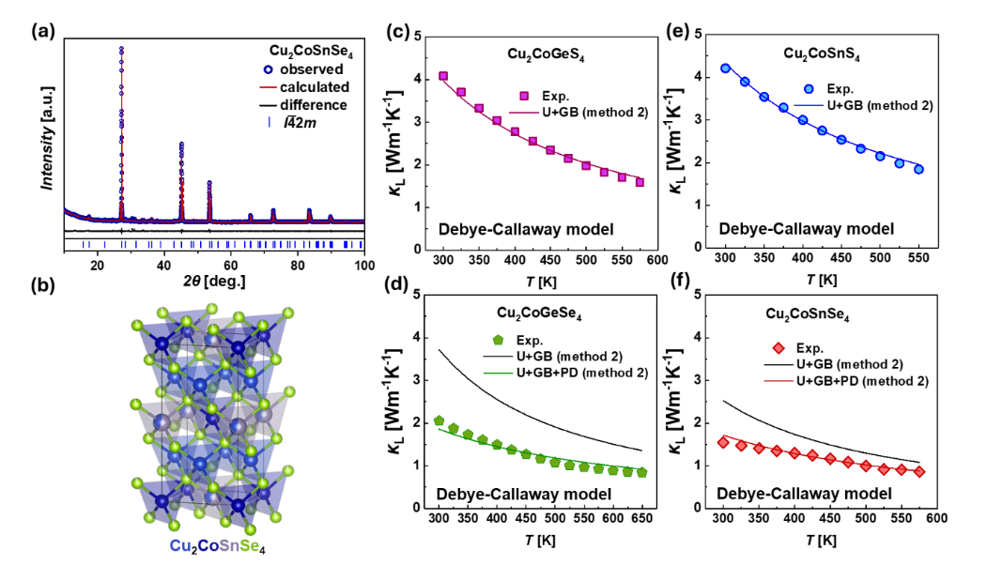
Figure 1. (a) Rietveld refinement of the powder XRD pattern of Cu₂CoSnSe₄. (b) Crystal structure of Cu₂CoSnSe₄. Results of the Debye-Callaway calculations of (c) Cu₂CoGeS₄, (c) Cu₂CoGeSe₄, (e) Cu₂CoSnS₄, and (f) Cu₂CoSnSe₄ diamond-like chalcogenides. Panels of the figure are reproduced from [1].
For the evaluation of the point defect scheme, it was used the results of the Rietveld refinement of the powder XRD patterns. In the case of the Cu₂CoSnSe₄ diamond-like chalcogenide, the better residual values of the Rietveld refinement were obtained using the mixed occupancy of Sn and Cu in the 2b atomic position (space group ). Therefore, in the Debye-Callaway calculations, it was used the defect scheme with the antisite defects Sn_{Cu} and Cu_{Sn} to account for the point defect scattering. Much better agreement between theoretical and experimental κ_{L}(T) was obtained for the investigated DLS material after accounting for the mentioned point defects. A similar defect strategy was also applied to the case of Cu₂CoGeSe₄ with the cation disorder in the 4a atomic position (space group F222). In the case of Cu₂CoSnS₄ and Cu₂CoGeS₄, the disorder was not used, neither in the case of the Rietveld refinement nor in the case of Debye-Callaway, confirming the effectiveness of the proposed approach.

[1] T. Parashchuk, The Journal of Physical Chemistry C, 129, 6 (2025) 3272.

[2] T. Parashchuk*, O. Cherniushok, O. Smitiukh, O. Marchuk, K.T. Wojciechowski, Chemistry of Materials, 35(12) (2023) 4772.
This work was funded by the National Science Center (Poland) under the research project “OPUS-26” UMO-2023/51/B/ST11/00329.

