Designing PROTACs Against Enteroviral 2A Protease via Cereblon E3 Ligase Recruitment

B. Kaščáková¹, H. El Kilani², H. Durmaz³, R. Kumar Akula³, K. Rox³, R. Hilgenfeld² and I. Kutá Smatanová¹

¹Department of Chemistry, University of South Bohemia, Branišovská 1645/31a, 370 05 Ceske Budejovice, Czech Republic

² Institute for Molecular Medicine, University of Lübeck, Ratzeburger Allee 160, 23538 Lübeck, Germany
³ Department of Chemical Biology, Helmholtz Centre for Infection Research, Inhoffenstr. 7, Braunschweig 38124, Germany

karafb00@jcu.cz
Enteroviruses (EV) such as EV-A71 and EV-D68 pose growing public health threats, particularly among children [1-2] , due to their association with severe neurological and respiratory illnesses, including hand, foot, and mouth disease (HFMD) [3-4] and acute flaccid myelitis (AFM) [5-6]. Despite their clinical significance, no targeted antiviral therapies currently exist. This project aims to address this gap by applying targeted protein degradation strategies to eliminate 2A protease (2A^{pro}), a viral enzyme essential for replication and immune evasion. EV 2A^{pro} mediates viral polyprotein processing, suppresses host translation by cleaving eIF4G, and disrupts type I interferon signaling via degradation of IFNAR1 and cleavage of MAVS and MDA5 [7-8]. Its essential role in viral pathogenesis makes it a high-priority antiviral target.
To overcome the limitations of conventional inhibitors, we propose the development of proteolysis-targeting chimeras (PROTACs) that direct 2A^{pro} to cereblon (CRBN)-mediated ubiquitination and proteasomal degradation [9-10]. PROTACs offer distinct advantages, including catalytic activity, degradation of the entire protein, reduced susceptibility to resistance, and the ability to target structurally challenging proteins [9, 11]. Using integrative structural biology approaches such as X-ray crystallography and crosslinking mass spectrometry, we will rationally design and optimize CRBN-recruiting PROTACs to achieve selective and sustained 2A^{pro} degradation.
To enable biochemical and structural characterization of 2A^{pro}, we established an optimized recombinant expression system in E. coli, using solubility-enhancing fusion tags and buffer screening to improve protein yield and purity. Affinity and size-exclusion chromatography workflows were tailored to obtain milligram quantities of active, monodisperse protein suitable for downstream structural studies and PROTAC binding assays.
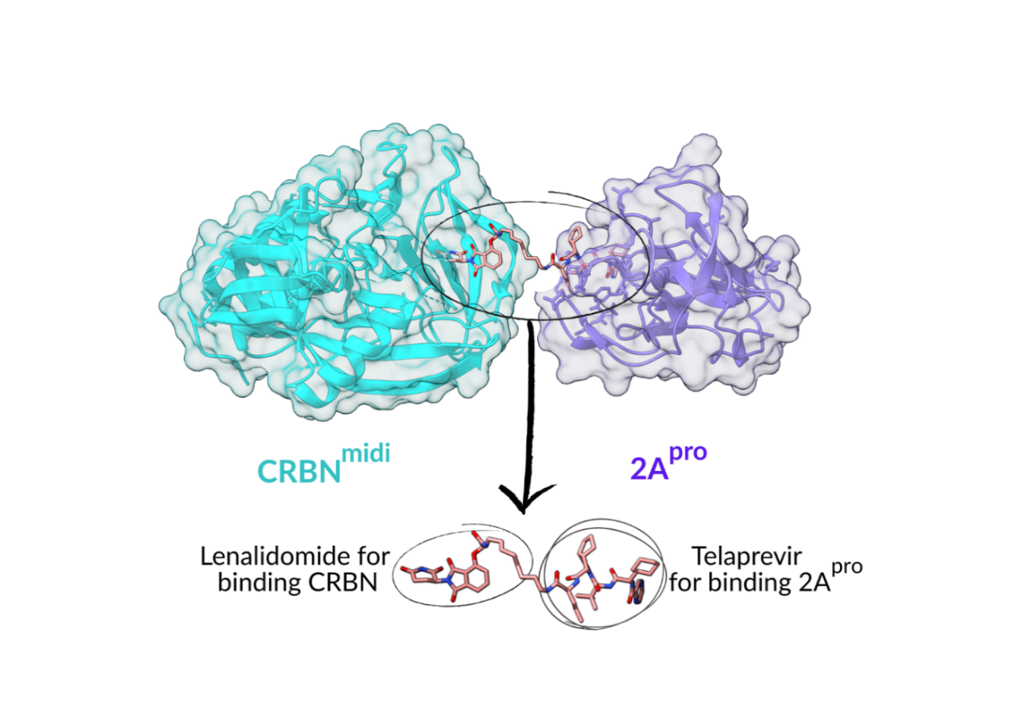This research builds on the PANVIPREP consortium’s vision for broad-spectrum antiviral development and represents a transformative shift in antiviral strategy—from enzymatic inhibition to targeted degradation. By establishing a scalable platform for degrader-based therapeutics, this project aims to deliver novel and effective antiviral candidates against enteroviruses and potentially other RNA viruses of epidemic and pandemic concern.
Figure 1. Graphical representation of an optimized PROTAC design. The protein structures are illustrated as cartoons, with CRBNmidi in cyan and 2Apro in purple, overlaid with a transparent surface. The docked PROTAC molecule, shown in salmon-colored sticks, demonstrates its bifunctional nature. The lenalidomide portion is responsible for binding to CRBN, while the telaprevir component (PDB 3SV6) targets 2Apro. A short linker connects the two, highlighting the strategic design to bridge both target proteins for degradation.

[1] Grizer, C. S., Messacar, K., & Mattapallil, J. J. (2024). Frontiers in virology (Lausanne, Switzerland), 4, 1328457. https://doi.org/10.3389/fviro.2024.1328457

[2] Ooi, M. H., Wong, S. C., Lewthwaite, P., Cardosa, M. J., & Solomon, T. (2010). The Lancet. Neurology, 9(11), 1097–1105. https://doi.org/10.1016/S1474-4422(10)70209-X

[3] Cordey, S., Petty, T. J., Schibler, M., Martinez, Y., Gerlach, D., van Belle, S., Turin, L., Zdobnov, E., Kaiser, L., & Tapparel, C. (2012). PLoS pathogens, 8(7), e1002826. https://doi.org/10.1371/journal.ppat.1002826

[4] Teoh, H. L., Mohammad, S. S., Britton, P. N., Kandula, T., Lorentzos, M. S., Booy, R., Jones, C. A., Rawlinson, W., Ramachandran, V., Rodriguez, M. L., Andrews, P. I., Dale, R. C., Farrar, M. A., & Sampaio, H. (2016). JAMA neurology, 73(3), 300–307. https://doi.org/10.1001/jamaneurol.2015.4388

[5] Xiang, Z., & Wang, J. (2016). Seminars in respiratory and critical care medicine, 37(4), 578–585. https://doi.org/10.1055/s-0036-1584795

[6] Vogt, M. R., Wright, P. F., Hickey, W. F., De Buysscher, T., Boyd, K. L., & Crowe, J. E., Jr (2022). The New England journal of medicine, 386(21), 2059–2060. https://doi.org/10.1056/NEJMc2118155

[7] Li, C., Qiao, Q., Hao, S. B., Dong, Z., Zhao, L., Ji, J., Wang, Z. Y., & Wen, H. L. (2018). Virus research, 244, 262–269. https://doi.org/10.1016/j.virusres.2017.11.023

[8] Feng, Q., Langereis, M. A., Lork, M., Nguyen, M., Hato, S. V., Lanke, K., Emdad, L., Bhoopathi, P., Fisher, P. B., Lloyd, R. E., & van Kuppeveld, F. J. (2014). Journal of virology, 88(6), 3369–3378. https://doi.org/10.1128/JVI.02712-13

[9] Ishida, T., & Ciulli, A. (2021). SLAS discovery : advancing life sciences R & D, 26(4), 484–502. https://doi.org/10.1177/2472555220965528

[10] Cowan, A. D., & Ciulli, A. (2022). Annual review of biochemistry, 91, 295–319. https://doi.org/10.1146/annurev-biochem-032620-104421

[10] Békés, M., Langley, D. R., & Crews, C. M. (2022). Nature reviews. Drug discovery, 21(3), 181–200. https://doi.org/10.1038/s41573-021-00371-6
This project has received funding from the European Union’s Horizon Europe research and innovation programme under Grant Agreement no. 101137229.

