# *pgtrainer*: a classroom tool and 3D models for teaching point group symmetry

## N. Trapp1, M. Solar1, M. Wörle1

### 1Small Molecule Crystallography Center, ETH Zürich, Vladimir-Prelog-Weg 3, CH-8093 Zürich nils.trapp@org.chem.ethz.ch

*pgtrainer* is a simple viewer program intended to assist with teaching point group symmetries, specifically the 32 crystal classes. It comes bundled with hundreds of different 3D models arranged in themed sets, such as crystal shapes, molecules or objects from daily life, with the intention of lowering the barriers for self study. The program has a simple uncluttered interface, making it suitable for both projection in a lecture setting and practicing at home. Models can be navigated by mouse, keyboard or presenter, and rotated/scaled/moved manually or continuously. The symmetry elements of the matching point group can be projected on the models.

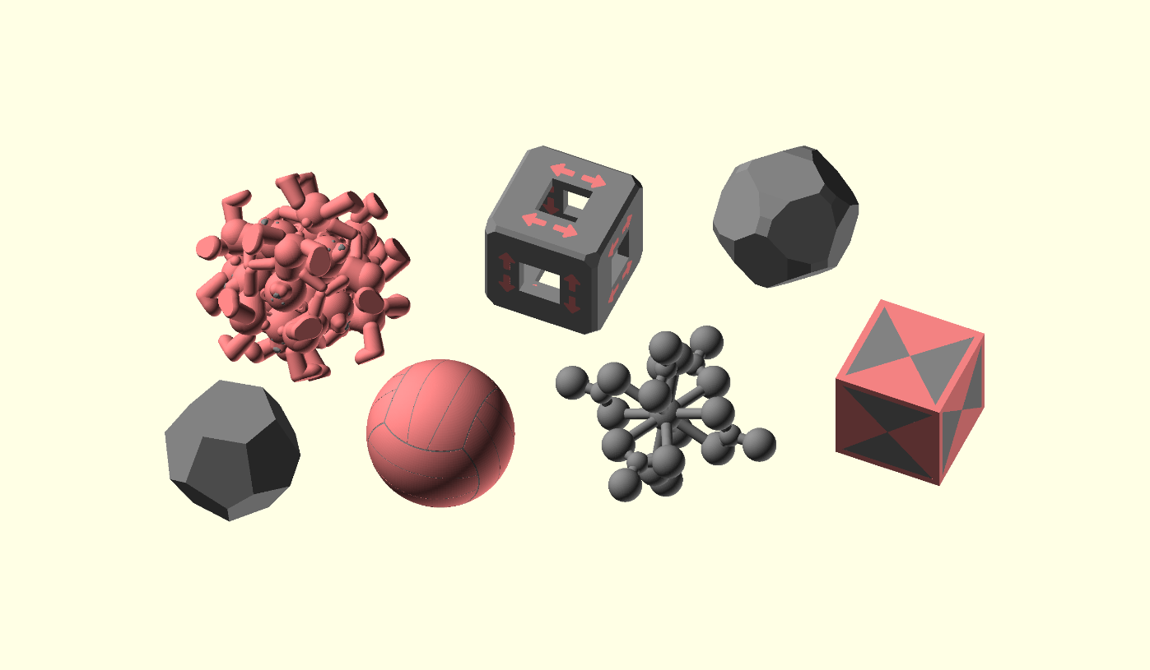

###### **Figure 1**. A selection of models representing point group $m\overline{3}$, illustrating some of the variety of model sets bundled with *pgtrainer.*

*pgtrainer* facilitates the import of existing model sets by other authors in a mostly automated process (files only need to be renamed and models rotated to match the coordinate system used by the program). Many of the bundled 3D models are suitable for 3D printing and made available for download [1,2], e.g. to be passed around the classroom or to design practical exercise sessions. *pgtrainer* will be made freely available for download prior to ECM35.

|  |  |  |
| --- | --- | --- |
|  |  |  |

#### [1] Trapp, N. (2021-2025) https://www.printables.com/@ntdesign/collections/2283402.

#### [2] Oakley, A. (2018) https://www.thingiverse.com/thing:2987632.