# Deciphering the mechanism of action of essential mycobacterial 4’-phosphopantetheinyl transferases.

## Sabine Gavalda1,3, Alexandre Faille1,4, Simone Fioccola2, Marie Brut2, Lionel Mourey1 & Jean-Denis Pedelacq1

### 1Institut de Pharmacologie et de Biologie Structurale (IPBS), Université de Toulouse, CNRS, Université Toulouse III - Paul Sabatier (UT3), Toulouse, France, 2LAAS-CNRS, Université de Toulouse, CNRS, UPS, Toulouse, France, 3Carbios, Biopôle Clermont Limagne, Saint-Beauzire, France, 4Cambridge Institute for Medical Research, Cambridge Biomedical Campus Keith Peters Building, Hills Rd, Cambridge CB2 0XY, United Kingdom

### jean-denis.pedelacq@ipbs.fr

Metabolites synthesized by fatty acid synthases (FAS), polyketide synthases (PKS), and non-ribosomal peptide synthetases (NRPS) encompass a wide variety of complex organic compounds, many of which exhibit significant biological activities and are largely explored in drug discovery. In contrast, species of the Mycobacterium genus use similar enzymatic machineries to synthesize essential components of their cell envelope as well as lipid-based virulence factors.

A shared and essential step in the biosynthesis of all these metabolites is the post-translational modification of the acyl carrier protein (ACP) domains within their multi-enzyme systems. This modification is catalyzed by 4'-phosphopantetheinyl transferases (PPTases), which transfer the phosphopantetheine (Ppant) moiety from coenzyme A (CoA) to a conserved serine residue on the ACP domain, in the presence of Mg2+ or Mn2+ metal ions. The thiol group at the extremity of the Ppant arm, approximately 20 Å long, functions as a flexible tether that enables the covalent attachment, elongation, and modification of intermediates through dynamic interactions with various catalytic domains.

*Due to their essential role in activating enzymes essential for bacterial viability and pathogenicity, PPTases have emerged as promising targets for the development of novel antimycobacterial agents.* In recent years, we have structurally characterized the mycobacterial PPTase PptTAb using *X-ray crystallography and NMR spectroscopy*, alone and in complex with the ACP domain of a PKS [1]. Our findings indicate that compounds of the amidinourea and hydroxypyrimidinethione type represent promising molecular scaffolds for the rational design of more efficient inhibitors [2]. These structural studies also raised fundamental questions about the sequence of events that precede ACP activation and the precise mechanism underlying Ppant transfer. To address these, *we carried out an integrative study combining in-depth biophysical and structural analysis with quantum dynamics/molecular mechanics (QM/MM) molecular dynamics simulations [3]. This approach enabled us to reconstruct the key steps in the Ppant transfer process (Fig. 1).*

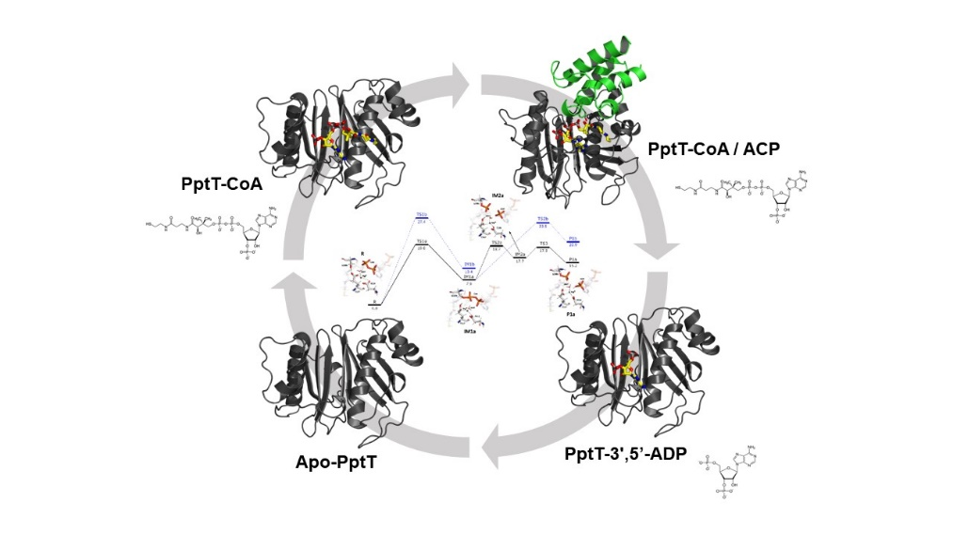

###### **Figure 1**. Schematic representation of the activation cycle of PptT from *Mycobacterium tuberculosis*.

#### [1] Nguyen, M. C., Saurel, O., Carivenc, C., Gavalda, S., Saitta, S., Tran, M. P., Milon, A., Chalut, C., Guilhot, C., Mourey, L., and Pedelacq, J.-D. (2020). *FEBS J.*, **287**, pp. 4729-4746.

#### [2] Carivenc, C., Maveyraud, L., Blanger, C., Ballereau, S., Roy-Camille, C., Nguyen, M. C., Genisson, Y., Guilhot, C., Chalut, C., Pedelacq, J.-D., and Mourey, L. (2021). *Sci. Rep.* **11**, 18042.

#### [3] Gavalda, S., Faille, A., Fioccola, S., Nguyen, M. C., Carivenc, C., Rottier, K., Rufin, Y., Saitta, S., Czaplicki, G., Guilhot, C., Chalut, C., Brut, M., Mourey, L., and Pedelacq, J.-D. (2024). *ACS Catal.,* **14**, pp. 8561-8575.