**Cryo-EM and ED are driving structural studies at the University of Warsaw**

**Tomasz Góral1, Szymon Sutuła1, Krzysztof Woźniak1,2,3**

# *1 Cryomicroscopy and Electron Diffraction Core Facility, Centre of New Technologies, University of Warsaw, ul. Banacha 2C, 02-097 Warszawa, 2Biological and Chemical Sciences Research Centre, University of Warsaw, ul. Żwirki i Wigury 101, 02-089 Warszawa 3Department of Chemistry, University of Warsaw, ul. Pasteura 02-093 Warszawa*

*Email of communicating author: t.goral@cent.uw.edu.pl*

In 2019 the University of Warsaw purchased and installed one of the first cryo-EM microscopes in the country - the 200kV Glacios equipped with a Falcon3EC camera and a phase plate solution. In the next few years the Cryomicroscopy and Electron Diffraction Core Facility has been established and started providing many local structural biologists and chemists with a direct access to this groundbreaking and Noble-winning cryo-EM technology. To date, there have been only three cryo-EM Core Facilities operating in Poland which provide services in all cryo-EM modalities.

This poster shows the current possibilities of our Core Facility and a range of services which are offered to our users. We follow the open-access policy and welcome users from both national and international academic institutions as well as industry. Our recent developments include benchmarking the Single Particle Analysis (SPA) reconstruction of GroEL with GroTAC peptide at the 2.45Å resolution level with local resolution reaching 2.2Å (PDB: 8S32) [1] and the 2.27Å reconstruction of the AbiK bacterial polymerase (PDB:7R06) [2]. The results are further enhanced with the microcrystal electron diffraction (micro-ED) - additional functionality of the microscope allowing for a rapid structure determination of small molecules and/or proteins based on electron diffraction data as e.g. in Fig.1 [3-4]. We highlight the importance of smaller cryo-EM Core Facilities such as ours to serve as a first point of contact for users, in particular for those who are new to the cryo-EM field and would like to explore different possibilities of getting high quality data prior to applying for the measurement time on high-end 300kV microscopes. We also show that being able to offer all cryo-EM modalities in one instrument (SPA, cryo-tomography and micro-ED) significantly boosts a research potential and opens up new possibilities across many Life Science applications.

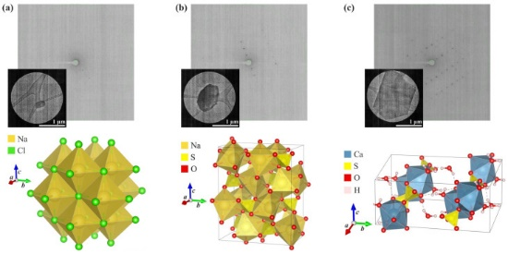

**Figure 1**. MicroED analysis of crystals from the surface of *A. maritima* leaves (the measured microcrystal, an exemplary frame showing the diffraction signal, and the crystal packing of the compound): (**a**) sodium chloride (halite), (**b**) sodium sulphate (thénardite), and (**c**) calcium sulphate dihydrate (gypsum).

[1] Izert-Nowakowska, M. et al. (2025). *EMBO Rep. (accepted).*

[2] Figiel, M et al. (2022), *Nucleic Acids Res.,* **50(17),** 10026 - 10040

[3] Trzybiński, D. et al, (2024). *Molecules*., **29(20),** 4916

[4] Kumar, A. et al., (2024). *Acta Crystallogr C Struct Chem,* **80,** 264-277