# Structural Phase Transition and Intrinsic Optical Properties of a Hybrid (Pip)2[KBiBr6]; Luminescence and DFT Calculations

## M. N. Rowińska1, Oleksandr Korolevych1, Adam Kabański1, Dagmara Stefańska1, T. J. Bednarchuk1, A. Piecha-Bisiorek2, A. Gągor1

### 1Institute of Low Temperature and Structure Research, Polish Academy of Sciences, Okólna 2, 50-422 Wrocław, 2Faculty of Chemistry, University of Wroclaw, 14 F. Joliot - Curie, 50-383 Wroclaw, Poland

### [m.rowinska@intibs.pl](mailto:m.rowinska@intibs.pl)

Hybrid organic-inorganic materials, particularly methylammonium lead iodide, have drawn extensive interest due to their superior photovoltaic properties [1]. However, the presence of lead and phase instability limit their practical application. Halide double perovskites with general formula A₂MM′X₆ offer a promising lead-free alternative, incorporating small organic cations (e.g., FA⁺, MA⁺) at the A-site, monovalent cations (e.g., K⁺, Ag⁺, Cu⁺) at the B-site, and trivalent cations (e.g., Bi³⁺, Sb³⁺) at B′ [2,3]. While 3D structural dimensionality remains a challenge due to the limited availability of organic amines with appropriate steric properties to accommodate the inorganic framework, low-dimensional analogs can offer new functionalities. Besides, low-dimensional 1D and 3D hybrid halide double perovskites can form with the same general formula [4]. A major limitation in stabilizing Bi(III)-based double perovskites is the tendency of Bi(III) to preferentially crystallize into A₃Bi₂X₉, A₂BiX₅, or A₅Bi₂X₁₁ phases, which lack monovalent metal cations.

Here, we report the structural and physicochemical characterization of (piperidinium)₂[BiKBr₆], a one-dimensional double perovskite-related material exhibiting an order-disorder phase transition at 303 K related to the temperature activated dynamics of molecular substructure. Inorganic component is built of 1D pillars composed of face-sharing Bi(III)Br6 octahedra and trigonal KBr6 antiprisms. A symmetry reduction from 2/*m*F1 gives rise to switchable ferroelastic domains. Dielectric relaxation in the vicinity of Tc indicates gradual ordering of piperidinium down to 200 K. The compound exhibits purplish-blue photoluminescence arising from high-energy excitons and Bi(III) emission attributed to electronic confinement within the inorganic pillars and the absence of concentration quenching. Density functional theory calculations confirm that the electronic structure is dominated by Bi3+ and Br- states and reveal that electron and hole migration occurs between neighboring chains, being suppressed alongside the inorganic pillars. These findings shed a new light on the electronic properties of double perovskites and related structures with strongly ionic M-X bonds between alkaline metal cations and halide ligands.

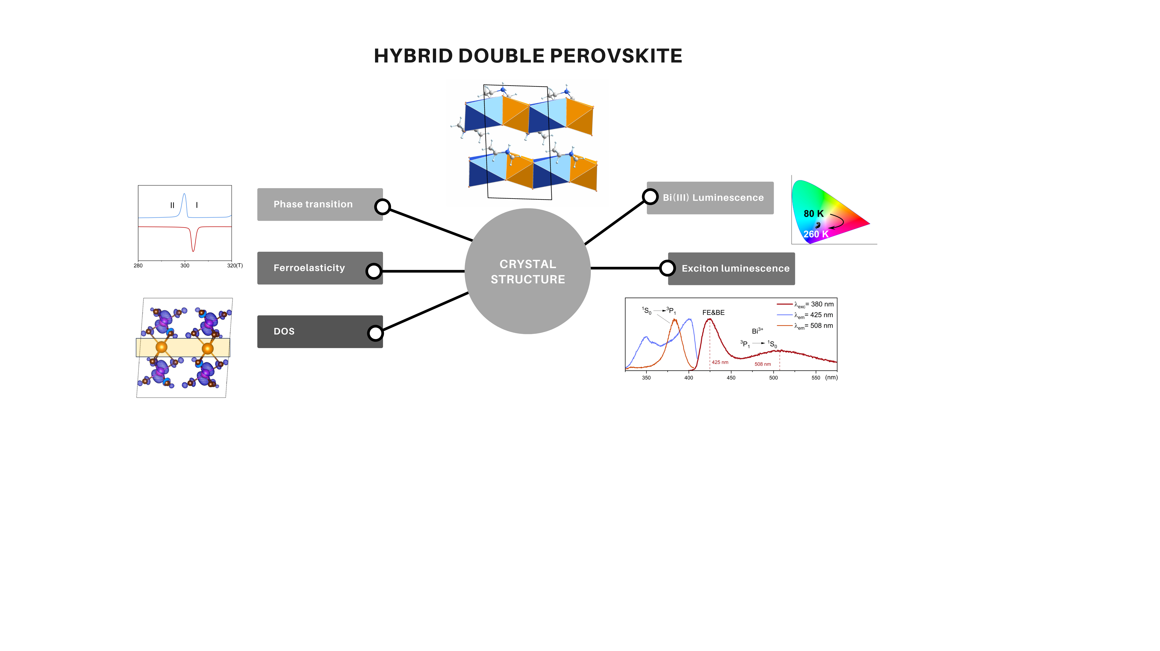

###### **Figure 1**. A schematic representation of the physicochemical properties of the (Pip)2[KBiBr6].

###### [1] M. M.; Teuscher, J.; Miyasaka, T.; Murakami, T. N.; Snaith, H. J. *Science* (2012), **338**, 643−647.

###### [2] F. Wei, Z. Deng, S. Sun, F. Xie, G. Kieslich, D. M. Evans, M. A. Carpenter, P. D. Bristowe, A. K. Cheetham, *Mater. Horiz*. (2016), **3**, 328–332.

###### [3]J. Zhou, et al. *Angew. Chem.* *Int. Ed.* (2023), **62**,35.

###### [4] P.Vishnoi. et al *Angew. Chem. Int* *Ed*. (2020), **59**, 8974-8981.

This research was funded by the National Science Centre, Poland, grant number 2021/43/B/ST5/01172.