# Gold in the +II oxidation state: A quantum and resonant crystallographic characterisation

## A. Hinterberger, F. Meurer, M. Bodensteiner

### 1University of Regensburg, Universitätsstr. 31, 93053 Regensburg, Germany

### angelika.hinterberger@ur.de

Porphyrins, especially tetraphenylporphyrins (TPP), represent a diverse platform for developing functional molecular systems due to their extended π-electron system, structural modularity, and ability to coordinate metals. Their metallated derivatives - metalloporphyrins - are not only central in biological systems such as haemoglobin and chlorophyll, but are also of growing interest for catalysis and materials chemistry.[1] Gold is here a particularly fascinating central atom, as it can be complexed in three different oxidation states (Au(I), Au(II), Au(III)). While Au(I) complexes are valued above all for their ability to activate multiple bonds and Au(III) porphyrins are established oxidative catalysts, Au(II) has long remained an unstable, rare species. Since Au(II) is paramagnetic and possesses an unpaired electron, it is eager to either react oxidatively into the Au(I) oxidation state or reductively into the Au(III) oxidation state. However, more recent studies show that stable Au(II)TPP (Fig. 1) complexes can be produced by targeted reduction of Au(III) porphyrins. [2]

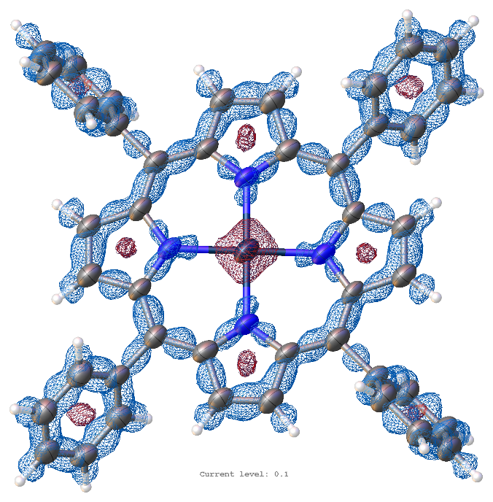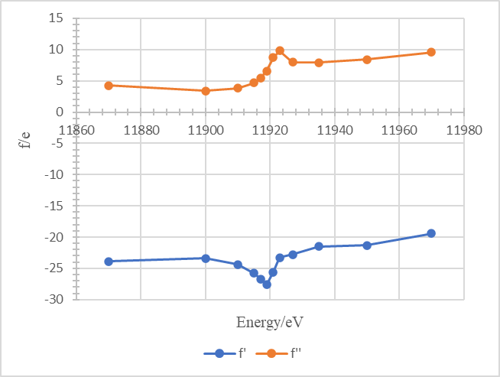

**Figure 1:** Left: Deformation density of Au(II)TPP at the 0.1 eÅ-3 iso-level. Blue indicates positive regions and therefore electron density accumulation, red indicates negative regions and electron density depletion. Right: Obtained values for f’ and f’’ for the Au(II) in AuTPP at several energies close to the Au-L3 absorption edge.

In the present work, we synthesised TPP-gold complexes known in the literature [3] and characterise them, combining resonant X-ray diffraction [4] and X-ray absorption spectroscopy (XAS) by measurements on our in-house devices as well as by measurements at the European Synchrotron (ESRF). Quantum crystallographic analyses through Hirshfeld-Atom-Refinement complement the structural data to elucidate electron density distributions and metal-ligand interactions. Our results are directly compared to the previous study on AuTPP and discuss the rare Au(II) oxidation state character in AuTPP.

#### [1] J. Chen, Y. Zhu, S. Kaskel, *Angew. Chem. Int. Ed.* **2021**, *60*, 5010.

#### [2] J. Mehara, A. K. Surendran, T. van Wieringen, D. Setia, C. Foroutan-Nejad, M. Straka, L. Rulíšek, J. Roithová, *Chem. Eur. J.* **2022**, *28*, e202201794.

[3] S. Preiß, C. Förster, S. Otto, M. Bauer, P. Müller, D. Hindersberger, H. H. Haeri, L. Carella, K. Heinze, *Nature Chem.* **2017**, *9*, 1249. [4] F. Meurer, O. V. Dolomanov, C. Hennig, N. Peyerimhoff, F. Kleemiss, H. Puschmann, M. Bodensteiner, *IUCrJ* **2022**, *9*, 604.