# Adding Cryo-EM to the palette of structural biology techniques at SOLEIL

## E. Larquet1, H. Soufari1, A. Thompson2, P. Legrand2

### 1I2BC UMR9198 du CNRS - 1, rue de la Terrasse, 91190 Gif-sur-Yvette,

### 2Synchrotron SOLEIL, L’Orme des Merisiers, 91192 Saint Aubin

### Eric.larquet@synchrotron-soleil.fr

A Titan KRIOS G4 has recently been installed in the experimental hall at SOLEIL as part of the EQUIPEX+ project France Cryo-EM. Technical solutions have been implemented to provide a mechanically, thermally and electromagnetically stable environment, permitting the acquisition of test apoferritin single particle analysis data giving a Fourier Shell Correlation resolution of 1.14 Angtröem. A rolling access system of peer review has been put into place, and, since January 2025, user experiments have been performed on approved projects, in both Single Particle Analysis (SPA) and Cryo-electron tomography, which often combine data from other SOLEIL beamlines. We will present the installation of the microscope and its room and first results from this facility, underlining opportunities in integrative methods.

Fig. 1. Fourier shell correlation curve and apoferritin density map from Cryo-SPARC illustrating the best resolution achieved by POLARIS in SPA mode during the commissioning phase of the microscope. Subsequent improvements to the environment have been made and this result can probably be improved on.

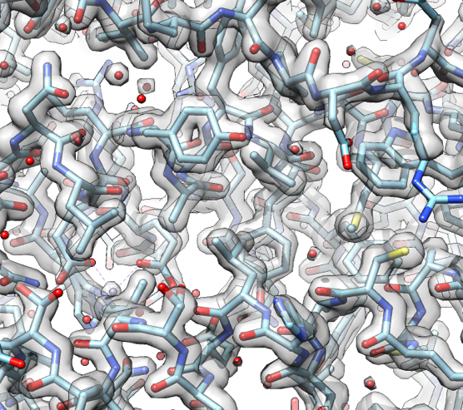

#### [1] Susini, J., Cassagne, JM., Gagey, B. *et al.*  *Eur. Phys. J. Plus* **139**, 80 (2024). https://doi.org/10.1140/epjp/s13360-024-04872-2

[2] Man-Yip. K, Fischer. N, Paknia.E, Chari.A and Stark.H. Nature **587** 157-161, (2020). https://doi.org/10.1038/s41586-020-2833-4