# Molecular Heterometallic Clusters Enable Precise Integration of Mixed-Metal Centers into Metal-organic Frameworks

## C. López‐García1, A. A. Skorynina2, F. Esteban‐Betegón1, J. Pérez‐Carvajal1, M. Iglesias1, M. A. Monge1, E. Gutiérrez‐Puebla1, F. Gándara1

### 1Materials Science Institute of Madrid (ICMM) – Spanish National Research Council (CSIC)

### Sor Juana Inés de la Cruz, 3, 28049, Madrid, Spain, 2 CELLS-ALBA Synchrotron Carrer de la Llum 2-26, Cerdanyola del Vallès, 08290 Barcelona, Spain

### f.gandara@csic.es

The controlled incorporation of selected combinations of different metal elements into metal-organic frameworks (MOFs) remains a challenge. Recently, we have reported a versatile one‐pot synthetic strategy that exploits the use of heterometallic molecular clusters as “messenger building units” (*m*BUs) to achieve atomic‐level control over metal‐organic framework (MOF) architectures and their emergent material properties [1, 2]. By pre‐assembling the heterometallic wheel-shape [Ga7MF8(PivO)16] (Piv = (CH3)3CCOO, M = Ni, Co) molecular clusters and coupling them with organic linkers of varying connectivity— 2,6-naphthalene dicarboxylic acid, (2,6-NDC) 1,3,5‑tris(4‑carboxyphenyl)benzene (H3BTB) and tetrakis(4‑carboxyphenyl)porphyrin (H6TCPP)—we direct the formation of porous frameworks with **sra**, **sit** and **fry** topologies, respectively. Single‐crystal and powder X‑ray diffraction, X‑ray absorption spectroscopies, and electron microscopy confirm the faithful translation of the intended bimetallic combinations into the secondary building units (SBUs) of the MOFs, while gas sorption analyses reveal tunable porosity arising from topology and linker choice, in some cases resulting in flexible frameworks that exhibit single-crystal transformations. Furthermore, we demonstrate how molecular‐scale design translates into catalytic function by embedding the selected multi-metal MOFs into alginate bead composites, which act as efficient heterogeneous photocatalysts displaying enhanced activity and selectivity relative to single‑metal analogues.

Financial support through PID2021-123287OB-I00 funded by MCIN/AEI/10.13039/501100011033 is acknowledged. Beamtime at BL22-CLAESS at the ALBA synchrotron under experiment number 2024028252 is acknowledged.

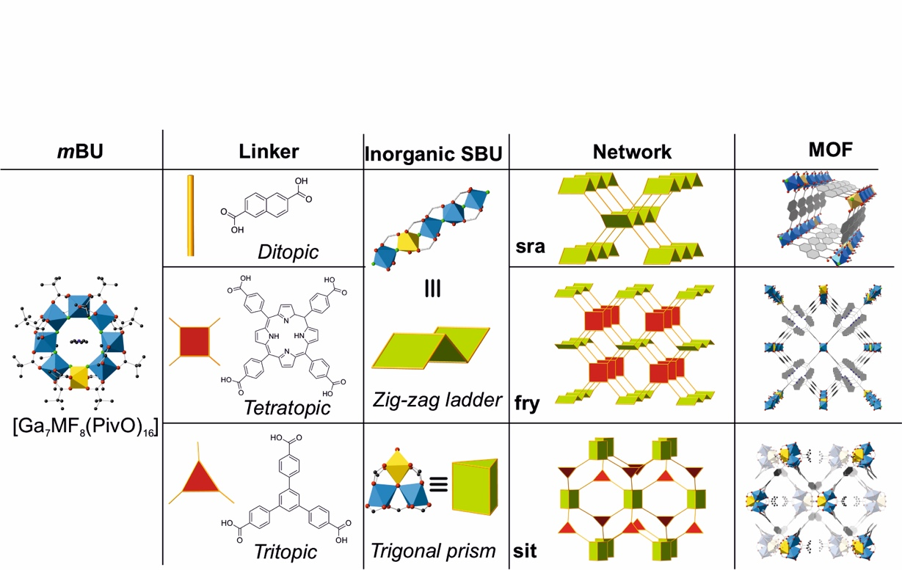

###### **Figure 1**. The *m*BU approach is based on the use of an heterometallic molecular unit, left, which is transformed into inorganic secondary building units when reacted with organic linkers, resulting in frameworks with various topologies, and controlled arrangement of the selected metal atoms.

#### [1] López-García, C., Canossa, S.; Hadermann, J, Gorni, G., Oropeza, F.E.; de la Peña O’Shea, V.A.; Iglesias, M.; Monge, M.; Gutiérrez-Puebla, E.; Gándara, F. (2022). *J. Am. Chem. Soc.* **144**, 16262.

#### [2] López‐García, C.; Skorynina, A.A.; Esteban‐Betegón, F.; Pérez‐Carvajal, J.; Iglesias, M.; Monge, M.A.; Gutiérrez‐Puebla, E.; Gándara, F. (2025). *Small Structures*, **123**, 202400581.