# Structural insights into NaDCC solvates with glymes and crown ethers: snapshot-driven structural design of novel solid polymer electrolytes

## M. Fabiański1, 2, 3, L. García2, I. Aldalur2, E. Sánchez-Diez2, M. Dranka1

### 1Faculty of Chemistry, Warsaw University of Technology, Noakowskiego 3 00-664 Warszawa, Poland, 2Centre for Cooperative Research on Alternative Energies (CIC energiGUNE), Basque Research and Technology Alliance (BRTA), 01510 Vitoria-Gasteiz, Spain, 3ALISTORE European Research Institute, FR CNRS 3104, 80039 Amiens Cedex, France

### michal.fabianski.dokt@pw.edu.pl

The rapid growth of lithium-ion battery (LIB) and post-lithium battery technologies is driving the development of novel components for energy storage systems. Among the battery elements, electrolytes play a key role by enabling efficient ionic transport between   
the cathode and anode while simultaneously acting as electronic insulators. Typically, a “two-dimensional” design strategy   
is employed for electrolytes, focusing on the selection of a conducting salt and appropriate solvent, followed by concentration optimization to achieve high ionic conductivity. However, this approach often overlooks the “third dimension” of electrolyte design – the coordination structure – which can be leveraged to tune the electrochemical properties of the conducting system.[1]

This perspective has led to the emergence of new functional electrolyte classes with enhanced electrochemical performance,   
such as high-concentration and localized high-concentration electrolytes (HCEs and LHCEs), water-in-salt electrolytes (WISEs),   
and weakly solvating electrolytes (WSEs). The Polymer Ionic Research Group at Warsaw University of Technology has extensively investigated polymer-based HCEs with Hückel-type salts, particularly lithium 4,5-dicyano-2-trifluoromethylimidazolate (LiTDI,   
Fig. 1a) in polyethers such as poly(ethylene oxide) (PEO),[2] particularly by capturing snapshots of the local dynamic structure   
of electrolytes via crystal structure determination of polyether solvates. This analysis has led to the discovery of a mechanism responsible for the enhanced electrochemical performance of LiTDI/PEO electrolytes at high concentrations: lithium-cation acid-base disproportionation. This phenomenon results in the differentiation of ion coordination environment, resulting in “free” cations coordinated solely by ether molecules and TDI anions immobilized within a coordinated polymer network, ultimately improving ionic conductivity and yielding high lithium-ion transference numbers. [3-5]

In the presented work, a comprehensive structural analysis of a novel Hückel-type salt – sodium 2-chloro-4,5-dicyanoimidazolate (NaDCC, Fig. 1b) – is reported. The crystal structures of several solvates with glymes and crown ethers are presented,   
along with an examination of coordination polymers and intermolecular interactions. Based on those structural insights, implications for the transport properties of NaDCC in polyether electrolytes are discussed. Additionally, preliminary electrochemical properties   
are investigated to evaluate the applicability in sodium batteries. This work provides a foundation for the development of advanced electrolyte systems for sodium-ion batteries (SIBs), all-solid-state sodium-metal batteries (ASSSMBs), and other sodium-based energy storage technologies.

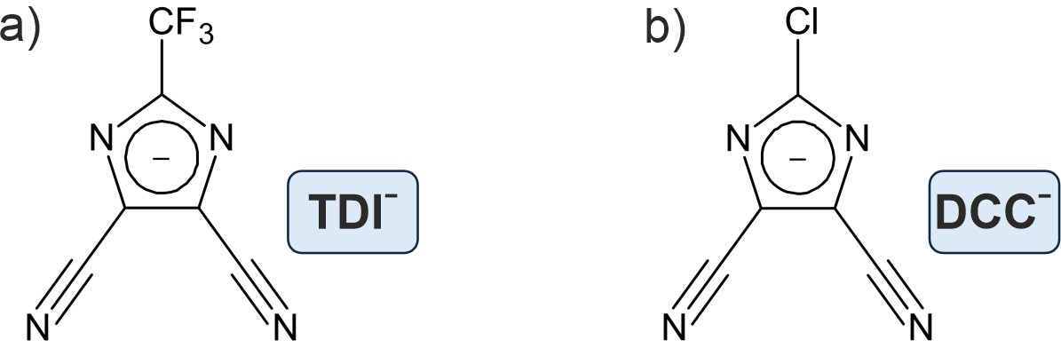

###### **Figure 1**. The molecular structure of anions. a) 4,5-dicyano-2-trifluoromethylimidazolate anion (TDI−). b) 2-chloro-4,5-dicyanoimidazolate anion (DCC−).

#### [1] Yamada, Y. (2017). *Electrochemistry,* **85**, 559-565.

#### [2] Armand, M., Johansson, P., Bukowska, M., Szczeciński, P., Niedzicki, L., Marcinek, M., Dranka, M., Zachara, J., Żukowska, G., Marczewski, M., Schmidt, G., Wieczorek, W. (2020). *J. Electrochem. Soc.*, **167**, 070562.

#### [3] Jankowski, P., Dranka, M., Żukowska, G. Z., Zachara, J. (2015). *J. Phys. Chem. C*, **119**, 9108-9116.

#### [4] Jankowski, P., Dranka, M., Żukowska, G. Z. (2015). *J. Phys. Chem. C*, **119**, 10247-10254.

#### [5] Jankowski, P., Żukowska, G. Z., Dranka, M., Marczewski, M. J., Ostrowski, A., Korczak, J., Niedzicki, L., Zalewska, A., Wieczorek, W. (2016). *J. Phys. Chem. C*, **120**, 23358–23367.

This work has been supported by the Basque Government under Elkartek 2024 (KK-2024/00062)