Synthesis, characterization and biological evaluation of a tyrosinase inhibitor
with antimelanoma potential

E. Pindelska¹, M. Majka¹, H. Naklicka², Izabela Madura³

¹Faculty of Pharmacy, Medical University of Warsaw, Banacha 1, 02-093 Warsaw, Poland, ²Scientific Circle “Crystals” at Department of Pharmaceutical Chemistry and Biomaterials, Faculty of Pharmacy, Medical University of Warsaw, Banacha 1, 02-093 Warsaw, Poland, ³ Faculty of Chemistry, Warsaw University of Technology, Noakowskiego 3, 00-664 Warsaw, Poland

edyta.pindelska@wum.edu.pl
4,4'-(sulfanediyldimethanediyl)diphenol [IT] was first identified and isolated from Gastrodia elata Blume [1]. Isolating IT from plant material is not very efficient. The IT content of material from different crops is variable. The most efficient method for obtaining IT is chemical synthesis. IT is the most potent tyrosinase inhibitor known [2]. Tyrosinase is an enzyme involved in pigment synthesis in pigment cells - melanocytes. Melanoma cells also produce melanin.
The purpose of this study is to optimize synthesis conditions, physicochemical and structural characterization, and determine the sensitivity of various melanoma cell lines to IT.
The synthesis of IT was performed by Bunte salts as intermediates. In order to simplify the synthesis, the indirectly formed Bunte salts were not isolated. 4-Hydroxybenzyl alcohol and sodium thiosulphate were placed in the flask. Acid solutions were added dropwise to the resulting suspension and heated by maintaining the temperature in the 60-80oC range. Formic, acetic, propionic, citric and hydrochloric acids were used as acids. The drained product was washed several times with water and left to dry in air. The structure of IT was determined using X-ray (SCXRD and PXRD) and spectroscopies (FTIR and NMR) methods. The IT content of the crude reaction product was determined by HPLC. The effect of IT on the viability of MNT1 was assessed using MTS assay.
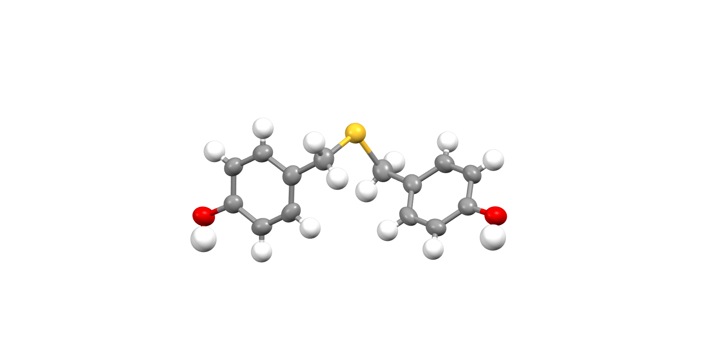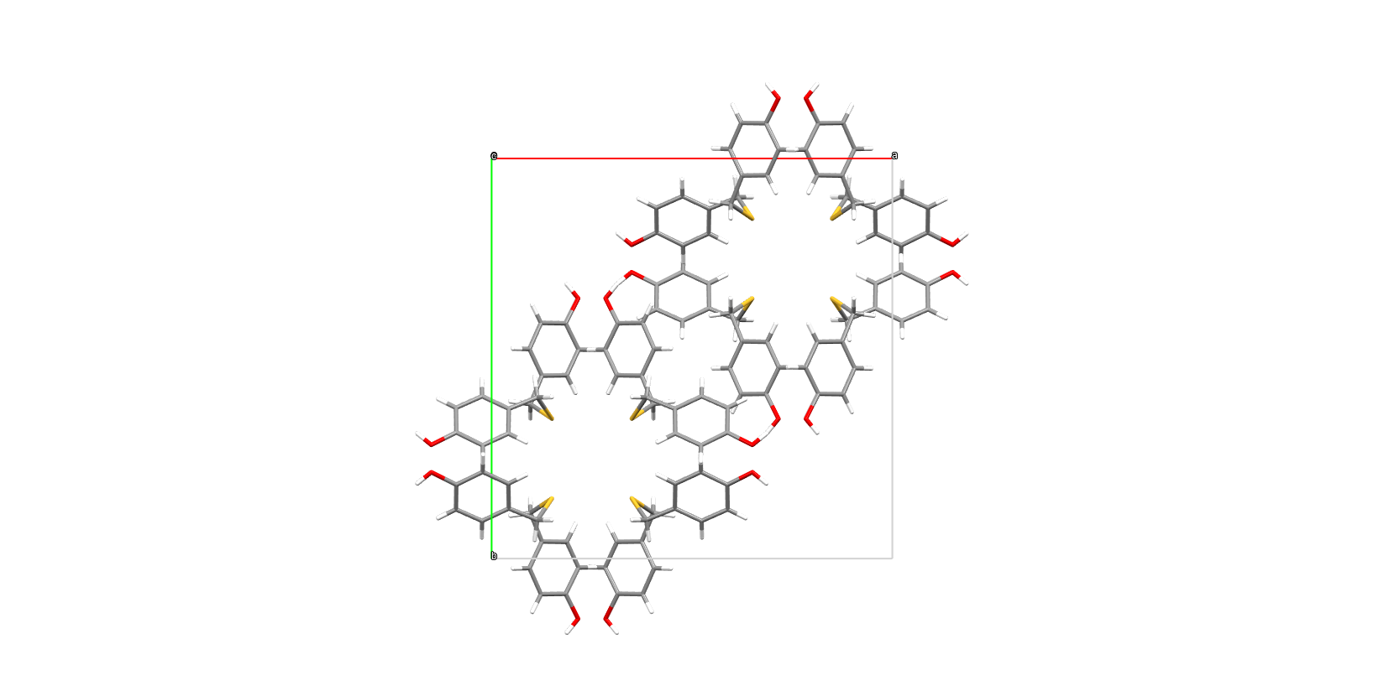

Figure 1. X-ray structure and crystal packing of IT. IT crystalizes in P 4/n c c.

The findings of this study suggest that citric acid, when employed in the IT synthesis reaction, yields superior outcomes in comparison to acetic acid. As demonstrated in the extant literature, the optimal yield is achieved through the utilisation of acetic acid. The results of the cellular investigation indicate that melanoma cells are sensitive to the presence of IT.
The findings suggest that IT synthesis is more efficient in the presence of acids of higher potency than acetic acid. GOLD molecular docking analysis was applied to investigate the binding interactions of IT molecule with mushroom tyrosinase to elucidate the possible molecular mechanism. The results of the structural studies will facilitate the design of other tyrosinase inhibitors for the treatment of melanoma.

[1] Xiao, Y.Q.; Li, L., You, X.L. (2002), China J. Chin. Materia Med. 27, 35.

[2] Chen, W.C., Tseng, T.S., Hsiao, N.W., Lin, Y.L., Wen, Z.H., Tsai, C.C., Lee, Y.C., Lin, H.H., Tsai, K.C. (2015), Sci Rep. 23, 5, 7995.

This work was financially supported by Medical University of Warsaw, grant number 20/F/MG/N/24.

