# Hidden broken symmetries and magnetic behaviour of the nickelate series Pr2-xCaxNiO4+*δ* (*δ* >> 0, *δ* ≈ 0)

## Jaskaran S. Mangat 1 and Mark S. Senn 1

### 1 Department of Chemistry, University of Warwick, Gibbet Hill Road, Coventry CV4 7AL, United Kingdom

### Contact author: jaskaran.mangat@warwick.ac.uk

Distortions in the crystal structure of layered perovskite oxides are well-known to accompany unusual emergent phenomena such as charge-ordering and superconductivity, with a prototypical example being the tetragonal-to-orthorhombic (*I*4/*mmm* -> *Bmab*) structural phase transitions in 214 superconducting cuprates [1]. The neighbouring family of Ruddlesden-Popper nickelates are a chemically similar yet relatively less explored family, also hosting strongly correlated behaviour such as striped charge and spin order in La1.5Sr0.5NiO4 [2] and high-temperature superconductivity in La3Ni2O7 under pressure [3], giving this family potential to act as a Rosetta Stone of exotic condensed matter.  
  
We have explored the ambient-pressure phase diagram of the nickelate Pr2-xCaxNiO4+*δ* (both *δ* >> 0 and *δ* ≈ 0) using high-resolution powder X-ray diffraction, DC magnetometry and resistivity measurements, decomposing their structural evolution through irreducible representation (irrep) analysis in a monoclinic basis. The symmetry of the *δ* >> 0 series increases with Ca occupancy until distorting into the *I*4/*mmm* aristotype at *x* = 0.2; whereas the *δ* ≈ 0 series instead undergoes a strong monoclinic shear as the Ca occupancy increases from *Bmab* to *P*2/*c* at *x* = 0.6, concomitant with a massive shift (>2%) in the amplitude of the *Γ*4+ and *Γ*2+ strain modes and a change in the best-fitting order parameter direction. Despite the mutual presence of a well-known *Bmab* -> *P*42/*ncm* phase transition on cooling in Pr2NiO4 and the 214 cuprates, the effect of hole-doping evidently does not necessitate an increase in the tolerance factor, highlighting a link between the monoclinic distortion in this nickelate system and the under-studied monoclinic 214 charge-ordered cuprates such as La1.88Sr0.12CuO4 and La1.875Ba0.125CuO4 [4,5]. The symmetry-breaking degree of freedom across the *δ* ≈ 0 series is the *X*3+ displacive mode (representing octahedral tilting), which also parameterises weak ferromagnetism from the Dzyaloshinskii-Moriya interaction (DMI), in agreement with our magnetisation measurements showing a strong ZFCW-FCC splitting and weak hysteresis present only upon loss of the interstitial oxygen. Our results highlight the significance of oxygen content in changing the physics of nickelate perovskite systems hosting emergent phenomena.

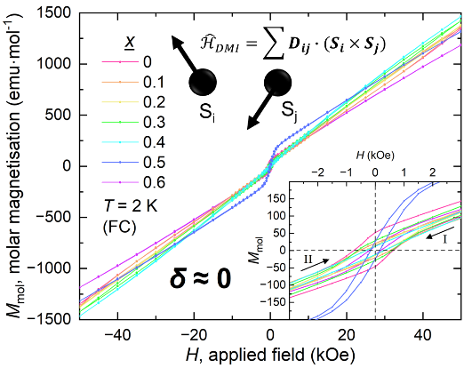

**(c)**

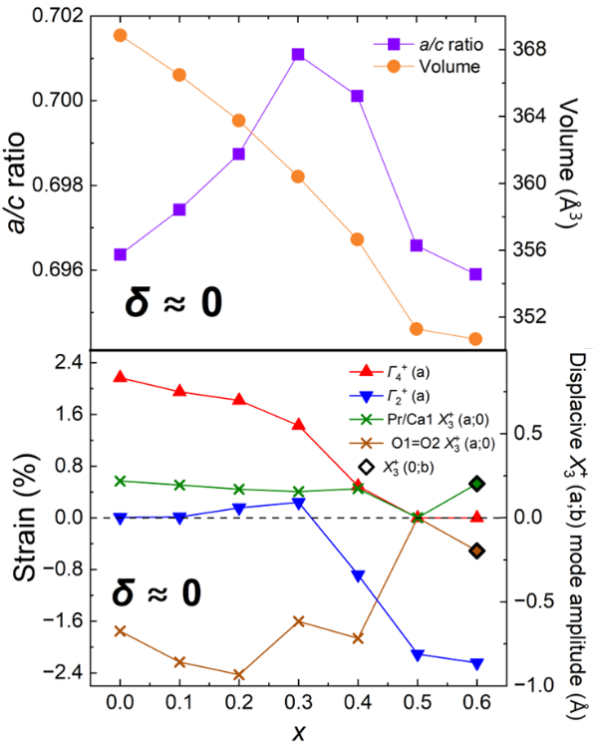

**(a)**

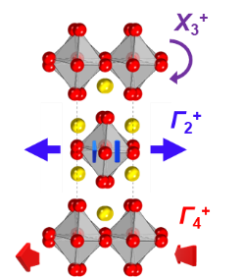

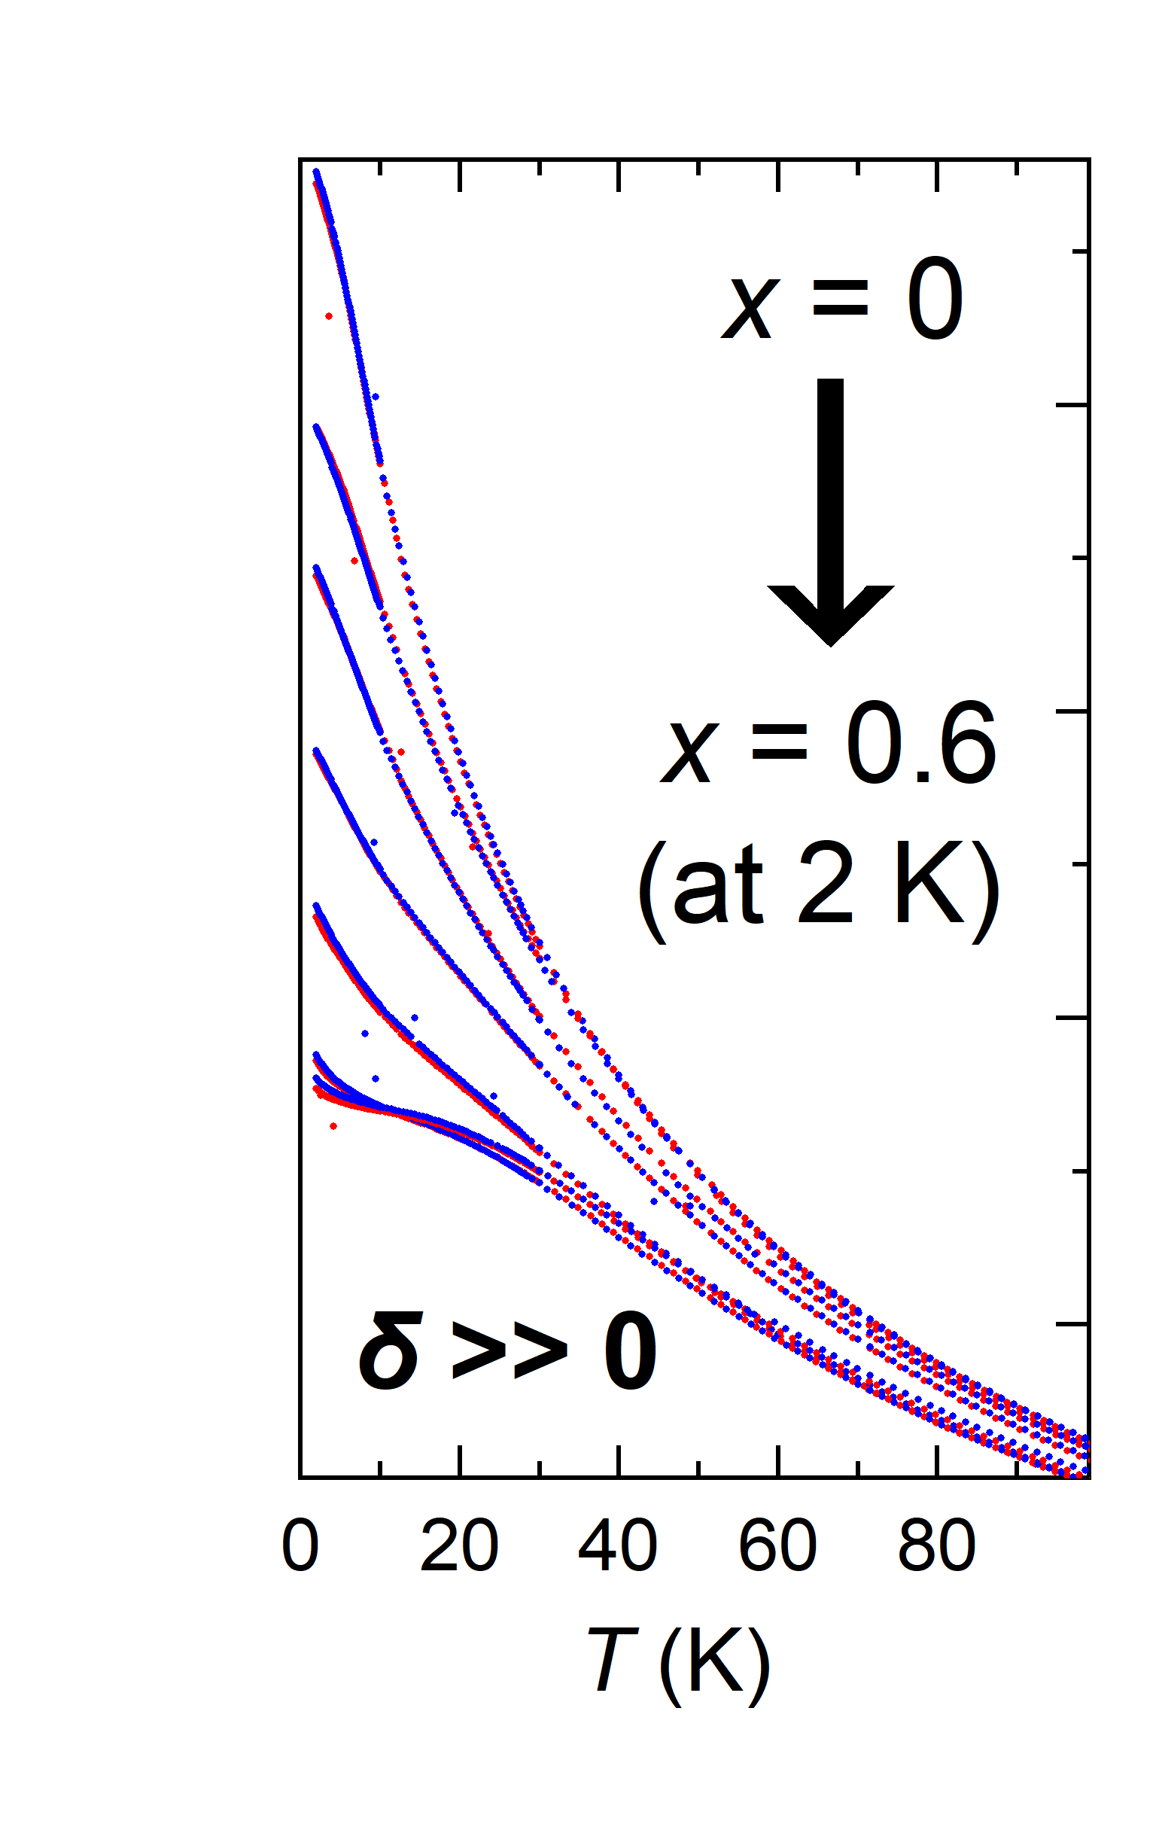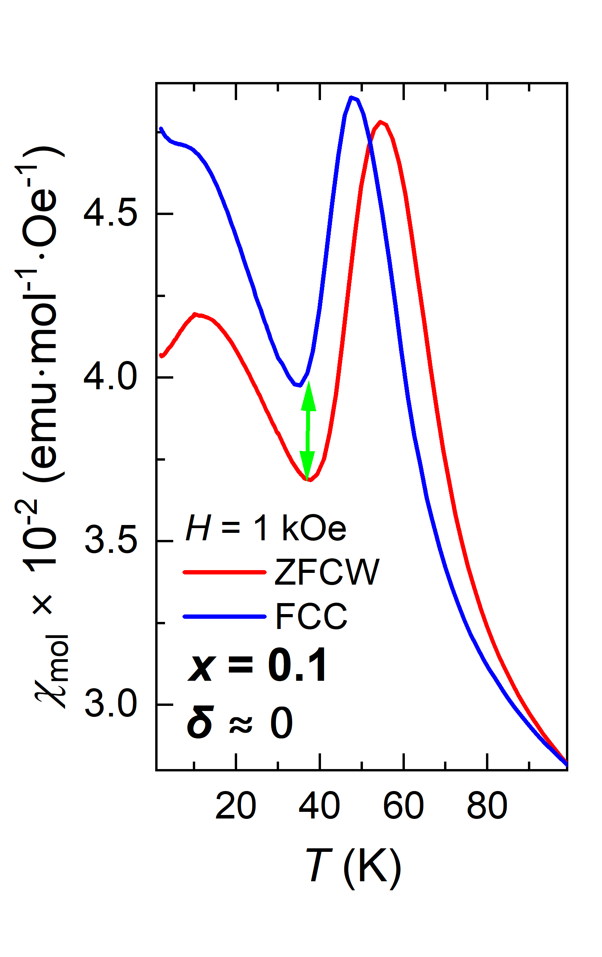

**(b)**

**(e)**

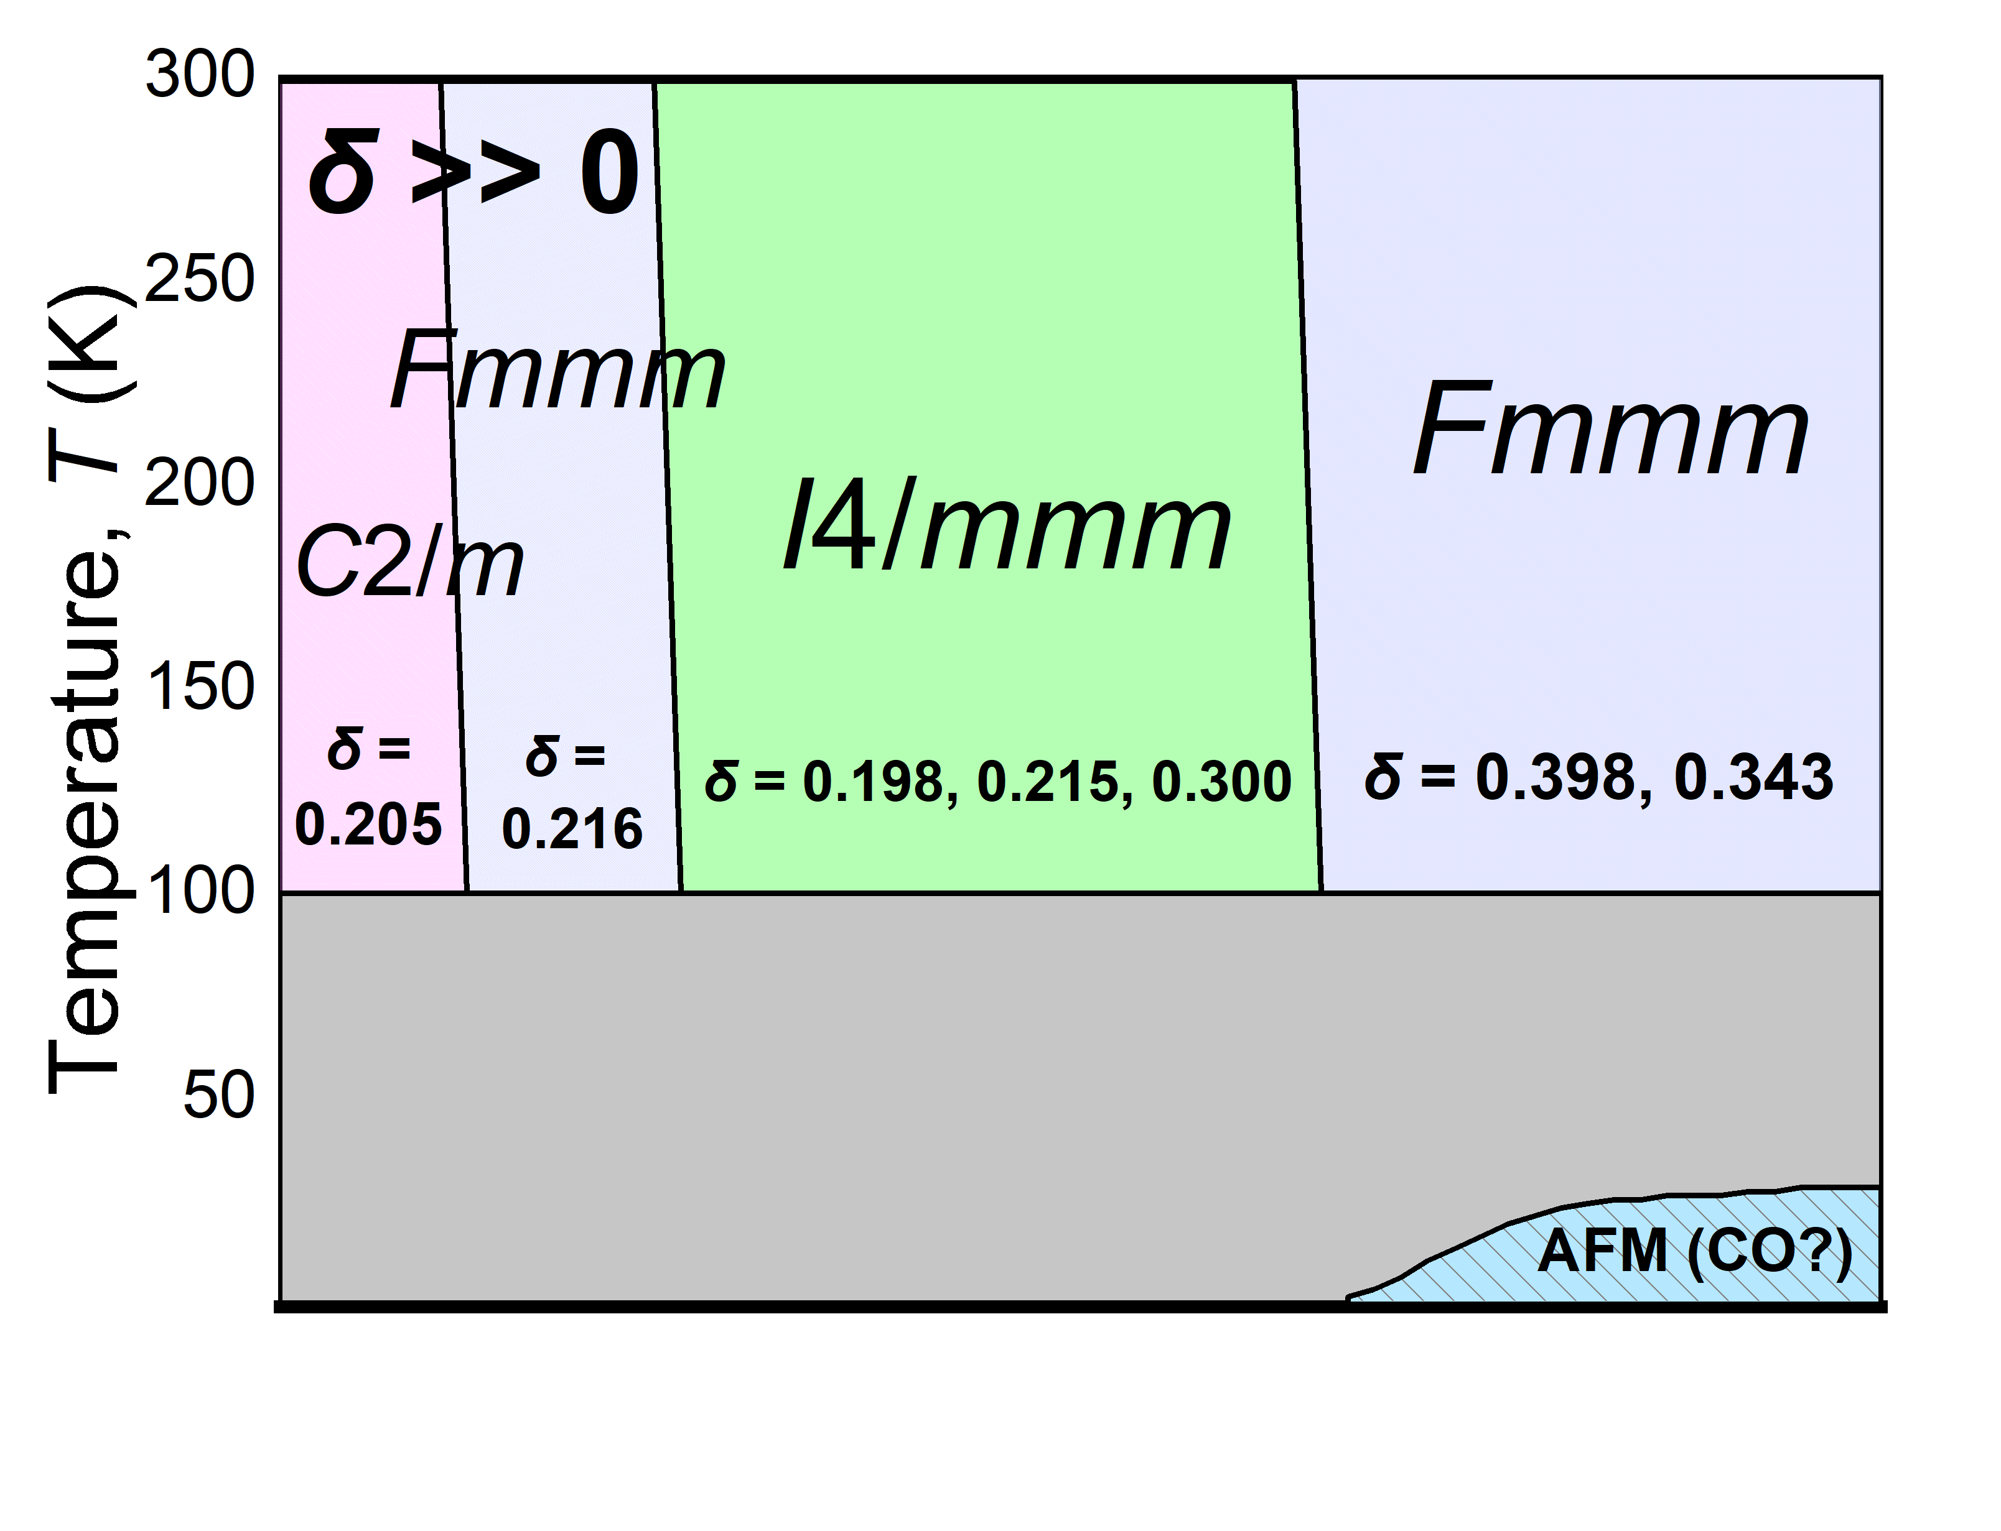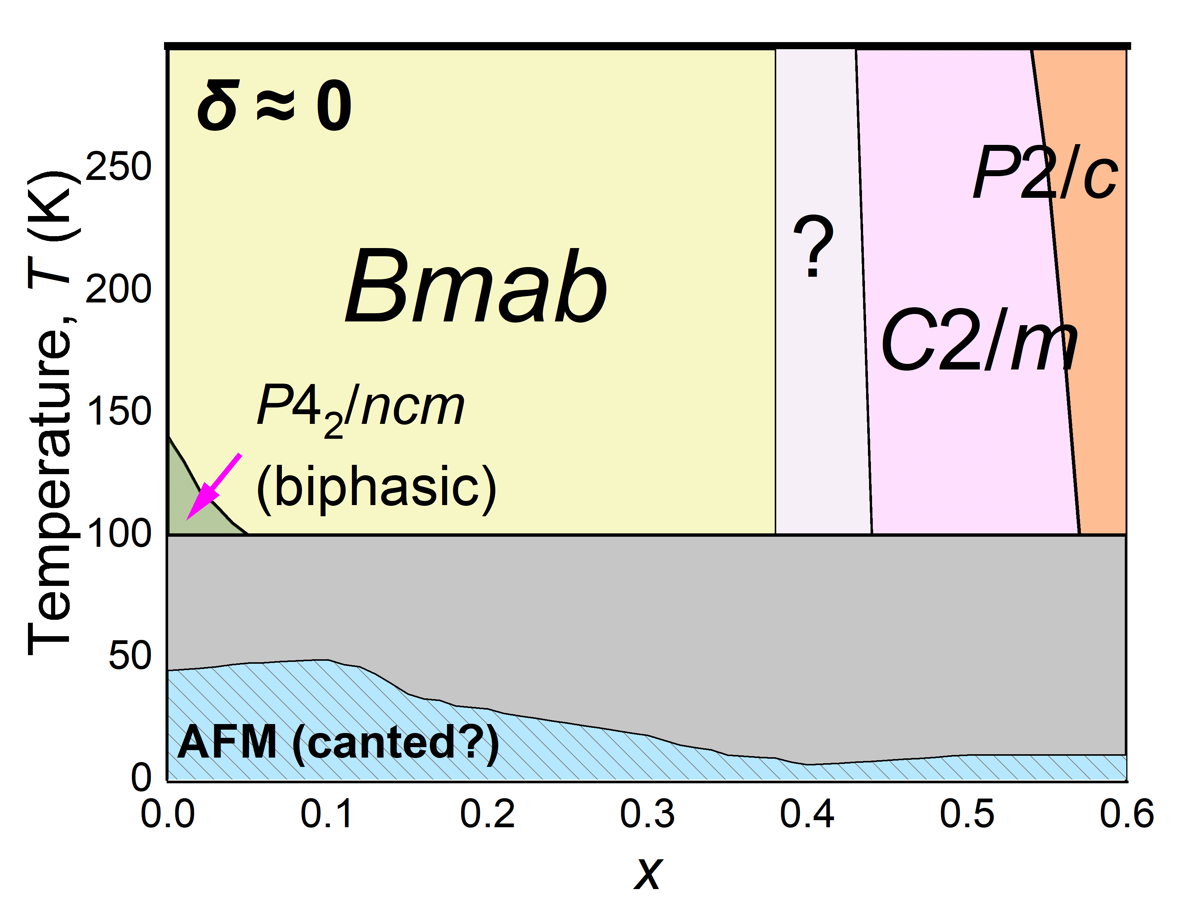

**(d)**

Fig. **(a)**. Variation of displacive and strain distortion modes with Ca-doping in the deoxygenated series, with stark magnetisation splitting and enhanced antiferromagnetism shown in **(b)** in contrast to the *δ* >> 0 series. Weak ferromagnetism caused by the DMI, domain orientation and monoclinic shear is presented in **(c)**, whilst the overall structural phase diagrams of both series below 300 K are showcased in **(d)**. The visual effect of the distortion modes are described in **(e)** down the [001] direction of a *P*2/*c* unit cell (*Γ*2+ also squeezing the unit cell in this direction).

###### 

###### [1] Axe, J. D.; Moudden, A. H.; Hohlwein, D.; Cox, D. E.; Mohanty, K. M.; Moodenbaugh, A. R.; Xu, Y. *Phys. Rev. Lett.,* **62** (2751), 1989.

[2] Kajimoto, R.; Ishizaka, K.; Yoshizawa, H.; Tokura, Y. *Phys. Rev. B*, **67** (014511), 2003.

[3] Sun, H.; Huo, M.; Hu, X.; Li, J.; Liu, Z.; Han, Y.; Tang, L.; Mao, Z.; Yang, P.; Wang, B.; Cheng, J.; *et al.* *Nature*, **621** (493–498), 2023.

[4] Frison, R.; Küspert, J.; Wang, Q.; Ivashko, O.; Zimmermann, M. v.; Meven, M; Bucher, D.; Larsen, J.; *et al*. *Phys. Rev. B,* **105** (224113), 2022.

[5] Hu, X.; Lozano, P. M.; Ye, F.; Li, Q.; Sears, J.; Zaliznyak A.; Gu, G. D.; Tranquada, J. (2025). *Phys. Rev. B*, **111** (064504), 2025.