# The search for FGE stabilizing molecules: from fragment screen hits to potential lead(s)

## J. L. Kowal1, N. Ezzaidi2, J. Wollenhaupt3, K. Radhakrishnan4, T. Pietrowski1, M. Löwen1, M. Thangarasah1, H. J. Horstmeier1, E. Baum1, W. Keller1, S. Alam4, M. S. Weiss3, M. G. J. Baud2, H. H. Niemann1

### 1Structural Biochemistry, Department of Chemistry, Bielefeld University, Germany, 2Scool of Chemistry and Institute for Life Sciences, University of Southampton, United Kingdom, 3Macromolecular Crystallography, Helmholtz-Zentrum Berlin, Germany, 4Biochemistry III, Department of Chemistry, Bielefeld University, Germany

### julia.kowal@uni-bielefeld.de

Formylglycine-generating enzyme (FGE) is key to the posttranslational modification of the active site of all known sulfatases. By conversion of a cysteine to formylglycine, FGE activates the sulfatases in the endoplasmic reticulum. Missense mutations in the gene encoding FGE lead to catalytically impaired or unstable protein variants that are prone to degradation. The resulting lack of sulfatase modification leads to the rare disease known as multiple sulfatase deficiency (MSD) [1]. Here, we present up-to-date results from the first structure-based approach to stabilize mutated FGE variants and rescue their activity by development of pharmacological chaperones [2]. Preformed crystals of human FGE were soaked with > 1000 small molecules from the F2X-Universal library, and additional compounds selected by ITC and DELT screening, to identify hits and interesting binding pockets on the enzyme surface [3, 4]. Data collection at BESSY beamlines 14.1 and 14.2 followed by data analysis in FragMAXapp [5] revealed more than 60 unique fragment hits in up to seven interaction sites, including the active site of FGE (Fig. 1). Two compounds with overlapping binding positions in site 2 were used for linking and synthesis of several follow-ups, based on the structural data. Data collection at DESY P13 revealed *Fo-Fc* density for one of these follow-ups in a data set from a single crystal, which suggests stronger interaction with the enzyme. To evaluate whether the discovered hits and follow-up compounds stabilize the protein or not, we obtained first results from differential scanning fluorimetry experiments. Since DSF indicated destabilization of the enzyme by the first follow-ups, a different starting point was considered for ligand-design by merging and growing from overlapping fragment hit structures. Evaluation of structures obtained from the last part of the F2X-Universal library screen and synthesis of further optimized follow-up compounds is in progress.

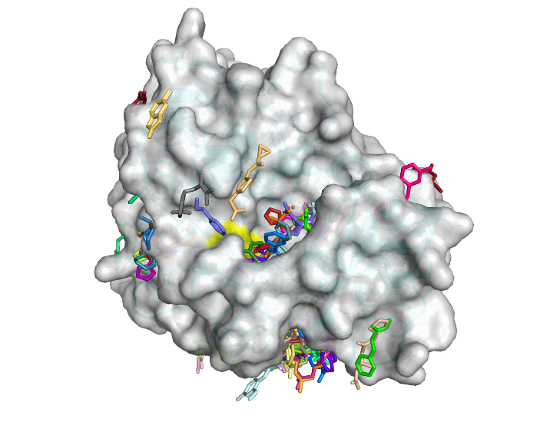

###### **Figure 1**. FGE surface overlayed with identified fragment hits in their respective binding positions.

#### [1] Dierks, T., Dickmanns, A., Preusser-Kunze, A., Schmidt, B., Mariappan, M. von Figura, K., Ficner, R., Rudolph, M. G. (2005). *Cell.* **121(4)**, 541-552.

#### [2] Liguori, L., Monticelli, M., Allocca, M., Hay Mele, B., Lukas, J., Cubellis, M. V., Andreotti, G. (2020). *Int J Mol Sci.* **21(2)**, 489.

#### [3] Wollenhaupt, J., Metz, A., Barthel, T., Lima, G. M. A., Heine, A., Mueller, U., Klebe, G., Weiss, M. S. (2020). *Structure*. **28(6)**, 694-706.e5.

#### [4] Wollenhaupt, J., Barthel, T., Lima, G. M. A., Metz, A., Wallacher, D., Jagudin, E., Huschmann, F. U., Hauß, T., Feiler, C. G., Gerlach, M., Hellmig, M., Förster, R., Steffien, M., Heine, A., Klebe, G., Mueller, U., Weiss, M. S. (2021). *JoVE*, **169**, e62208.

#### [5] Lima, G. M. A., Jagudin, E., Talibov, V. O., Benz, L. S., Marullo, C., Barthel, T., Wollenhaupt, J., Weiss, M. S. and Mueller, U. (2021). *Acta Cryst D*. **77**, 799-808.