# Synergistic insights from crystallographic and microcalorimetric studies in solution: a case of *R. etli* asparaginases

## J. Sliwiak1, M. Grzechowiak1, K. Pokrywka, P. Worsztynowicz, M. Ruszkowski, M., Gilski, M. Jaskolski

### 1First affiliation, address (Heading 3 style, Times New Roman 10pt, italic), 2Second affiliation, address (Heading 3 style)

### Email of communicating author@institution.org (Heading 3 style)

L-Asparaginases hydrolyze asparagine into ammonia and aspartic acid. They are divided into 3 structural classes and can exhibit substrate affinity ranging from low micromolar to high millimolar, as well as co-activities towards other substrates, such as L-glutamine or β-aspartyl peptides. There are also reports about their ability to process substrates like urea or acrylamide. Certain asparaginases are of medicinal or industrial importance as powerful drugs in the treatment of acute lymphoblastic leukemia or for reducing harmful acrylamide levels in processed food by decreasing the asparagine pool before heat processing. The focus of our studies is on rhizobial representatives of the novel Class 3 asparaginases (the constitutive ReaIV and inducible ReAV), which are metalloenzymes with no similarity to other asparaginases. As research tools, we combine X-ray crystallography with microcalorimetry (ITC), which has become a widespread method for studying not only molecular interactions but also enzyme kinetics. Such approach not only helped to structurally explain the nature of serendipitous acrylamide reaction of ReAIV monitored by ITC, but also helped to establish conditions sufficient to obtain a crystalline complex of ReAV with a substrate or explain the differences in the effect of the reaction products on the kinetics of both isoforms.

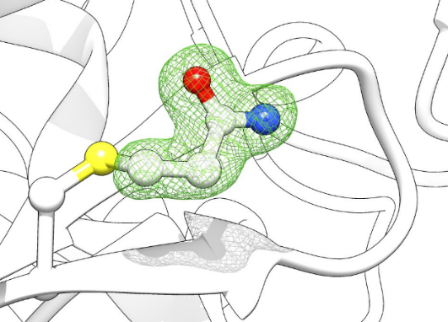

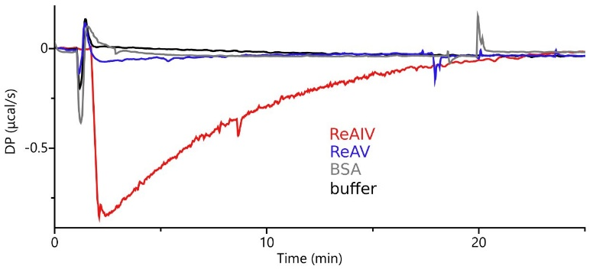

###### 

###### **Figure 1**. This is a figure caption (Heading 6 style, Times New Roman 9 pt).

References should be given in the text by square brackets [1]. Two or more references at a time may be put in one set of brackets [2-4] or [2, 3]. The references are to be numbered in the order in which they are cited in the text.

Use equation editors for equations, with layout as in this example, eq. (1):

|  |  |
| --- | --- |
| *a*2 + *b*2 = *c*2 | (1) |

The references should be in Heading 4 style (Times New Roman 9 pt) and listed immediately at the end of the text without a heading.

#### [1] Margilies, L., Kramer, M. J., McCallum, R. W., Kycia, S., Haeffner, D. R., Lang, J. C. & Goldman, A. I. (1999). *Rev. Sci. Instrum.* **70**, 3554.

#### [2] Chupas, P. J., Ciraolo, M. F., Hanson, J. C. & Grey, C. P. (2001). *J. Am. Chem. Soc.*, **123**, 1694.

#### [3] Bunge, H. J. (1982). *Texture Analysis in Materials Science*. London: Butterworth.

#### [4] Balzar, D. & Popa, N. C. (2004). *Diffraction Analysis of the Microstructure of Materials*, edited by E. J. Mittemeijer & P. Scardi, pp. 125-145. Berlin: Springer.

Any acknowledgements authors wish to make should be included at the end of the manuscript with no heading (use Acknowledgement style, Times New Roman 10 pt, italics).