Application of crystal engineering tools for the design of multiphase formulations for food and pharmaceuticals

E.Simone¹

¹Department of Applied Science and Technology, Politecnico di Torino, Torino, 10138, Italy

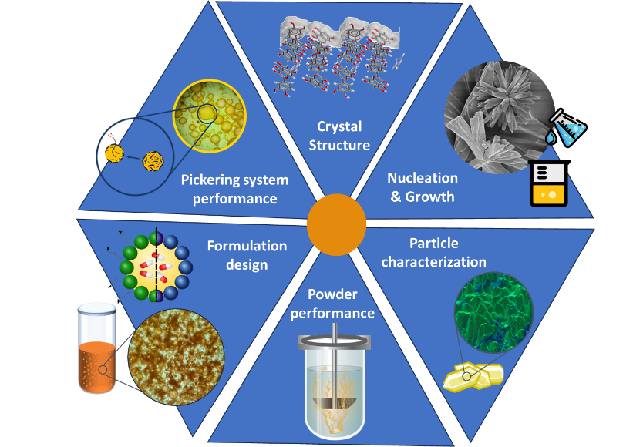
elena.simone@polito.it
Recent progress in pharmacology, plant biology and biotechnology has led to a dramatic increase in potency and specificity of new generation drugs, active agrochemical ingredients and food nutraceuticals. Unfortunately, this has been accompanied by poor bioavailability and water solubility: it is estimated that around 40% of the active pharmaceutical ingredients currently on the market and 60% of the ones still in development are poorly soluble due to their high molecular weight and structural complexity. These issues have pushed scientific research towards the design of complex formulations, with enhanced dissolution rate and bioavailability, which allow more efficient and targeted delivery of active ingredients (AIs). Multiphase systems (e.g., emulsions, foams, creams) are a convenient and effective encapsulation and delivery strategy, particularly for oral and topical formulations. Currently, synthetic excipients, surfactants and specialty polymers are used to create formulations with enhanced properties. However, these compounds are derived from non-renewable resources through some of the most greenhouse gas-intensive manufacturing processes. For this reason it is now necessary to replace the common synthetic stabilizers used for these products with natural, biocompatible and biodegradable materials. These include natural micro and nano-particles (Pickering stabilizers) such as proteins, polysaccharides and various crystalline materials including cellulose, chitin, fat crystals and polyphenol crystals. Pickering systems are particularly promising since particles adsorb at interfaces more strongly than surfactants, providing significantly more stable formulations. The stability of Pickering systems is strongly affected by particle size and shape, but surface wettability is the most important property of Pickering particles. For faceted, anisotropic crystals surface wettability is not easy to determine. In fact, crystals present multiple crystallographic facets, whose surface properties (e.g., polarity, wettability) depend on the type and directionality of the intermolecular interactions that characterize each facet. The purpose of the presented work is to understand how crystal properties (size, shape and polymorphism) of Pickering particles affect their surface properties, hence their orientation and adsorption behaviour at interfaces. In order to achieve this goal and enable the design of optimized multiphase formulations, we applied an unprecedented combination of modelling techniques, ranging from the molecular (synthons analysis from crystallographic data, molecular dynamics), meso (population balance equations, interfacial particle stabilization) and continuum (diffusion, dissolution) scales, and experimental activities, including particle characterization (facet-specific and bulk measurements such as nano-IR and electron diffraction) and powder performance determination (kinetic parameters estimation, stability studies) measurements to better understand Pickering stabilization and enable optimal multiphase formulation design (Figure 1). Different model systems including mixtures of edible triacylglycerides and flavonoids of various nature (e.g., quercetin, curcumin, xanthone) were used and will be illustrated.
Figure 1: Graphical representation of the work conducted.

[1] Prandini et al. (2024) Powder Technology, 443, 119927.

[2] Del Duca et al. (2024) Food Research International, 194, 114871.

[3] Klitou et al. (2023) Crystal Growth and Design, 23, 6034 – 6045.
This work has received funding from the European Research Council (ERC) under the European Union’s Horizon 2020 research and innovation programme (grant agreement no. 949229), which enable the creation of the Crystallization & Crystal Engineering team at Politecnico di Torino (Dr Emmanuele Parisi, Dr Cecilia Fiore, Miss Giulia del Duca, Miss Emilia Prandini, Mr Pierfrancesco Latorre) who performed experiments and simulations. Essential support was provided by Dr Antonio Buffo and Prof. Enzo di Fabrizio (Politecnico di Torino), Dr Nicodemo di Pasquale and Dr Serena Bertoni (University of Bologna) for the modelling and experimental tasks. Dr Mauro Gemmi (IIT Pontedera) and Rikagu Electron Diffraction are acknowledged for their support in the collection and analysis of electron diffraction data. Dr Andy Malony and CCDC are acknowledged for further financial support.

