# Compressing secondary arsenic∙∙∙halogen bonds: high-pressure X-ray diffraction study of As2O3 intercalation compounds

## P. A. Guńka1, S . Milos2, M. Ende3, F. Alabarse4, R. Miletich2, K. F. Dziubek2

### 1 Warsaw University of Technology, Faculty of Chemistry, ul. Noakowskiego 3, 00-664 Warszawa, Poland, 2 University of Vienna, Department of Mineralogy and Crystallography, Althanstraße 14, A-1090 Wien, Austria, 3 Martin-Luther-University Halle-Wittenberg, Institute for Geosciences and Geography, 06120 Halle (Saale), Germany, 4Elettra Sincrotrone Trieste S.C.p.A, XPRESS Beamline, AREA Science Park, I-34149 Basovizza, Trieste, Italy

### piotr.gunka@pw.edu.pl

Arsenic atoms form in arsenic(III) oxycompounds three strong primary bonds and, in addition to that, up to three weaker secondary bonds which are localized *trans* with respect to primary bonds [1]. It has recently been demonstrated that arsenic∙∙∙halogen (hereafter denoted As∙∙∙Hal, where Hal stands for Cl, Br and I) secondary bonds exist in arsenic(III) oxide intercalates, and their nature is analogous to that of secondary As∙∙∙O bonds [2]. Herein, we will present the results of high-pressure structural studies of three As2O3 intercalates, which have been carried out to investigate the influence of pressure on As∙∙∙Hal secondary bonds and to compare it to the pressure variation of As∙∙∙O secondary bonds.

Crystal structures of arsenic(III)-oxide intercalation compounds with ammonium chloride (NH4Cl∙As2O3∙1/2H2O), ammonium bromide (NH4Br∙2As2O3), and ammonium iodide (NH4I∙2As2O3) have been determined under high pressure up to 15, 11 and 15 GPa, respectively. The compression of As∙∙∙Hal secondary bonds, expressed as penetration indices of the bonds [3], has been shown to be a linear function of unit cell volume ratio *V*/*V*0, where V0 is the unit cell volume at ambient pressure, with similar slopes as the compression of As∙∙∙O secondary bonds (see Fig. 1). The behavior of arsenic first-order valence entropy coordination number at high pressures and the stereoactivity of arsenic lone electron pairs in the studied intercalates is the same as in arsenic(III) oxide polymorphs – the former decreases linearly with *V*/*V*0, while the latter remains unchanged [4]. The high-pressure study lends further support to the fact that the nature of As∙∙∙Hal and As∙∙∙O secondary bonds is the same

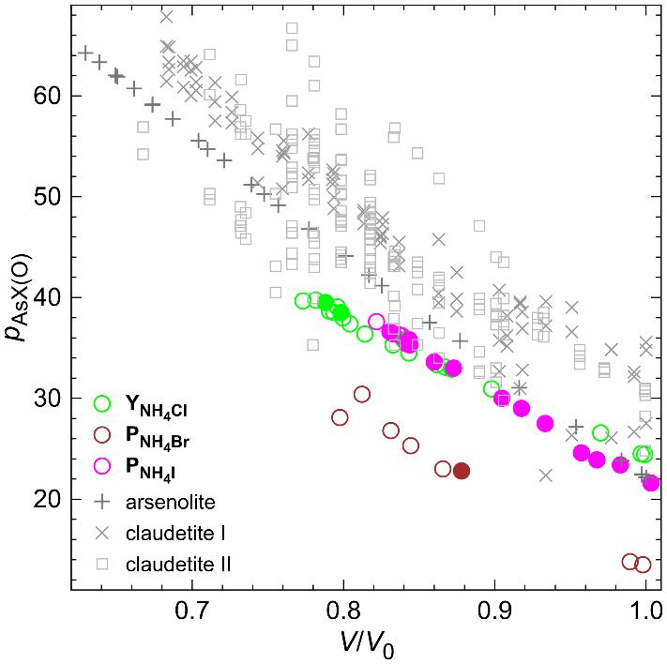

###### **Figure 1**. Penetration indices of As∙∙∙X and As∙∙∙O secondary bonds in the studied intercalates and As2O3 polymorphs plotted as a function of *V*/*V*0 unit cell volume ratio.

#### [1] Pertlik F. (1979). *Monatsh. Chem.* **110**, 387.

#### [2] Dąbrowski M., Wrześniewska W., Prystupiuk A., Zachara J. & Guńka P. A. (2023). *Cryst. Growth. Des.* **23**, 6081.

[3] Echeverría J. & Alvarez A. (2023). *Chem. Sci.* **14** 11647.

[4] Guńka P. A. Zachara J. (2019) *Acta Crystallogr. Sect. B* **75**, 86.

The Polish National Science Center is gratefully acknowledged for financing the research (project no. 2020/39/D/ST4/00128) and Elettra synchrotron for providing beam time for the experiments at the Xpress beamline (proposals 20230005 and 20240142).