# Fourier goggles: on! Rediscovering crystallography through the beauty of frequences

## S. Canossa1

### 1ETH Zurich, Vladimir-Prelog-Weg 1, 8093 Zurich, Switzerland

### scanoss@ethz.ch

Fourier synthesis, Fourier maps, Fourier space… crystallography makes an abundant use of the Fourier transform (FT), but this mathematical operation is far from being a friendly topic in academic courses. A curious and undeniably nerdy tendency for calculating FT of casual pictures led me to realize that the more I observed these patterns and their relationship with the original images, the more I felt confident with understanding actual diffraction experiments. Most notably, interpreting complex scattering phenomena including diffuse scattering or satellite peaks from local superstructures became an increasingly intuitive and playful experience. Hoping to share it with as many students and educators as possible, I decided to create *Specialdefects*, an open-access gallery of artistic and educational pictures (Fig. 1) that encourage to test this visual exercise [1]. In this contribution, I will give an outline of how such a singular initiative began, where it is possibly heading, and how any student or educator can engage in it at their own pace and with their own style, discovering an inclusive complementary approach to test their understanding of modern crystallography.

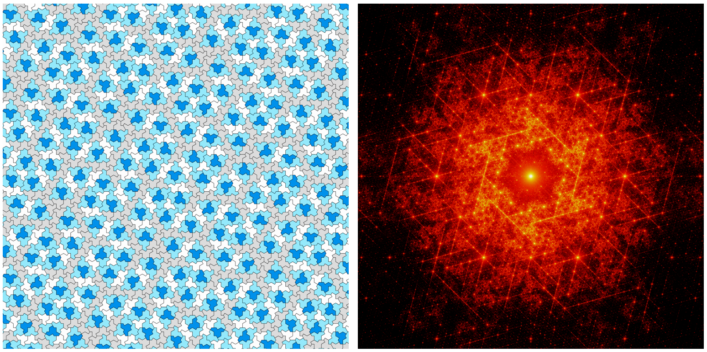

#### **Figure 1**. The first real-reciprocal space pair made for the Specialdefects initiative, which explores the recently discovered ‘Einstein aperiodic tiling’ (left) by displaying its thought provoking Fourier transform (right).

#### [1] Canossa, S., https://www.behance.net/specialdefects