# Anomalous crystallography - can we see oxidation states in crystal structures?

## M. Bodensteiner1, F. Meurer1, A. Zwolenik2, A. Makal2

### 1University of Regensburg, Faculty of Chemistry and Pharmacy, Universitaetstr. 31, 93055 Regensburg, Germany, 2University of Warsaw, Faculty of Chemistry Pasteura 1, 02-093 Warszawa

### michael.bodensteiner@ur.de

Both the measurement data and the structural models are subject to approximations and corrections in single-crystal structure determinations. Traditionally, these models have relied almost exclusively on spherical electron density distributions to represent atoms. This approach neglects important features such as atomic charges, bonding interactions and lone electron pairs. However, it is feasible to incorporate these features into the model, significantly improving structural quality — even when using standard data collected on virtually any diffractometer.[1]

In single-crystal structure determinations, absorption corrections are routinely applied to account for the fact that not all incident X-ray photons are diffracted — some are absorbed by the crystal. This absorption correction is intrinsically linked to the correction for anomalous dispersion, which is applied to the structural model instead. These two phenomena — X-ray absorption and anomalous dispersion — contribute to the discrepancy observed between the number of diffracted electrons and the actual electron count in the crystal.[2]

Crucially, these two correction methods are closely related are firmly grounded in the principles of X-ray absorption spectroscopy (XAS). Together XRD and XAS provide a coherent framework for accurately interpreting the obtained data. For example, XAS is often used to determine the formal oxidation state of metal atoms. The interplay between and absorption can also be applied directly to diffraction data, potentially enabling the determination of formal oxidation states even using home laboratory diffractometers. In contrast to XAS, the strength of anomalous dispersion refinement in XRD lies in the fact that it can determine separate values for different metal positions in a compound

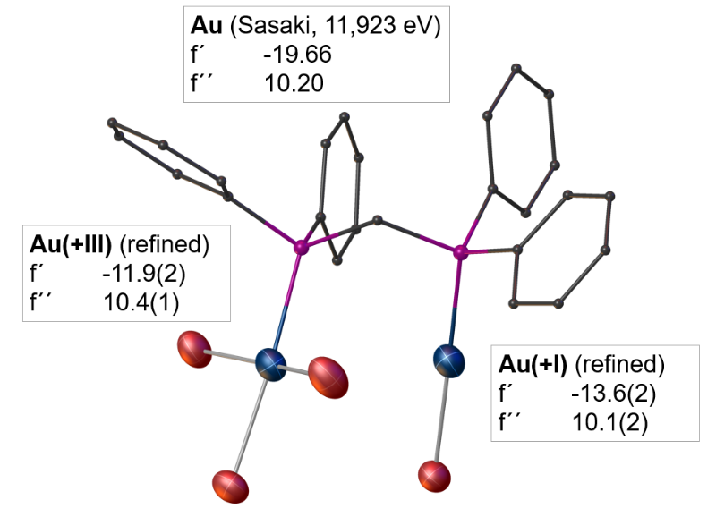

###### **Figure 1**. Different formal oxidation states reflected in the real part of the refined anomalous dispersion parameter *f’*.

#### [1] Kleemiss, F., Dolomanov, O. V., Bodensteiner, M., Peyerimhoff, N., Midgley, L., Bourhis, L. J., Genoni, A., Malaspina, L. A., Jayatilaka, D., Spencer, J. L., White, F., Grundkötter-Stock, B., Steinhauer, S., Lentz, D., Puschmann, H. & Grabowsky, S. (2021). *Chem. Sci.* **12**, 1675.

#### [2] Meurer, F., Dolomanov, O. V., Hennig, C., Peyerimhoff, N., Kleemiss, F., Puschmann, H. & Bodensteiner M. (2022). *IUCrJ*, **9**, 604.