## From structure to reactivity: Quantum crystallography in organometallic chemistry

## F. Meurer1, C. Riesinger1, F. Kleemiss2, M. Bodensteiner1

### 1University of Regensburg, Universitätsstr. 31, 93053 Regensburg, Germany 2RWTH Aachen, Landoltweg 1a, 52074 Aachen, Germany

### florian.meurer@ur.de

Recent developments in quantum crystallography facilitate its ability to investigate the electronic structure and bonding in molecular crystals in detail.[1] Here, we want to showcase the quantum crystallographic evaluation of [Ni]P3 (Fig. 1, [2]), an isolobale homolog for white phosphorus employing X-ray restrained wavefunction fitting (XRW) and multipolar modeling (MM). Metal-phosphorus bonding is discussed in relation to the Dewar-Chatt-Duncanson model based on its topology of total electron density and various bonding parameters. As a result, the difference in the frontier orbitals obtained by the XRW and previous DFT studies on [Ni]P3 can be explained regarding its reactivity towards nucleophilic attacks on the phosphorus atom.

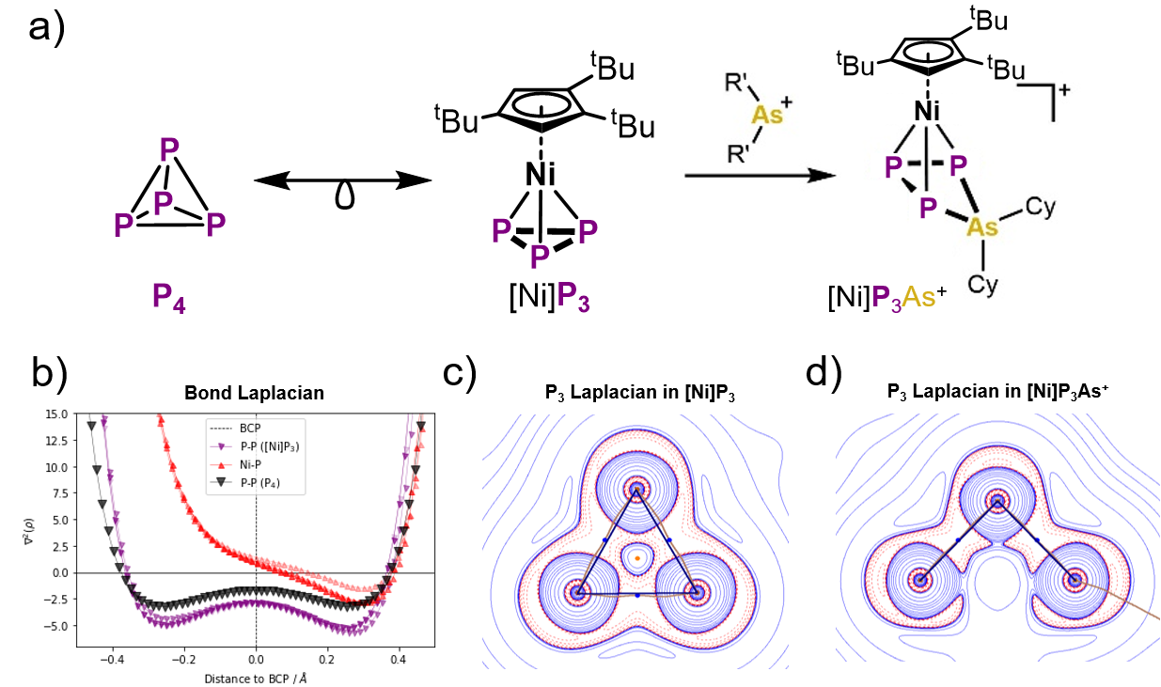

###### **Figure 1**. a) Schematic of the structures, isolobale relationship, and the reaction of [Ni]P3 with AsCy2+. b) Bond Laplacian of selected bonds in [Ni]P3. c) and d) show the in-plane Laplacian of the two *cyclo*-P3 fragments in [Ni]P3 and [Ni]P3As+.

Following the thorough description of [Ni]P3, we investigated its reactivity towards P-P arsenium bond insertion [3], yielding a cationic [Ni]P3As+ species. The driving force of this reaction can be explained by the ring-opening of the *cyclo*-P3 in [Ni]P3. As shown in Fig. 1 b), the bond critical points of the P-P lie outside the P3 triangle in a bonding fashion that was described as “banana” bonding because of the curved shape. After the arsenium bond insertion, the P-P bond critical points have significantly moved towards their shortest interatomic connecting pathway, showing energetic relief by the ring opening. In contrast, the P-P bond pathway, where insertion takes place, vanishes completely after the insertion in [Ni]P3As+.

#### [1] Grabowsky, S. (2022). *Complementary Bonding Analysis*, DeGruyter, DOI: 10.1515/9783110660074.

[2] Meurer, F., Kleemiss, F., Riesinger, C., Balázs, G., Vukovic, V., Shenderovich, I. G., Jelsch, C., Bodensteiner, M. (2024). *Chem. Eur. J.* **30**, e202303762, DOI: 10.1002/chem.202303762.

[3] Riesinger, C., Meurer, F., Zimmermann, L., Dütsch, L., Scheer, M., (2025). *Submitted*.

F.M. is grateful for funding from the Studienstiftung des Deutschen Volkes e.V. for a scholarship for his Ph.D.