# Investigating trimeron dynamics and lattice instabilities in Magnetite

## B. M. D. Fahl, A. Simonov

### ETH Zurich, Department of Materials, Zurich, Switzerland

### Benjamin.Fahl@mat.ethz.ch

Nearly 70 years after Verwey's discovery of the low-temperature phase transition in magnetite, Senn et al. finally solved its structure in 2012[1]. A key aspect of this phase's complexity is the existence of linear motifsconsisting of three iron atoms: one Fe2+ and twoFe3+ ions. In these Fe-Fe-Fe units, known as trimerons, theextra Fe2+ electron is shared. These trimerons form a complexnetwork of charge and orbital ordering, resulting in the observed monoclinicsuperstructure of magnetite [2].

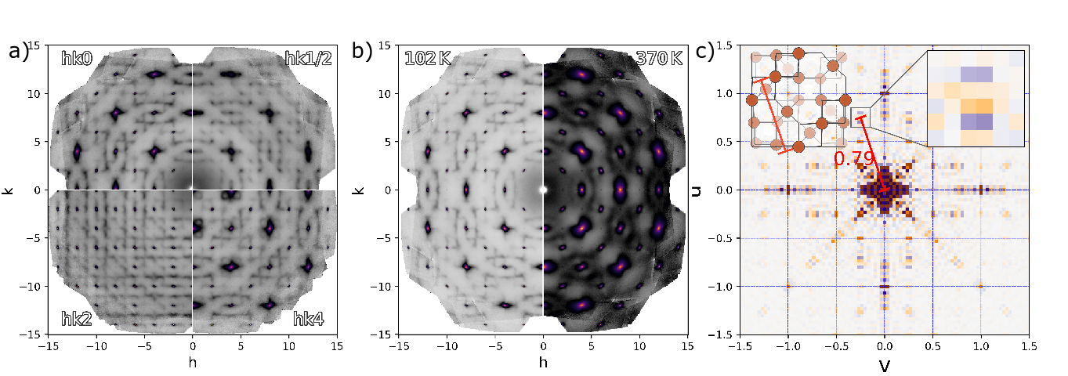Recent research using one-dimensional powder PDF analysis by Perversi et al. (2019) [3] has shown that trimerons, characteristic of the low-temperature phase, persist up to magnetite's Curie temperature (858 K [4]) They proposed a boxcar model where, above the phase transition, the average structure is an interpolation of the low-temperature phase over about 8 Å. Locally, the structure resembles the low-temperature Cc phase within this range. The model they use to compute distances is larger than the size extracted from the boxcar fit, meaning it does not match the experimental constraint. Since Verwey-like signatures are confined to about one unit cell in their model, but the Verwey phase extends over a larger scale, this further suggests that their model is incomplete. Powder averaging, which merges reciprocal space features, limits the resolution of structural information, measured at Diamond I19. To overcome these limitations for better structural insights, we employ single-crystal diffuse scattering and 3D-ΔPDF analysis to solve the real structure of the high-temperature phase on local and average levels as seen in fig 1. Our data reveals sharp features throughout the Brillouin zone and unusual displacment correlations in the 3D-ΔPDF, suggesting a more complex local structure than simple Verwey-like features condensing into the Verwey phase near the transition temperature.

###### **Figure 1** (a) Diffuse scattering diversity in magnetite near the 102 K phase transition, with dynamic features seen from the lack of X-ray form factor decay in hkx (x = {0, 1/2, 2, 4}). (b) Comparison of diffuse scattering at 102 K and 370 K showing persistent trimeron features. (c) PDF showing inter-trimeron chain correlation with missing horizontal component, suggesting unusual dynamics.

To disentangle these complex structural dynamics, we are developing an all-order phonon approach to thermal diffuse scattering (TDS). This method describes the undistorted magnetite structure's TDS contributions directly in reciprocal space, utilizing an atomic displacement pair correlation approach.We separate the contributions of regular thermal vibrations from those arising from lattice instabilities and polaron formations.This separation of scattering components provides insight into the interplay between thermal effects and electronic correlations in the pre-Verwey transition regime.Our findings suggest that the Verwey transition results from a balance ofcompeting lattice instabilities rather than a straightforward ordering process.

In conclusion, our research refines the understanding of magnetite's electronic behavior and offers insights into the origins of the Verwey transition and provides a new framework for investigating similar phenomena in other strongly correlated electron systems.

[1]Senn, M. S., Wright, J. P. & Attfield, J. P. Nature 481, 173–176 (2012).

[2]Perversi, G. et al. Chemical Communications, vol. 52, no. 27, pp. 4864–4867, 2016.

#### [3]Perversi, G. et al. Nat Commun 10, 2857 (2019).

#### [4]M. Hoesch. et al. Phys. Rev. Lett. 110, 207204 (2013)