Matching powder patterns to crystal structures with AutoFIDEL

A.G.P Maloney¹, N.F. Francia¹, J. Nyman¹

¹The Cambridge Crystallographic Data Centre, 12 Union Road, Cambridge, CB2 1EZ, UK

maloney@ccdc.cam.ac.uk
Accurately matching an experimental powder X-ray diffraction (PXRD) pattern to a pattern simulated from a crystal structure is essential for identifying materials, especially for polymorphs in complex landscapes. However, challenges such as low resolution of diffraction data, noise, and preferred orientation, can make this comparison process very difficult.
AutoFIDEL is an implementation of the FIDEL method [1] using similarity measures developed by de Gelder and co-workers [2] which allows for matching and optimising both experimental and predicted crystal structures against experimental PXRD patterns without requiring high-resolution transmission data and with preferred orientation. By automating the pattern matching process, good matches can be found objectively and efficiently. Once a close match is found, an algorithm to modify the cell parameters enables optimisation of the match, improving the accuracy of the structural analysis. AutoFIDEL has proven effective for factors like preferred orientation and sample height displacement. It has also been used to identify forms VII and VIII of the drug Galunisertib from PXRD patterns generated from structures obtained through Crystal Structure Prediction (CSP) [3].
This presentation will describe AutoFIDEL and the process of matching and optimising structures. It will highlight some case studies and demonstrate how to use the method in CCDC’s Mercury and CSD Python API software.
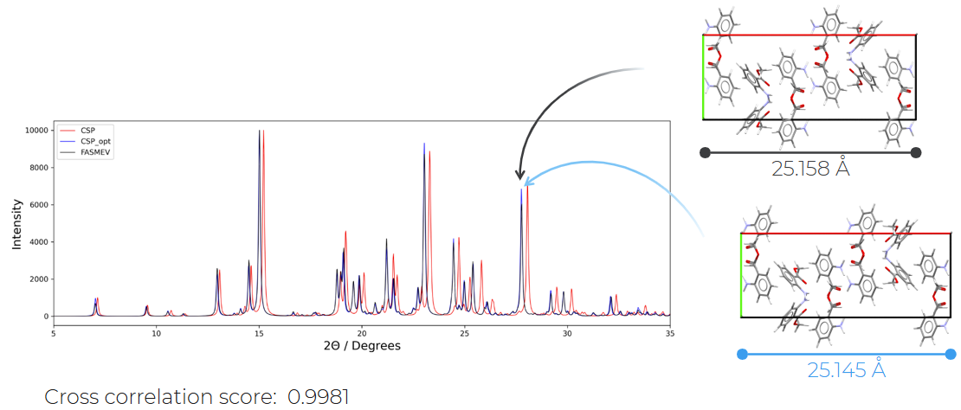

Figure 1. Optimisation of lattice parameters leads to an improved match between experimental and simulated patterns.

[1] Habermehl, S., Mörschel, P., Eisenbrandt, P., Hammer, S. M. & Schmidt, M. U. (2014). Acta Cryst. B70, 347-359.

[2] de Gelder, R., Wehrens, R., Hageman, J. A. (2001). J. Comput. Chem., 22, 273-289.

[3] Bhardwaj, R. M, McMahon, J. A., Nyman, J., Price, L. S., Konar, S., Oswald, I. D. H., Pulham, C. R., Price, S. L. & Reutzel-Edens, S. M. (2019). J. Am. Chem. Soc. 141, 35, 13887-13897.

