# Experimentally exploring the polymorphism of ROY through high throughput crystallisation

## M. R. Probert1, J. Weatherston1, M. J. Hall1

### 1Chemistry, School of Natural and Environmental Sciences, Newcastle University, NE1 7RU, UK

### michael.probert@ncl.ac.uk

Compounds that exhibit polymorphism present a unique opportunity to study the effects of crystallisation and the impact of different conditions that drive the formation of a particular solid-state form. The widely studied: 5-methyl-2-((2-nitrophenyl)amino)thiophene-3-carbonitrile, commonly known as ROY, has held the crown of being one of the most polymorphic compounds to studied to date. ROY has the added feature of varying colours of different solid-state forms that gives it its common name (red, orange and yellow) Therefore, ROY provides a perfect test case to study polymorphism, using high throughput methods and rapid analysis, to explore a large area of the solid-state landscape. The methodology used throughout this work is via our developed ENaCt protocols [1]. ENaCt uses an exclusively solution phase approach to crystallisation, however, the work presented will demonstrate that outcomes previously limited to more exotic approaches, such as melt and seeded melt methods, can be recovered via the kinetic trapping of more metastable forms.

The basic benefits of the ENaCt protocols are now well documented [2] and provide methods that are applicable to a wide range of materials with the added advantage or requiring very small quantities of analyte for rapid screening of crystallisation conditions. The basis of the methodology will be discussed alongside modifications that can be made to the approach to further aid the study of polymorphism and the wide ranging analysis of data that becomes available.

In addition to the ‘simple’ polymorphic outcomes (with all known solution phase results being achieved) the process also enables the ‘screening’ of more complex results, with the discovery of the first known solvate of ROY, access to unexpected reaction products formed during the crystallisation process, and access to a previously unknown polymorphic form (the 14th !), confirming ROY as the leader in this field [3].

The approach taken has also enabled statistical analysis of the global results, both positive and negative, to be studied. These data have enabled the directing influences of crystallisation conditions on the form obtained have been able to be accessed for the first time and a brief introduction to these analyses will be given, alongside the increasing future impact that access to these raw crystallisation data may provide.

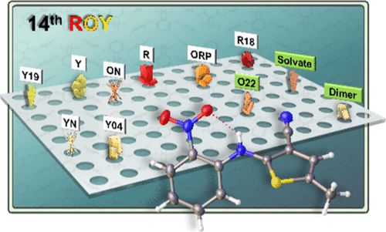

###### **Figure 1**. A artists impression of crystallisation results obtained from the ENaCt protocols for the highly polymorphic compound ROY [3].

#### [1] Tyler, A. R., Ragbirsingh, R., McMonagle, C. J., Waddell, P. G., Heaps, S. E., Steed, J. W., Thaw, P., Hall, M. J. & Probert, M. R. (2020). *Chem,* **6**, 1755–1765.

#### [2] Metherall, J. P., Carroll, R. C., Coles, S. J., Hall, M. J. & Probert, M. R. (2023). *Chem. Soc. Rev.*,**52**, 1995–2010.

#### [3] Weatherston, J., Probert, M. R. & Hall, M. J. (2025). *J. Am. Chem. Soc.*, **147**, 11949–11954.