# Minerals on Titan: the crystal structure of diacetylene

## L. Lopes Cavalcante1*, H. Maynard-Casely2, M. Cable3, S. Duyker4, E. Fayolle3, R. Hodyss3, B. Kennedy5, T. Vu3 and C. Ennis1,6

### 1Department of Chemistry, University of Otago, Dunedin 9054, New Zealand, 2Australian Centre for Neutron Scattering, ANSTO, Kirrawee, New South Wales 2232, Australia, 3Jet Propulsion Laboratory, California Institute of Technology, Pasadena, California 91109, United States, 4Sydney Analytical, Core Research Facilities, University of Sydney, NSW 2006, Australia, 5School of Chemistry, University of Sydney, Sydney, NSW 2006,Australia, 6MacDiarmid Institute for Advanced Materials and Nanotechnology, Wellington 6140, New Zealand

### *larissa.lopes_cavalcante@postgrad.otago.ac.nz

Saturn’s largest moon, Titan, is an important extra-terrestrial target for studying planetary chemistry and potential astrobiology. With an upper atmosphere rich in nitrogen and methane that undergoes conversion into hydrocarbons, nitriles and aerosols, this icy moon is a valuable model for investigating prebiotic chemistry analogous to early-Earth [1,2]. Among the larger molecules detected in Titan’s atmosphere, diacetylene (C4H2) is of particular interest due to its significant absorption of photons at longer wavelengths, which facilitates the formation of radical species such as C4H and C4H3 that are key to polycyclic aromatic hydrocarbon (PAHs) formation [3].

In this study, we combined powder X-ray and neutron diffraction, Raman spectroscopy and periodic-DFT calculations to characterise the crystal structure of diacetylene for the first time. The structure is described in the space group *P*212121 with four molecules in the unit cell (Fig. 1). The diacetylene molecules are arranged in a layered structure dominated by CH•••π interactions, which leads to anisotropic thermal expansion behaviour. At ambient pressure, no structural phase transitions were observed in the 5–220 K temperature range. Due to its structural similarity with acetylene, diacetylene may serve as a potential co-crystal component of particular importance for Titan’s surface chemistry and geomorphology. This is of potential importance in view of the upcoming NASA Dragonfly mission.

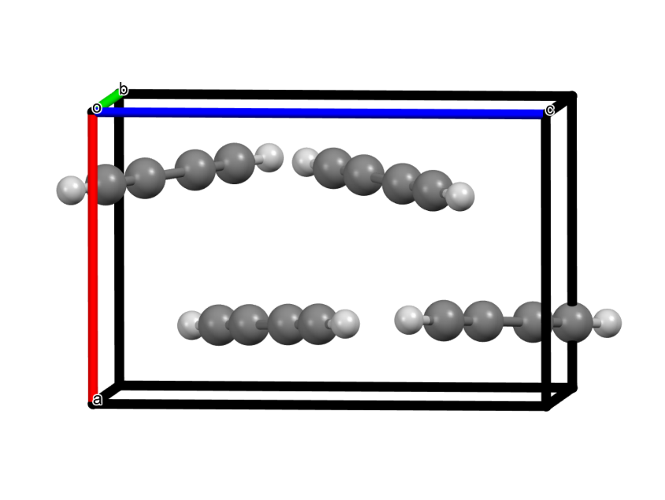

###### **Figure 1**. Representation of the structure of diacetylene refined in space group *P*212121 againstneutron powder diffraction data collected at 5 K.

#### [1] He, C., Smith, M. A. (2014). *Icarus*, **238**, 86-92.

#### [2] Raulin, F., Brassé, C.; Poch, O., Coll, P. (2012). *Chem. Soc. Rev.*, **41**, 5380.

#### [3] Huang, C., Zhang, F., Kaiser, R. I., Kislov, V. V., Mebel, A. M.; Silva, R., Gichuhi, W. K.; Suits, A. G. (2010). *ApJ*, **714**, 1249-1255.

This research was supported by the Marsden Fund Council from Government New Zealand funding, managed by Royal Society Te Apārangi (Proposal: 21-UOO-123), and by an AINSE Ltd. Postgraduate Research Award (PGRA). We thank New Zealand eScience Infrastructure (NeSI) for high-performance computing resources (Project UOO03077). We acknowledge the Australian Centre for Neutron Scattering for the provision of instruments through program proposal 13601. Part of this work was conducted at the Jet Propulsion Laboratory, California Institute of Technology, as part of the JPL Visiting Student Research Program (JVSRP), and under a contract with the National Aeronautics and Space Administration (80NM0018D0004).