# Complementary tools for in situ analysis of porous materials – some perspectives

## L. J. Barbour1,2

### 1 Department of Chemistry, School of Natural Sciences, University of Lincoln, Lincoln, UK, 2 Department of Chemistry and Polymer Science, Stellenbosch University, South Africa

### lbarbour@lincoln.ac.uk

The inclusion of small guest molecules into porous crystalline materials promises several exciting innovations in a wide range of areas, including separation and storage of gases or vapours, chemical sensing, and catalysis. Using now well-established principles of crystal engineering we can aspire to design porous materials with tailored structural and physical properties. However, there is still a need to develop new approaches to understanding the sometimes-complicated relationships between molecular-level structure and physico-chemical properties. In this regard, devising a range of complementary experiments to characterize materials under controlled environments such as gas pressure can be particularly challenging. This presentation will describe the development and application of a suite of approaches to structural analysis by means of in situ X-ray diffraction, complemented by physicochemical characterization using a combination of sorption analysis and thermoanalytical techniques.1-4

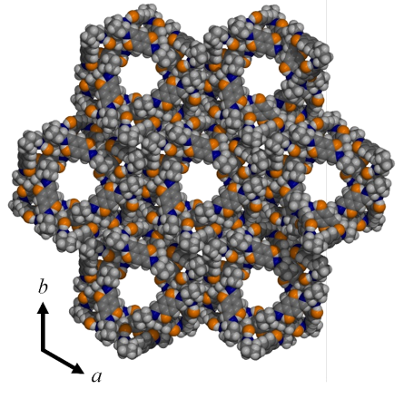

###### **Figure 1**. A molecular crystal forms 1 nm wide channels that readily and reversibly absorb water.3

#### [1] Lama, P., & Barbour, L. J. (2018) *J. Am. Chem. Soc.* **140**, 2145.

#### [2] Feldmann, W. K., Esterhuysen, C. & Barbour, L. J. (2020) *ChemSusChem* **13**, 5220.

#### [3] Eaby, A. C., Myburgh, D. C., Kosimov, A., Kwit, M., Esterhuysen, C., Janiak, A. & Barbour, L. J. (2023) *Nature* **616**, 288.

#### [4] Eaby, A. C., Loots, L., Basson, J. L., Esterhuysen, C. & Barbour, L. J. (2023) *Angew. Chem. Int. Ed.* **32**, e202304152.