# Three-faceted in situ setup for characterizing spinel high entropy oxides of 3d transition metal

## J. Edelvang-Pejrup1, A. Kirsch2, M. Arenz3, K. M. Ø. Jensen1

### 1CHEAC, Department of Chemistry, University of Copenhagen, 2Research Center Future Energy Materials and Systems, University Alliance Ruhr, 3NanoElectroCatalysis Group, Department of Chemistry Biochemistry and Pharmaceutical Sciences, University of Bern

### jep@chem.ku.dk

In the pursuit of new functional materials, increasing their compositional complexity opens up previously unexplored regions of composition space [1]. In this study, we synthesize spinel high entropy oxides (HEOs) by combining five distinct 3d transition metals – many of which are common components of simpler electrocatalysts for the oxygen evolution reaction (OER) [2]. The goal is to navigate this complex composition space and identify spinel HEOs with increased activity and stability compared to simpler spinel oxides.

However, with great compositional complexity comes great difficulty – namely in accurately characterizing the structure of the material. We demonstrate how the crystal structure of the nanocrystalline intermediate can be resolved by combining *in situ* x-ray diffraction (XRD) and total scattering (TS) measurements. However, this provides little information about the distribution of different metals within the spinel HEOs. Therefore, X-ray absorption near edge structure (XANES) data is also collected *in situ* to produce a three-faceted quasi-simultaneous dataset. XRD and TS reveal crystallographic phase evolution, while XANES provides site-specific insights into the coordination environments and oxidation states of the constituent metals, see fig. 1.

The complimentary nature of XRD, TS and XANES allows us to characterize the structure of materials that are increasingly compositionally complex. Specifically, we see that the investigated spinel HEOs go from a non-crystalline precursor through a nanocrystalline intermediate to a final crystalline spinel phase. The distribution of metals in tetrahedral and octahedral sites depends on which metals are in the sample and their ratios, and utilizing these trends is a promising way of manipulating the final structure of functional materials. Going forward we aim to link these structural features directly to catalytic activity for the oxygen evolution reaction [3]. Furthermore, the three-faceted *in situ* setup in itself provides a powerful tool for future investigation of compositionally complex materials.

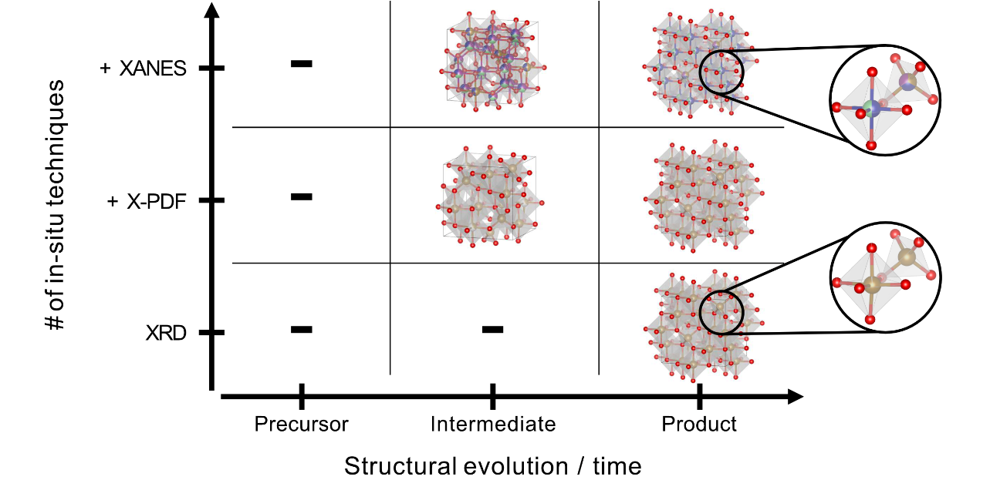

**Figure 1**. Table of what structural information can be accessed by combining different in-situ characterization techniques. During the synthesis of a five-metal spinel oxide, XRD is used to determine the structure of the crystalline product (bottom right cell), X-PDF sheds light on the local structure of the nanostructured intermediate (middle cell), while XANES provides insight into the elemental distribution in the tetrahedral and octahedral sites, respectively (top two cells).

#### [1] Löffler, T., Ludwig, A., Rossmeisl, J., S. & Wolfgang (2021). *Ang. Chem. Int. Edit*., **60**, 52.

#### [2] Jamesh, M. & Harb, M. (2021). *J. Energy Chem.*, **56**, 299.

#### [3] Svane, K. & Rossmeisl, J. (2022). *Ang. Chem. Int. Edit*., **61**, 19.