# Rapid development of a vast family of MOFs facilitated by 3D electron diffraction

## E. Svensson Grape1,2,3, J. A. Lopez Olvera 1, Y. Zheng1, J. Ha1, Y. Xia1, T. Willhammar1, A. K. Inge1

### 1Department of Chemistry, Stockholm University, Sweden, 2Department of Chemistry, Uppsala University, Sweden, 3Department of Chemistry and Biochemistry, University of Oregon, USA

### andrew.inge@su.se

3D electron diffraction (3D ED) facilitates structure determination from single submicron-sized crystallites. The technique has been particularly advantageous for determining structures of novel nanoporous materials, such as metal-organic frameworks (MOFs), of which growing larger crystals of certain phases can be challenging if not impossible. 3D ED is not only changing the way we determine crystal structures; it has started to influence how novel materials are synthesized and developed. Conventionally slow solvothermal synthesis methods have been the norm to develop novel porous materials to promote the growth of larger crystals needed for structure determination by single crystal X-ray diffraction. Without the need for large crystals for routine structure determination by 3D ED, synthesis conditions that promote the formation of smaller crystallites can offer advantages in the development of novel materials. Greener synthesis conditions using less energy, greener or no solvents, and fewer reaction derivatives may be applied to directly develop novel materials [1]. Rapid synthesis methods without the need for synthesis optimization can drastically accelerate the discovery of new materials saving weeks or months of time conventionally spent on synthesis optimization.

Ellagic acid is one of the building units of plant-based polyphenols: tannins. It is inexpensive, biocompatible and common in fruits, nuts, berries and tree bark. We have explored the use of ellagic acid as an organic linker to develop stable and biocompatible MOFs. The first metal-ellagate MOF, SU-101, was developed under green synthesis conditions at room temperature by mixing non-hazardous Bi3+ sources with edible pomegranate-sourced ellagic acid in water [2]. By changing the metal ion to Zr4+ and reacting it with ellagic acid in a DMF/H2O/acetic acid mixture, we developed the robust anionic MOF SU-102, which we utilized in capturing pharmaceutical pollutants in real municipal wastewater [3]. By only changing DMF for other organic molecules that behave as structure directing agents, an additional 20 MOFs were rapidly developed (Fig. 1) [4]. With a short 1-hour synthesis protocol and rapid structure determination by 3D ED that only takes a few minutes per crystal, three of these new MOFs were synthesized for the first time in the same morning, and all three crystal structures were determined later that same day. This work demonstrates how advances in structural characterization can rapidly accelerate the development of novel materials.

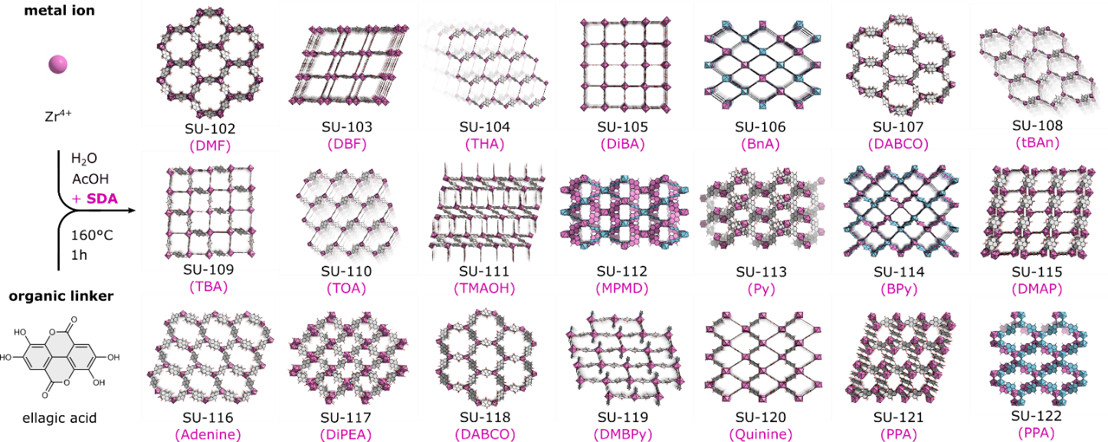

###### **Figure 1**. Crystal structures of a family of metal-organic frameworks rapidly developed in part due to 3D ED.

#### [1] Sala, A., Diouf, M. D. F, Marchetti, D., Pasquale, L. & Gemmi, M. (2024). *Cryst. Growth Des.* **24**, 3246.

#### [2] Svensson Grape, E., Flores, J. G., Hidalgo, T., Martínez-Ahumada, E. et al. (2020). *J. Am. Chem. Soc.*, **142**, 16795.

#### [3] Svensson Grape, E., Chacón-García, A. J., Rojas, S., Pérez, Y. et al. (2023). *Nature Water*, **1**, 433.

#### [4] Svensson Grape, E., Lopez Olvera, J. A, Zheng, Y., Ha, J., Xia, Y. et al. (2025). *ChemRxiv*, doi:10.26434/chemrxiv-2024-n90rn-v2